Contents
Sprint 2 Progress (At this stage trial is done till configuring terraform and Ansible scripts) 4
Docker Compose build: 4
All services are built successfully: 4
Kubernetes manifests: validated against real cluster with zero schema errors 5
Creating cluster: 5
Helm chart — parses, renders, and produces valid Deployments/Services/HPAs 6
Terraform — VPC, EKS cluster (ACTIVE, v1.33, 2 nodes Ready), ECR, S3, IAM, security groups, Jenkins EC2 all provisioned and verified on real AWS 7
Terraform init: 7
Created IAM user: 8
AWS CLI is configured: 8
S3 bucket and DynamoDb table is created before applying Terraform scripts for below reasons: 9
Create S3 bucket: 9
Create dynamodb table: 10
Run Terraform init again: 11
Terraform plan: 12
Confirm Jenkins EC2 is reachable: 43
All the resources are created on AWS: 43
VPC is created 43
2 public and 2 private subnets are created: 44
1 NAT Gateway: 45
1 Internet Gateway: 45
A public RT routing: 46
A private RT routing: 46
Streamingapp Cluster is created with node group and nodes: 47
EC2: 48
ECR: 49
S3: 49
IAM roles: 50
Dynamo DB: 51
KMS: 52
Cloudwatch: 52
Ansible — Jenkins EC2 fully configured via the dynamic AWS inventory, real SSH, real playbook run, zero failures 53
That's everything through Ansible confirmed working on actual AWS infrastructure, not just locally. 56
Next Steps: building/pushing real images to ECR, deploying the app to EKS, and eventually the ALB Ingress 56
Screenshots: 57
Sprint 2 Progress (At this stage trial is done till checking the App is live) 57
IAM User Creation 57
Configure AWS CLI: 58
Terraform infra: 58
Create S3 bucket: 58
Create DynamoDB table: 58
Terraform init and apply: 59
VPC is created: 89
2 public and 2 private subnets are created: 89
1 NAT Gateway: 90
1 Internet Gateway: 90
1 public routing: 91
1 private routing: 91
Streaming app cluster: 92
EC2: 92
ECR: 93
S3: 93
Dynamo DB: 94
Grant Terraform identity Kubernetes RBAC access 94
Ansible configures Jenkins EC2: 95
Generate SSH key pair and replace it in EC2.tf file: 95
Copy the key to wsl’s native filesystem: 95
Run the Ansible playbook: 96
Build and push real docker images to ECR: 97
Test the Jenkinsfile: 102
App is live : 104

Sprint 2 Progress (At this stage trial is done till configuring terraform and Ansible scripts)

Docker Compose build:

All services are built successfully:
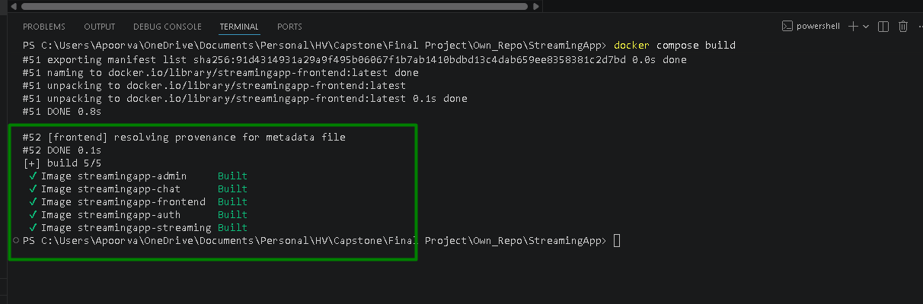

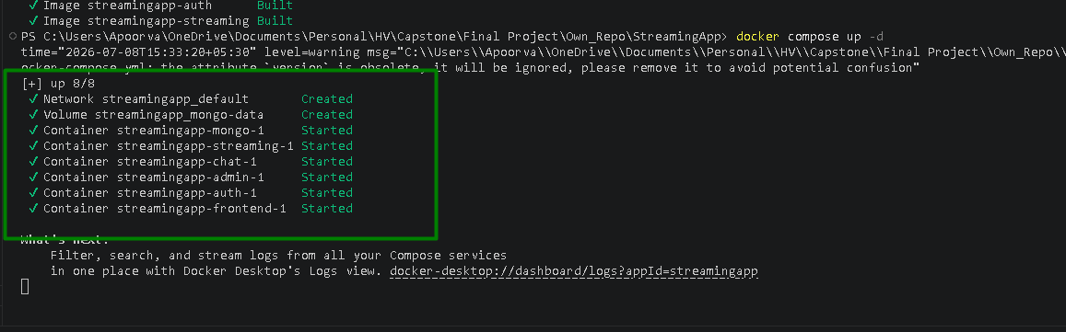
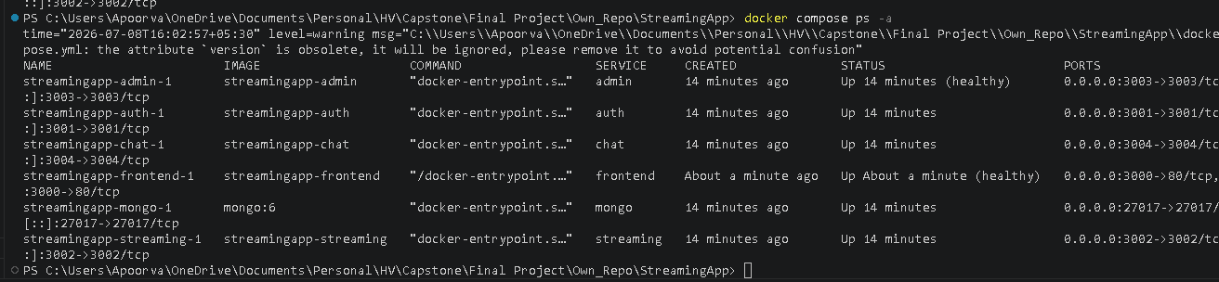

Kubernetes manifests: validated against real cluster with zero schema errors

Creating cluster:
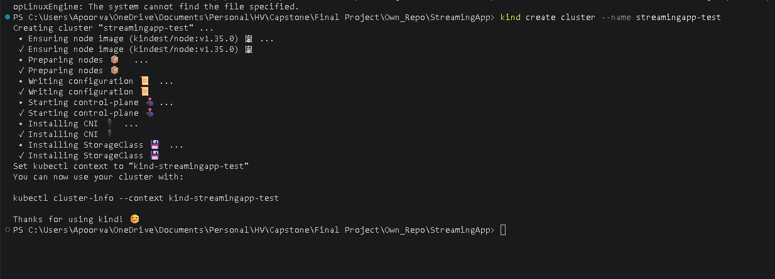
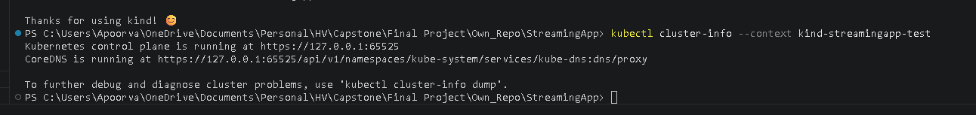
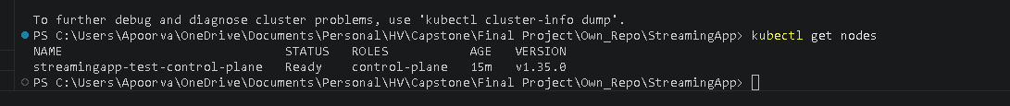
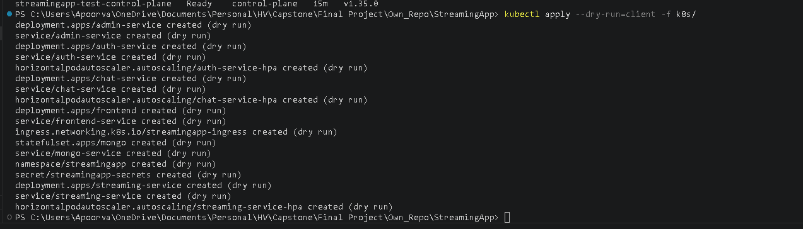
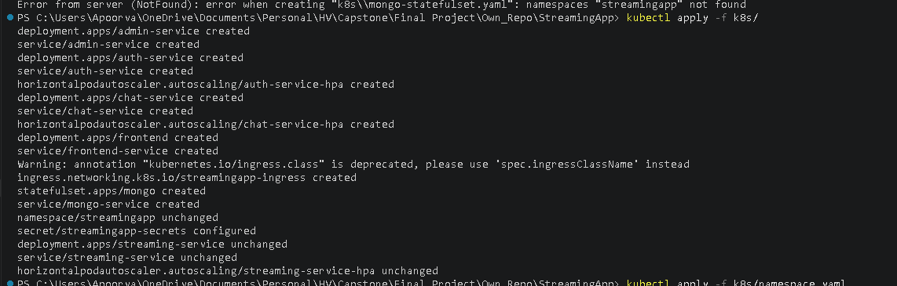

Helm chart — parses, renders, and produces valid Deployments/Services/HPAs
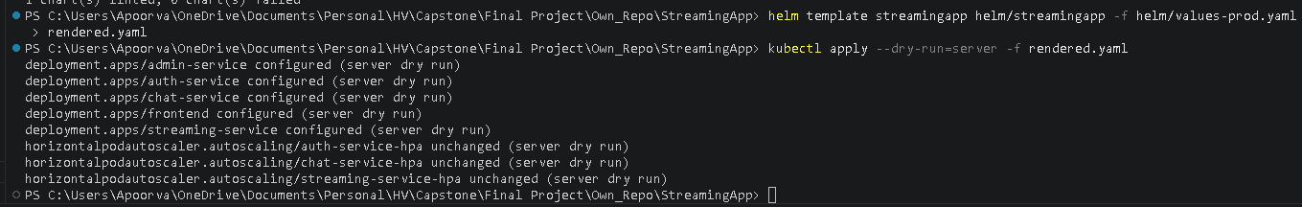
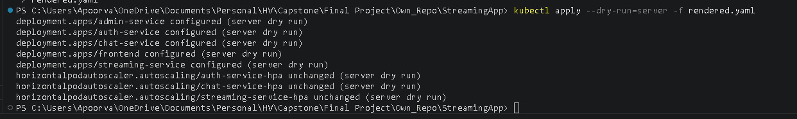
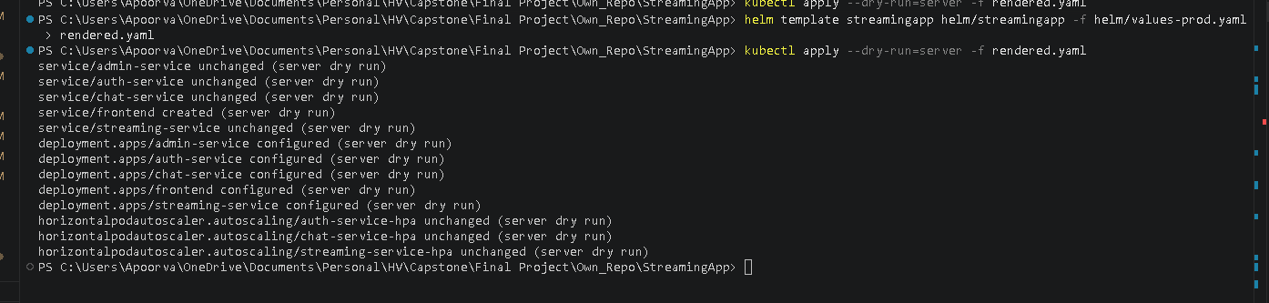

Terraform — VPC, EKS cluster (ACTIVE, v1.33, 2 nodes Ready), ECR, S3, IAM, security groups, Jenkins EC2 all provisioned and verified on real AWS

Terraform init:
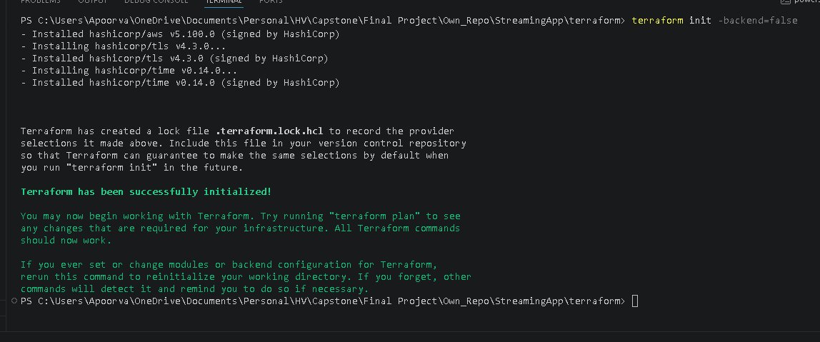

Created IAM user:
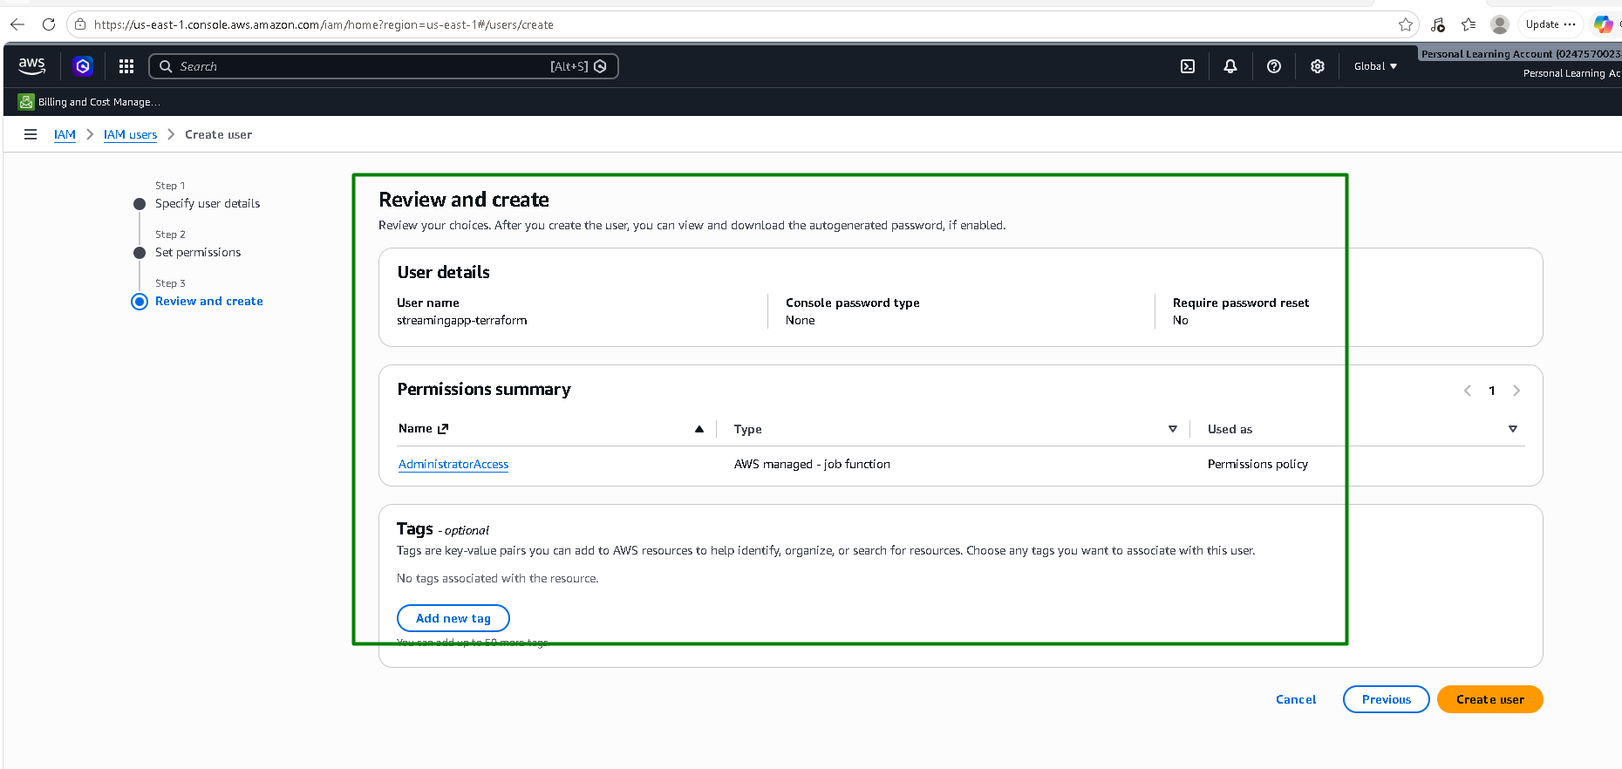

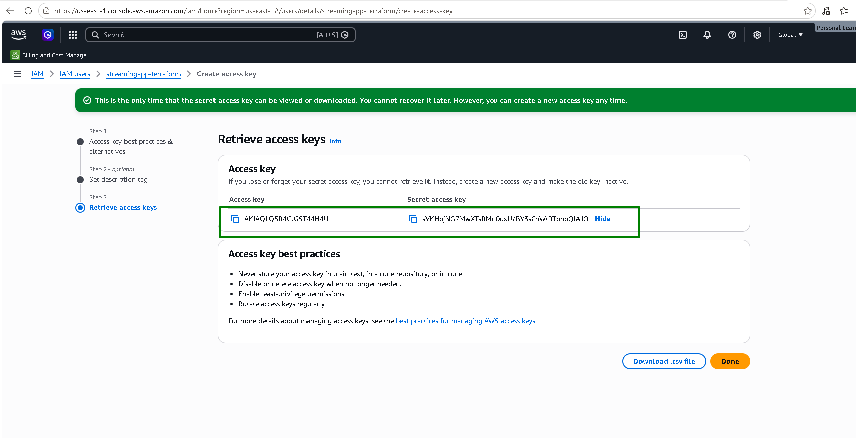

AWS CLI is configured:
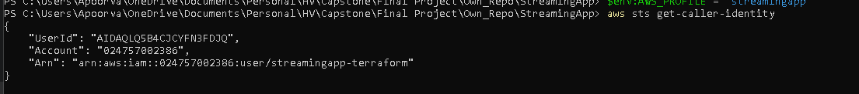

S3 bucket and DynamoDb table is created before applying Terraform scripts for below reasons:
S3 bucket (streamingapp-tfstate) — this is where Terraform stores its state file: a JSON record of every resource it manages and their current attributes, used to compute diffs on every plan/apply. Our terraform/main.tf backend block tells Terraform "store state remotely in this bucket" instead of a local terraform.tfstate file. But Terraform's S3 backend doesn't create its own storage — the bucket has to already exist before terraform init can point at it. If Terraform tried to create that bucket as part of the same run whose state it's supposed to be tracking in that bucket, we'd have a chicken-and-egg problem: it can't write its own state to a bucket while also treating that bucket's creation as something tracked in the state being written. So, the bucket has to be bootstrapped separately, outside the main config.
DynamoDB table (streamingapp-tflock) — this exists purely for state locking. Before any command that would modify state (apply, sometimes plan), Terraform writes a lock record into this table. If a lock is already present (say, from another terraform apply still running, or one you forgot you left mid-flight), the new command refuses to proceed instead of racing against it. Without this, two concurrent applies could corrupt the state file — e.g., both reading the same "current state," both computing different changes, and both writing back, with the second write silently clobbering the first's changes.

Create S3 bucket:

Create dynamodb table:
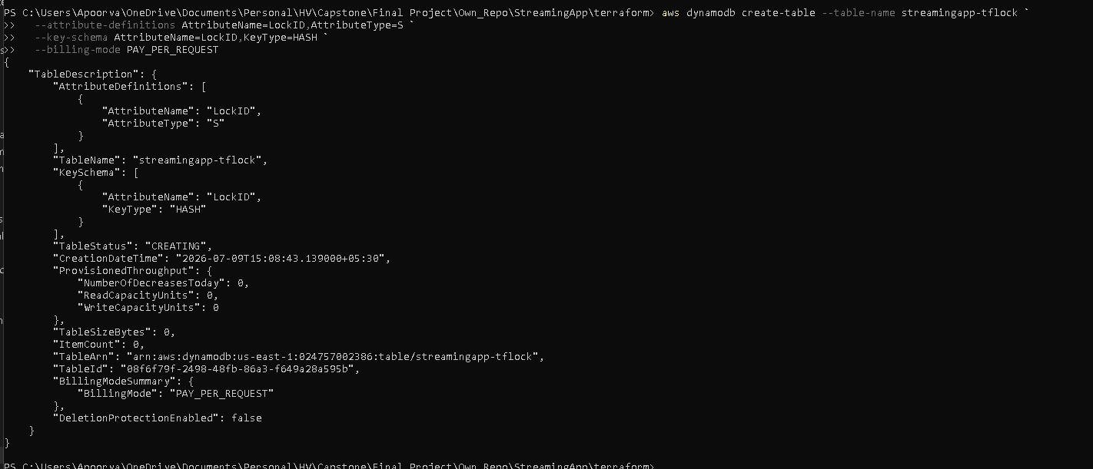

Run Terraform init again:
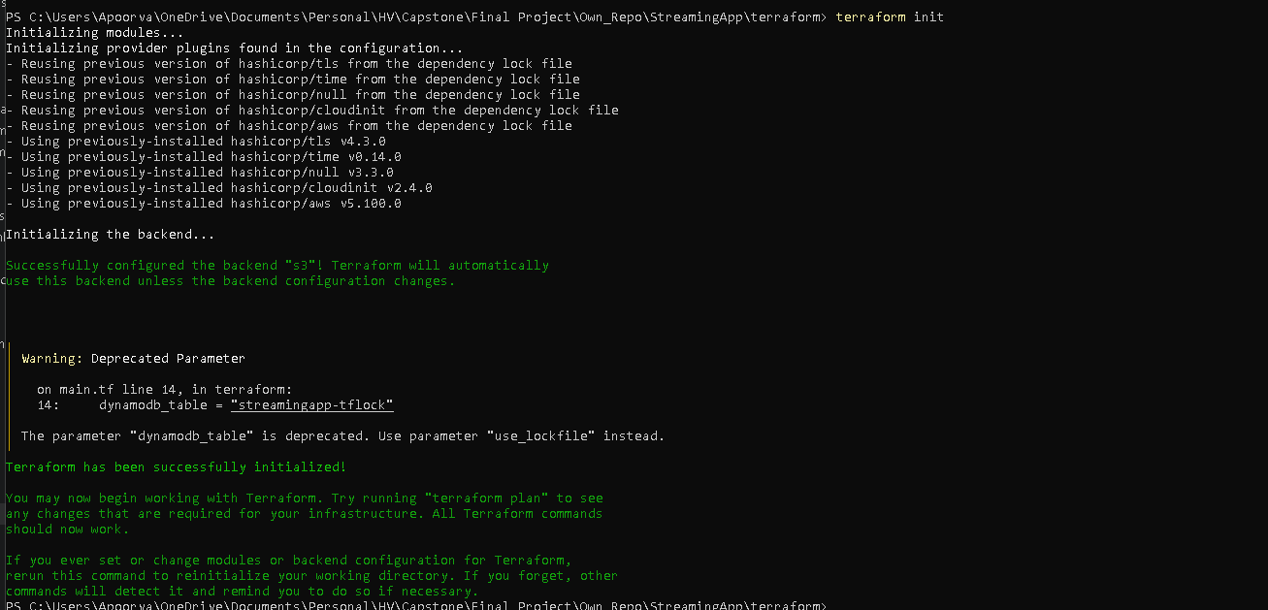

Terraform plan:
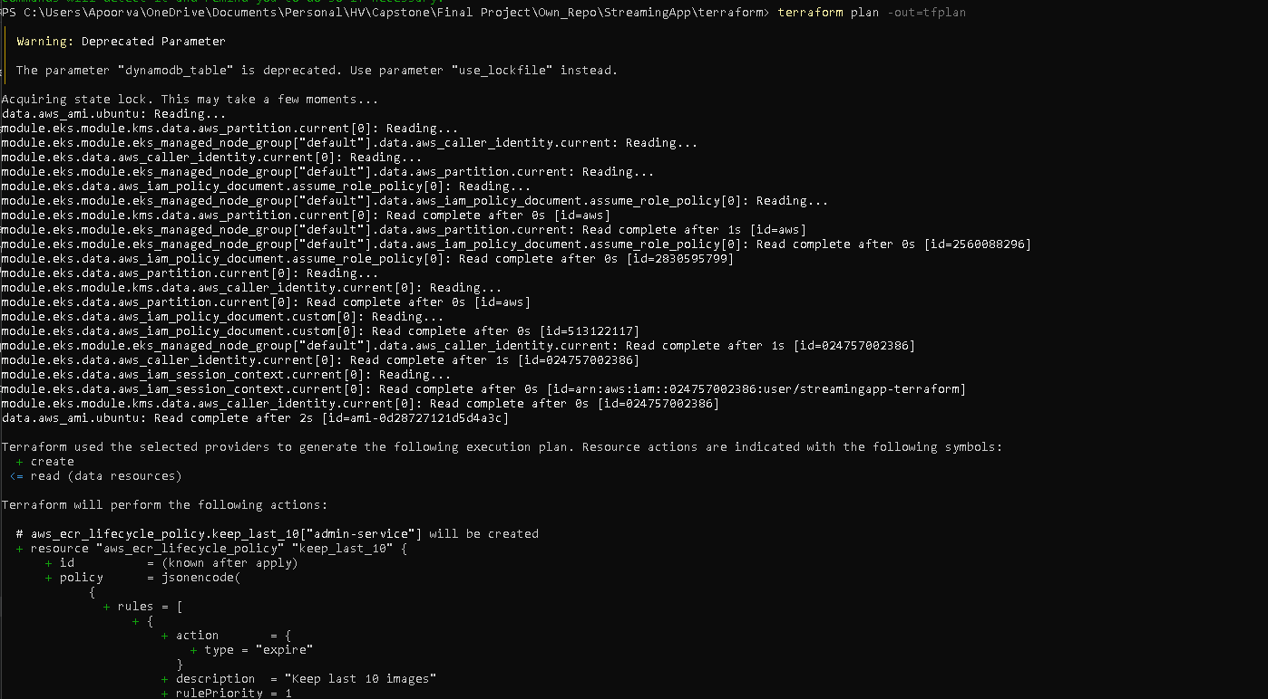
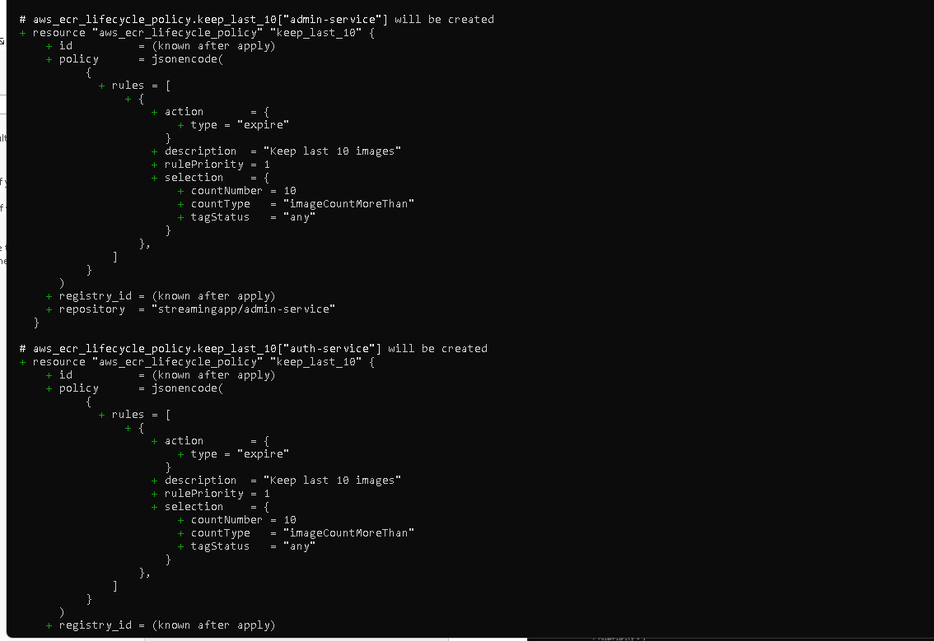
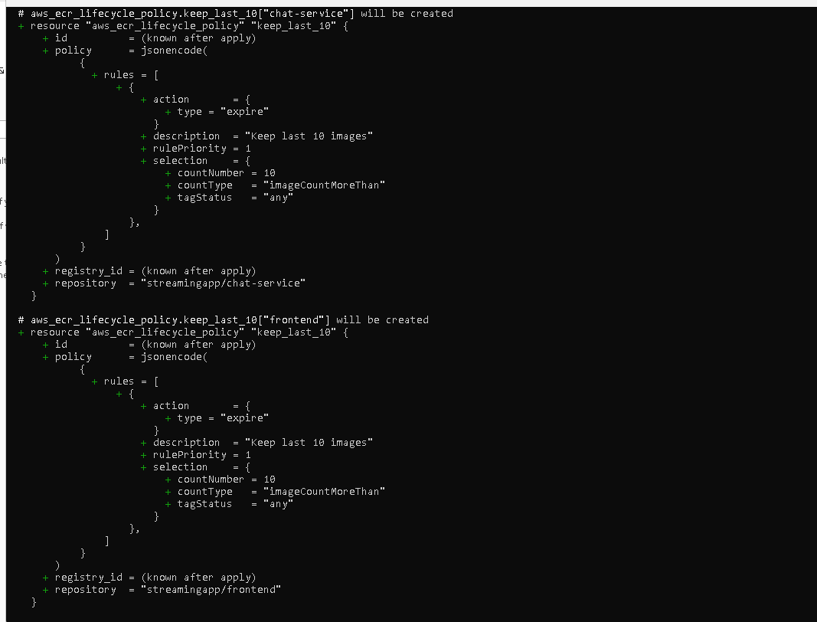
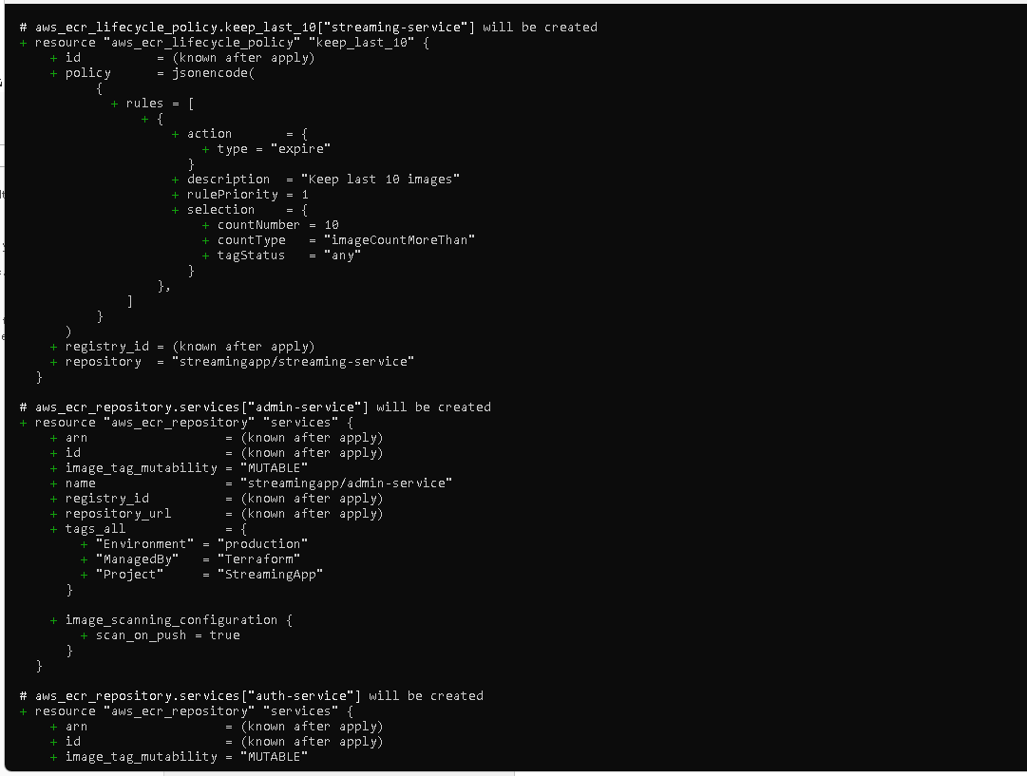
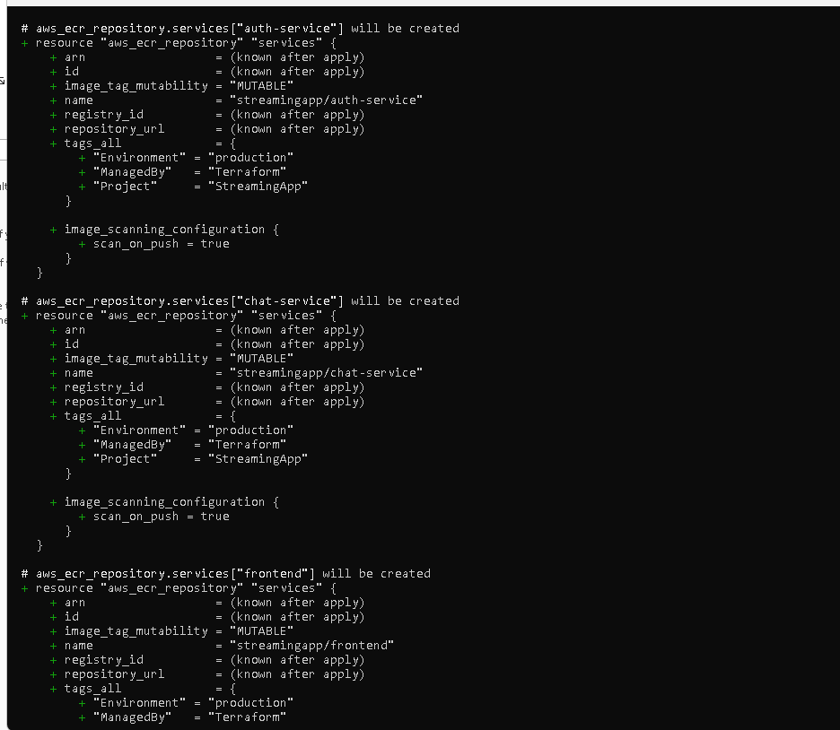
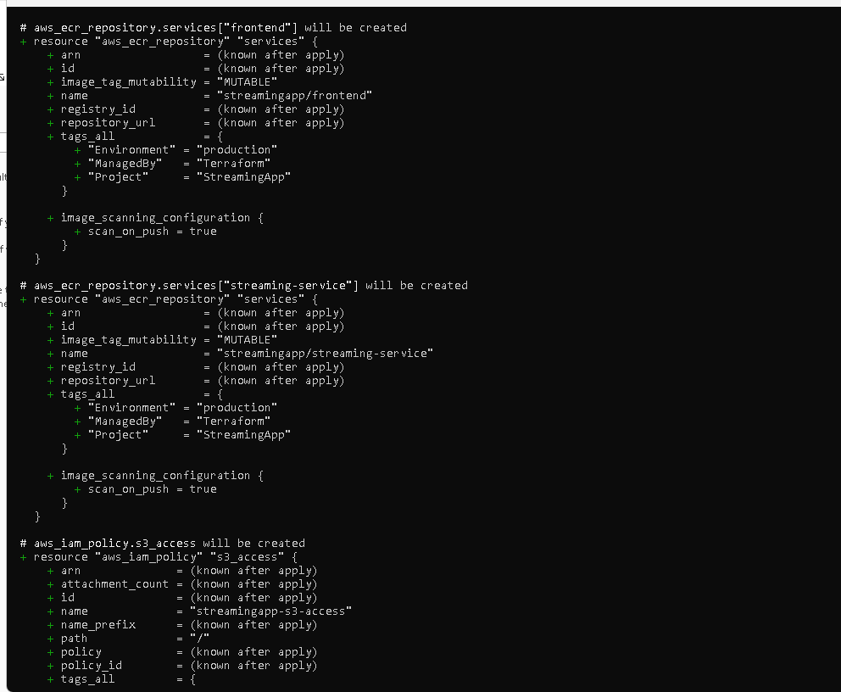
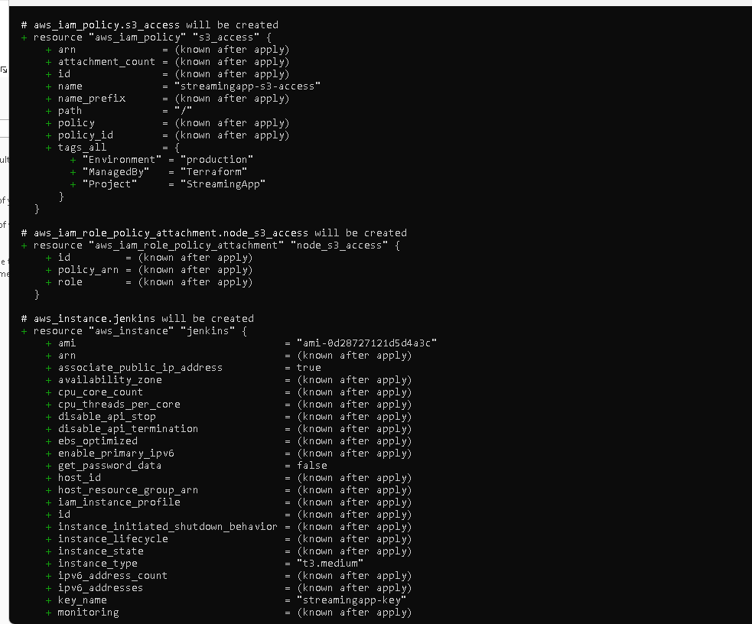
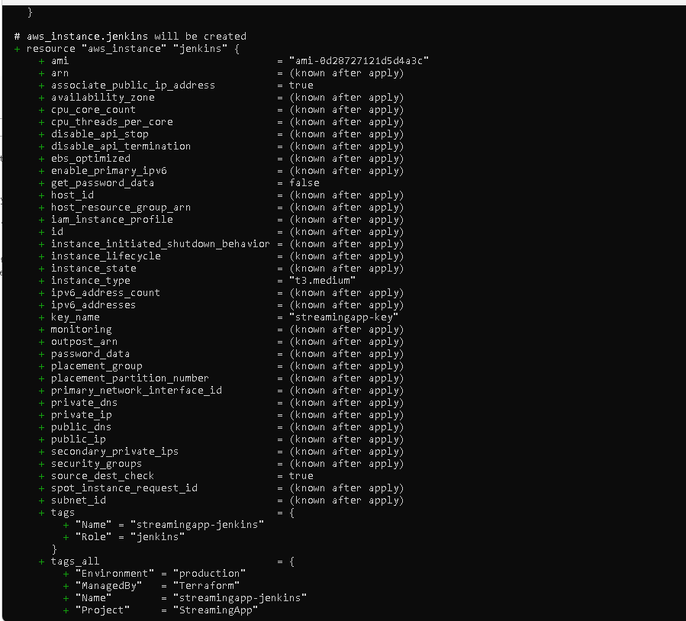
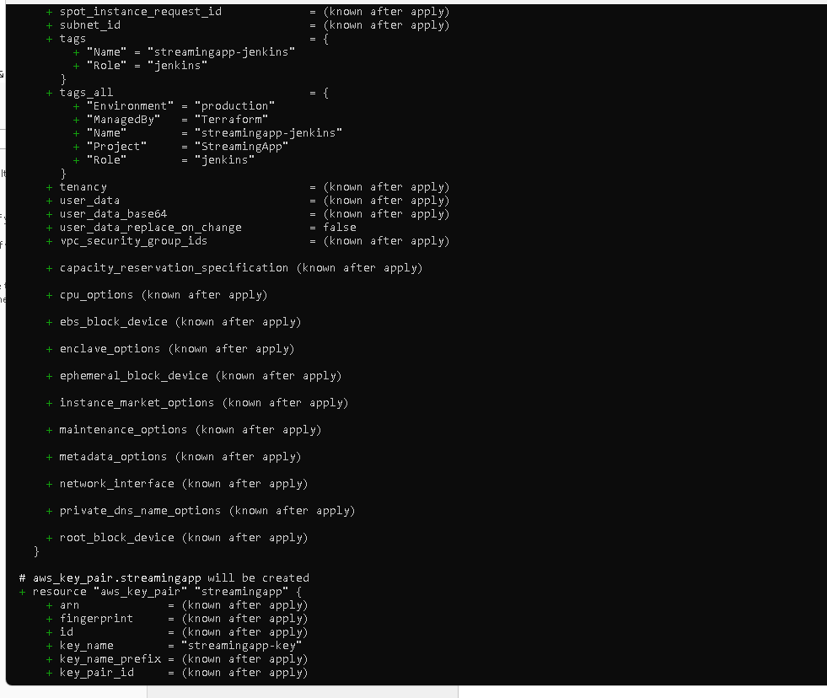
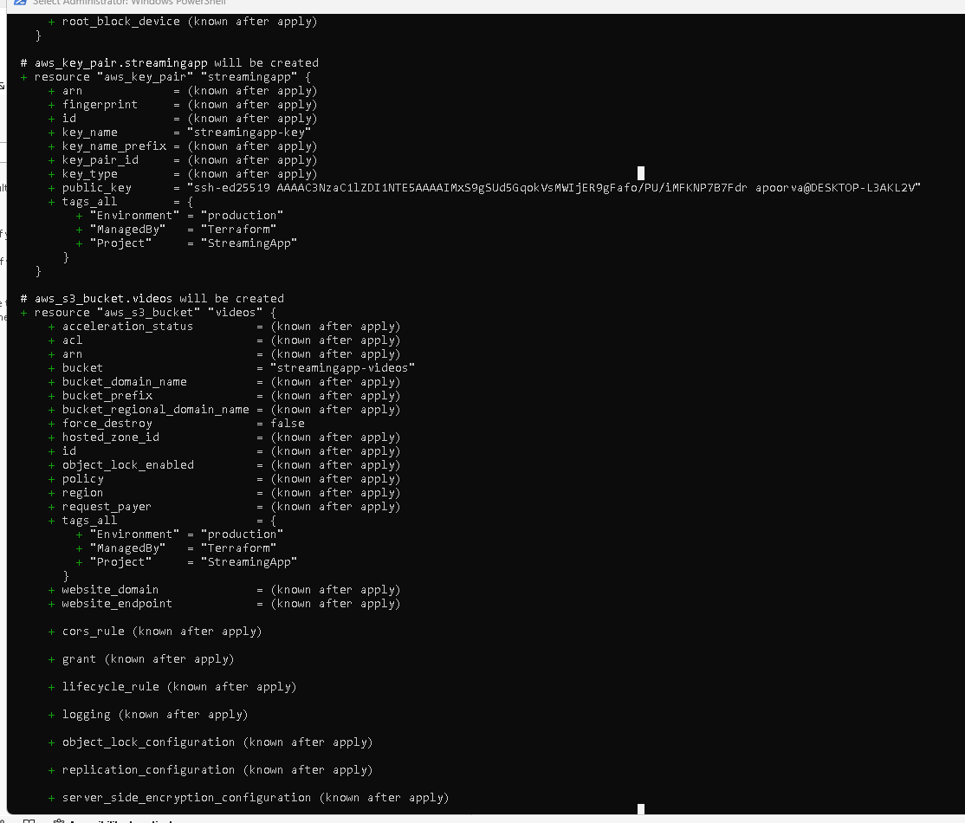
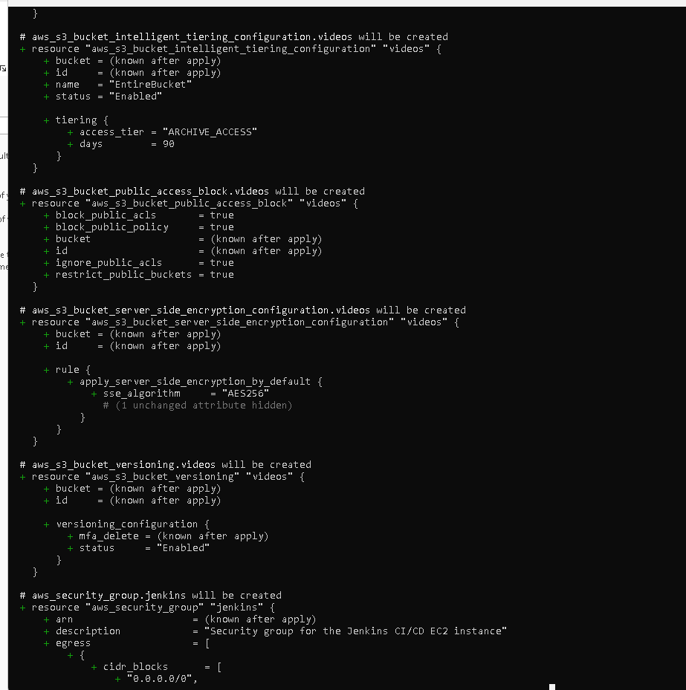
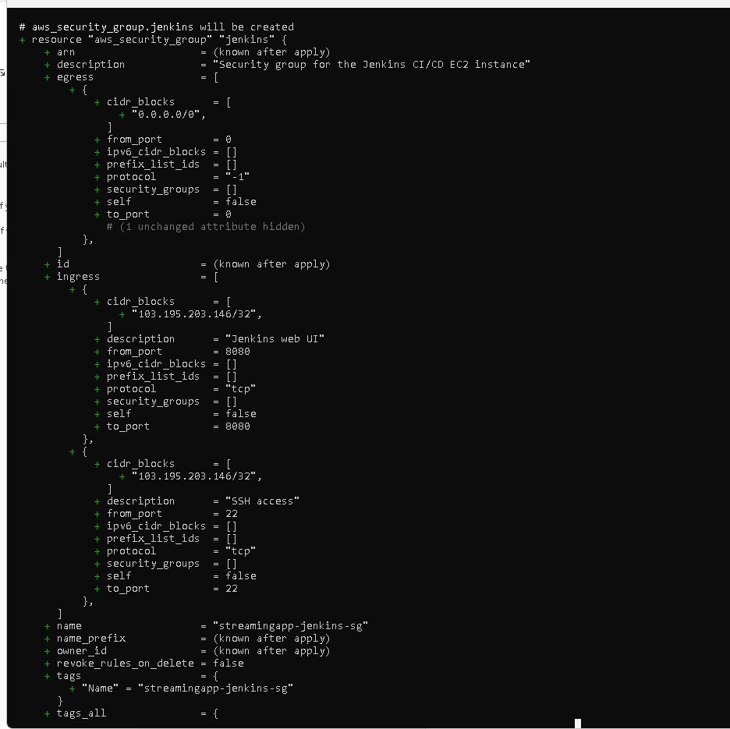
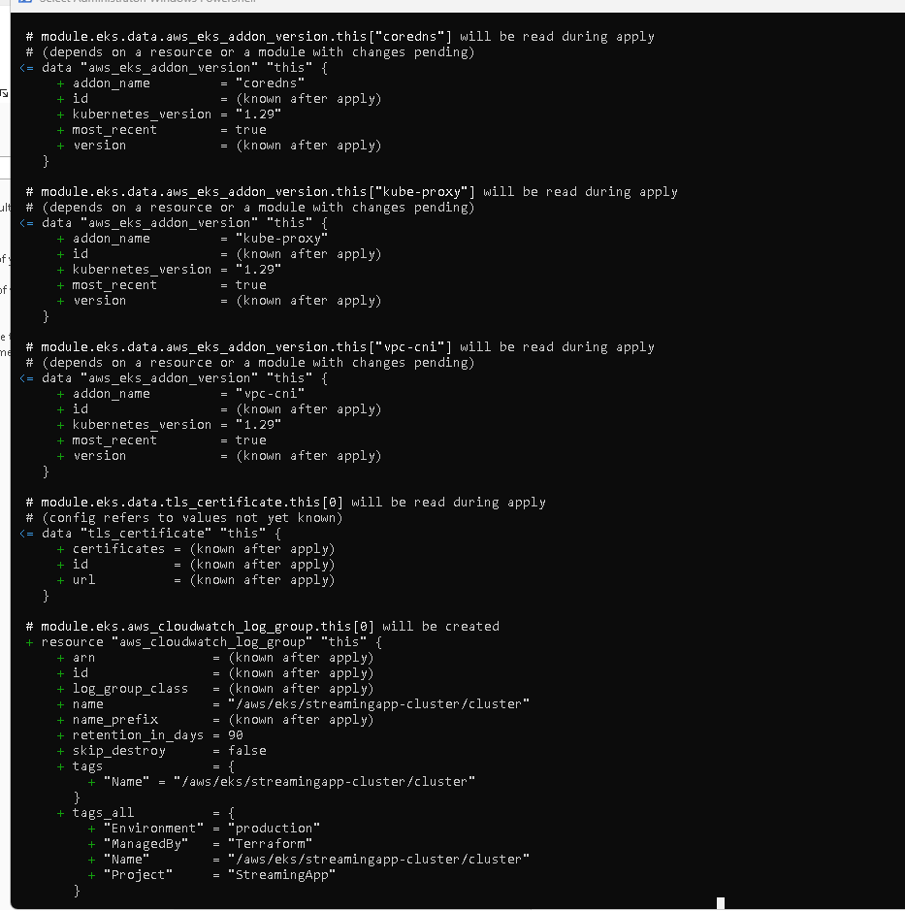
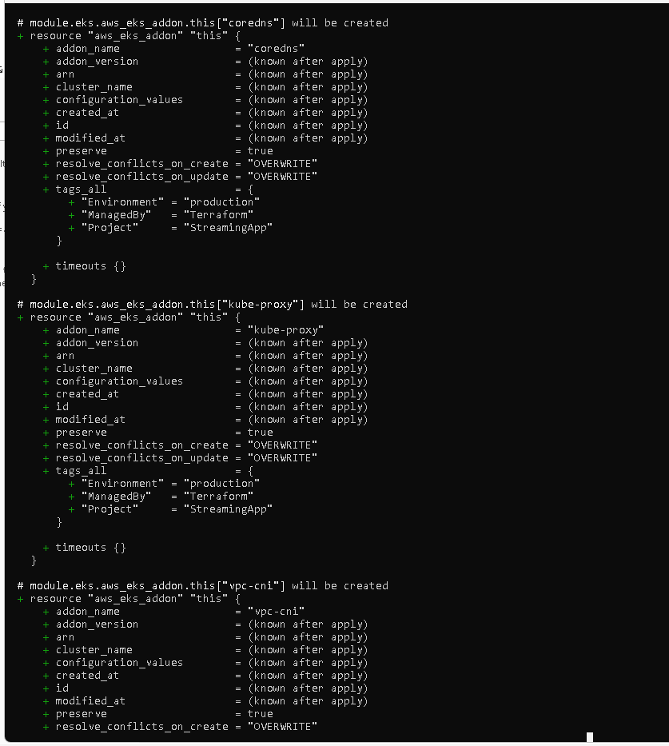
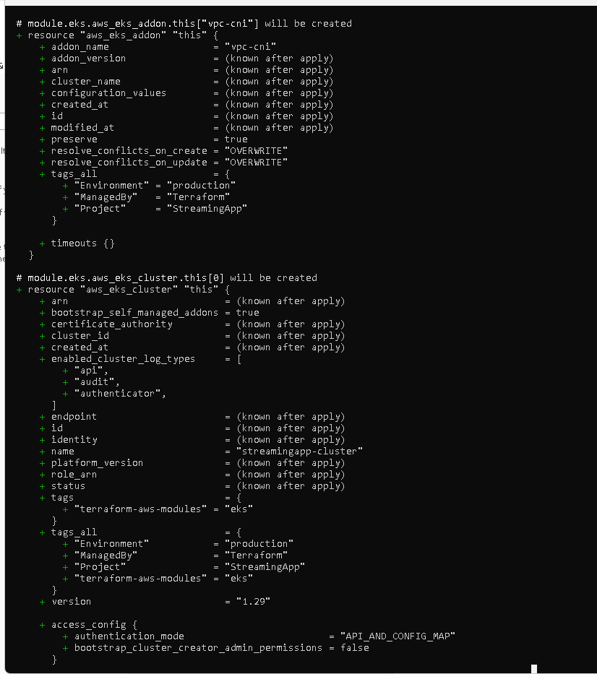
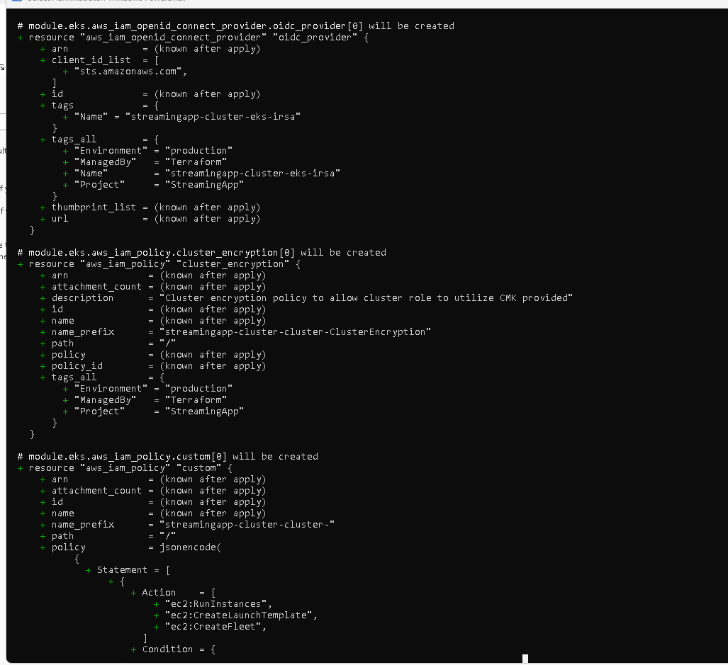
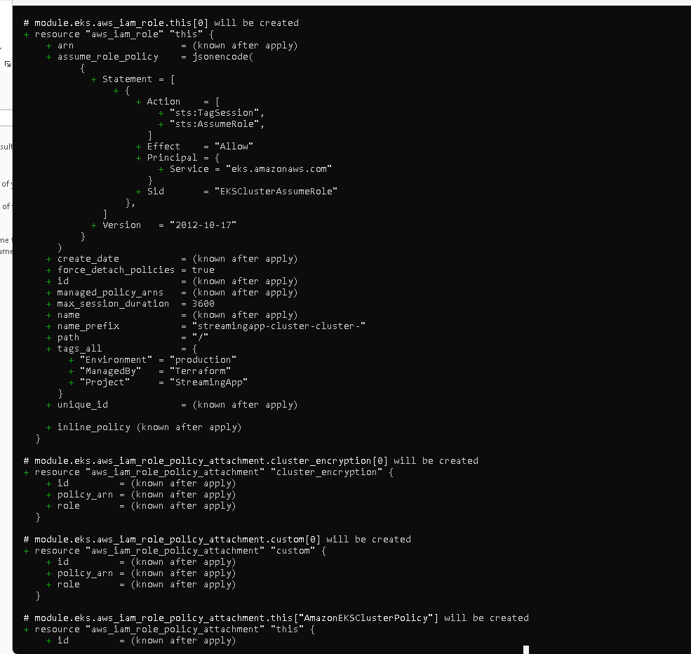
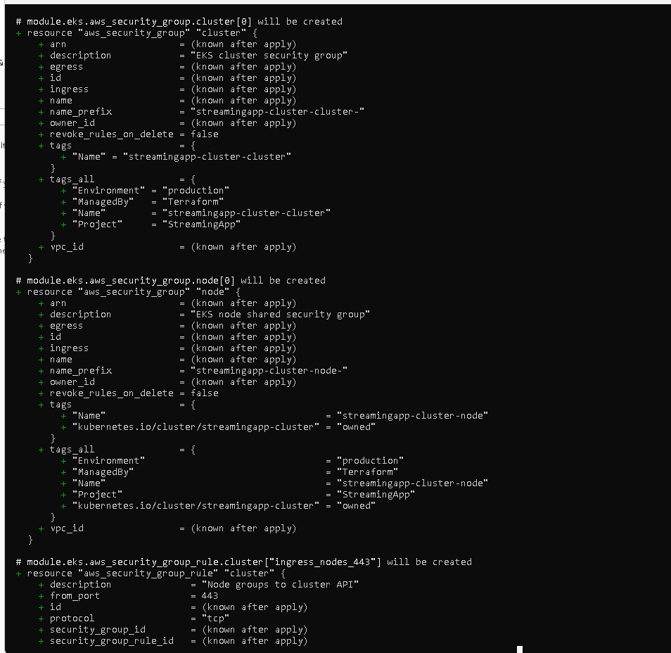
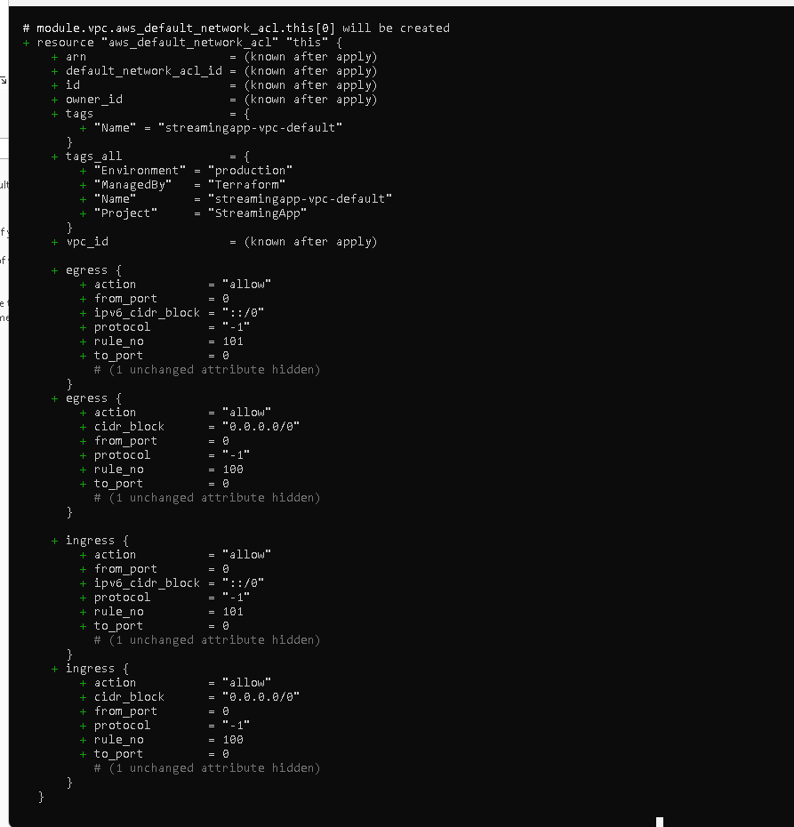
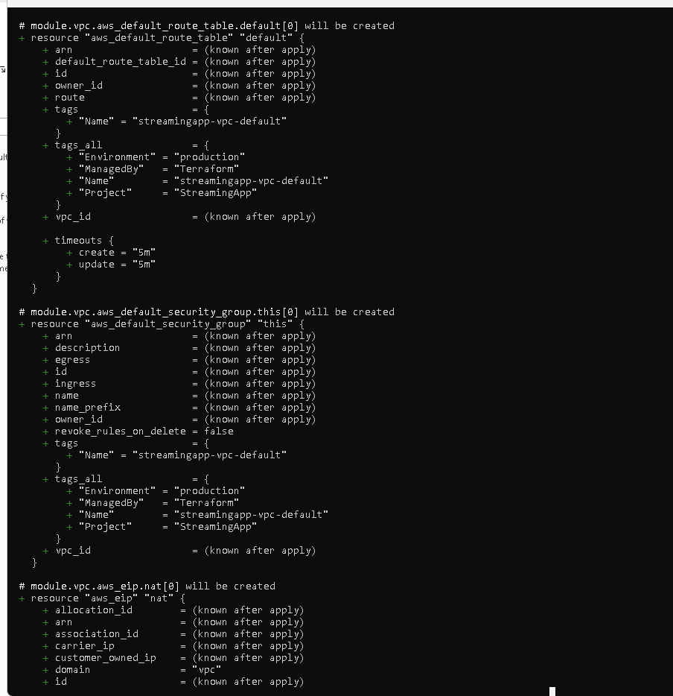
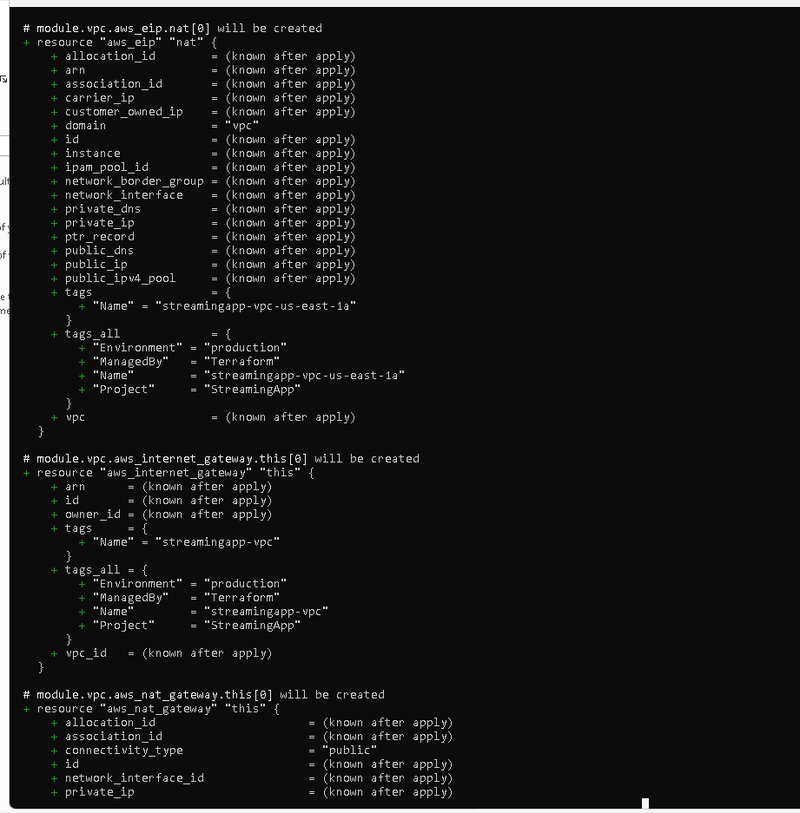
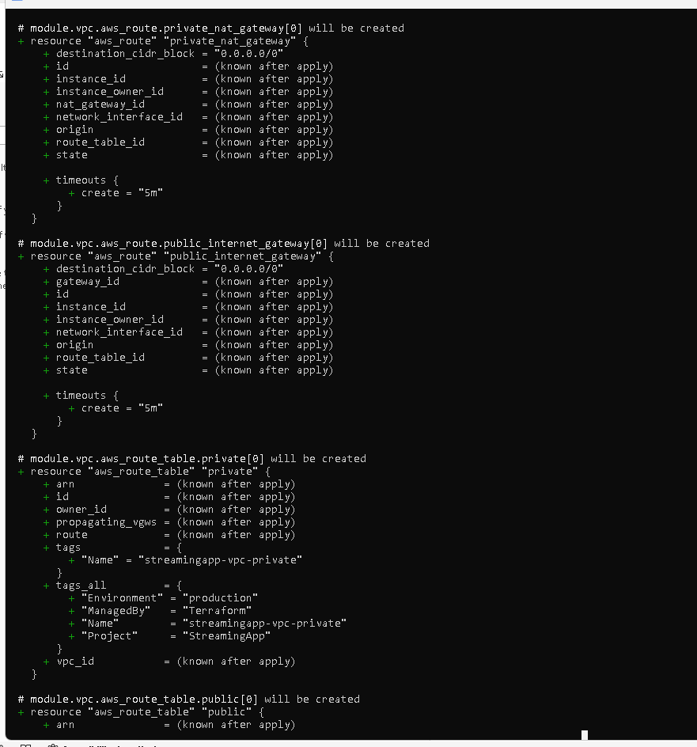
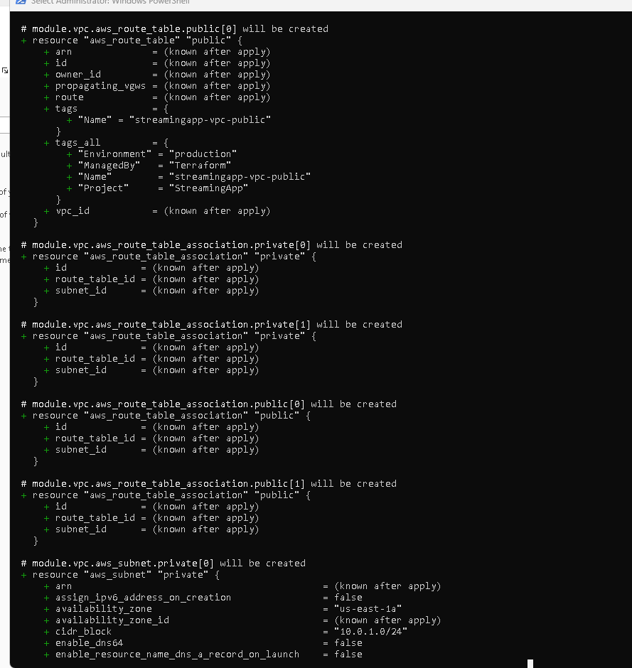
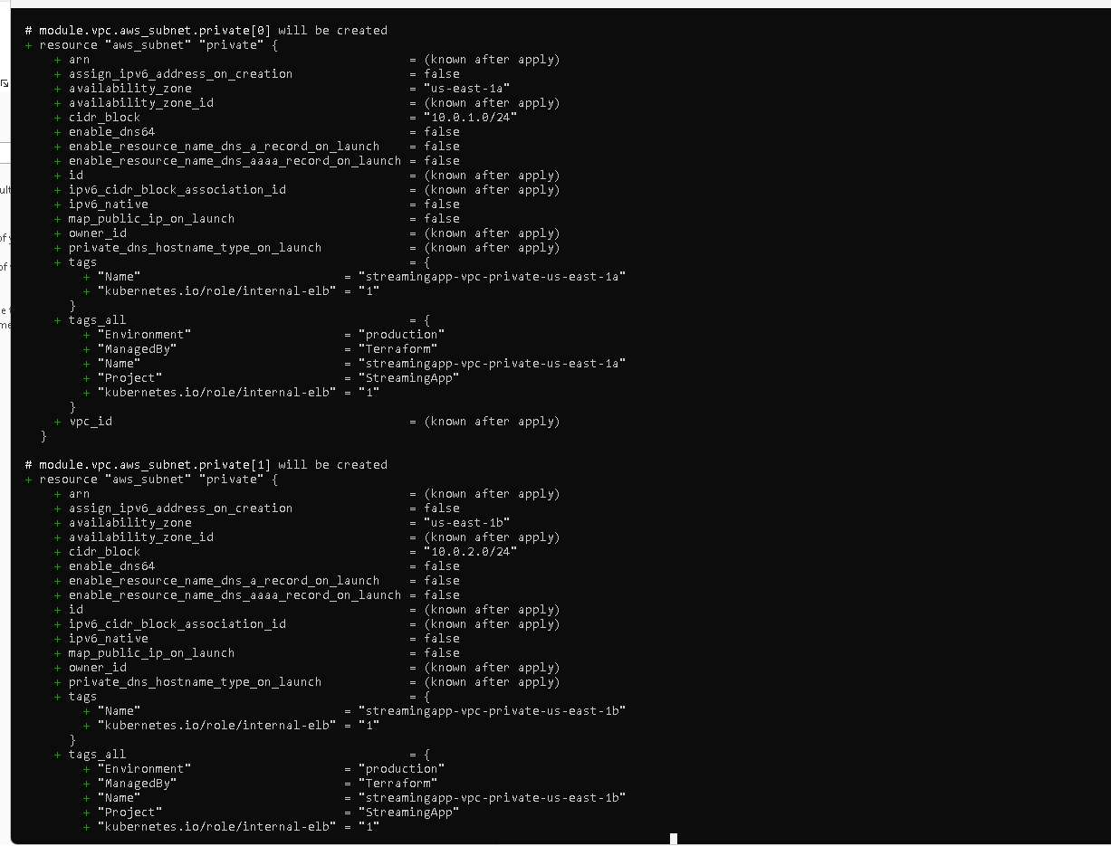
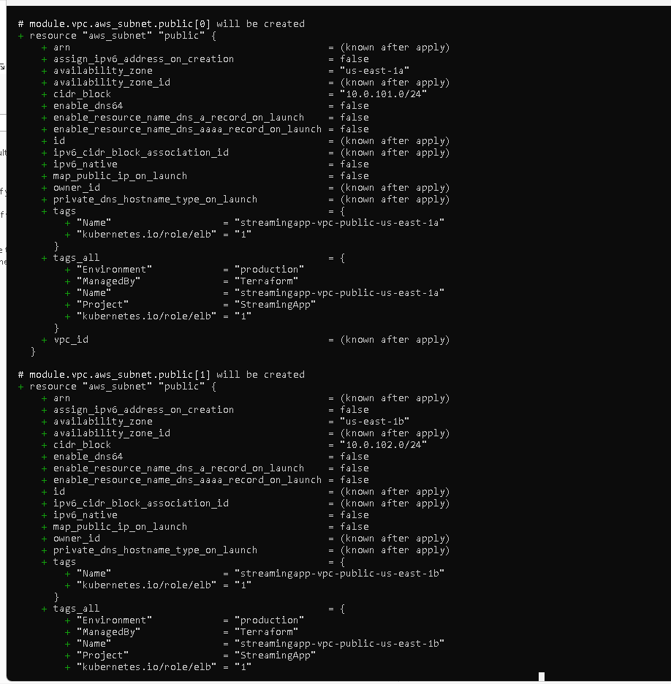
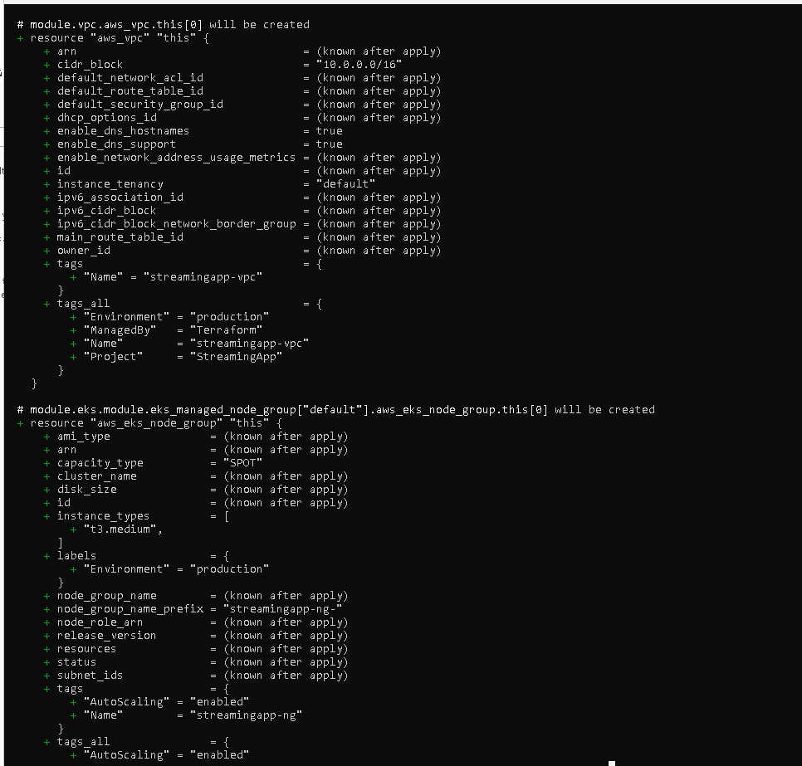
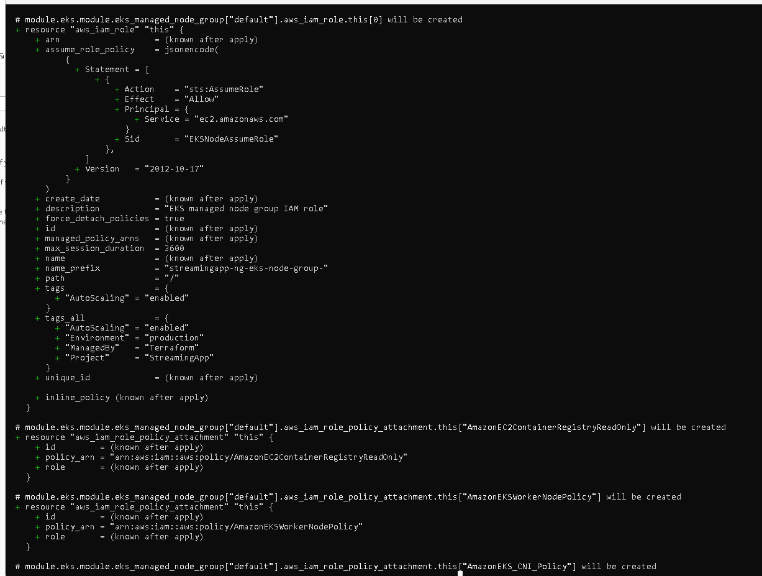
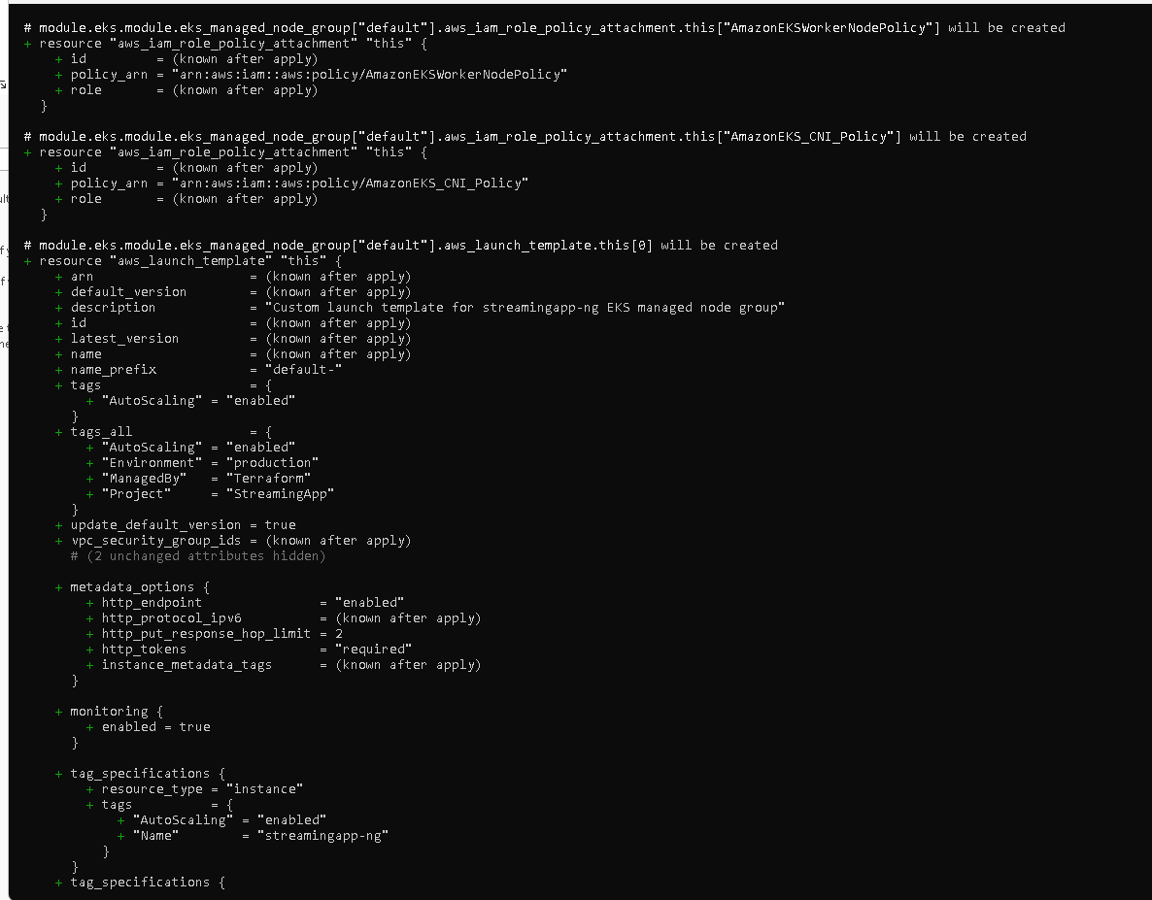
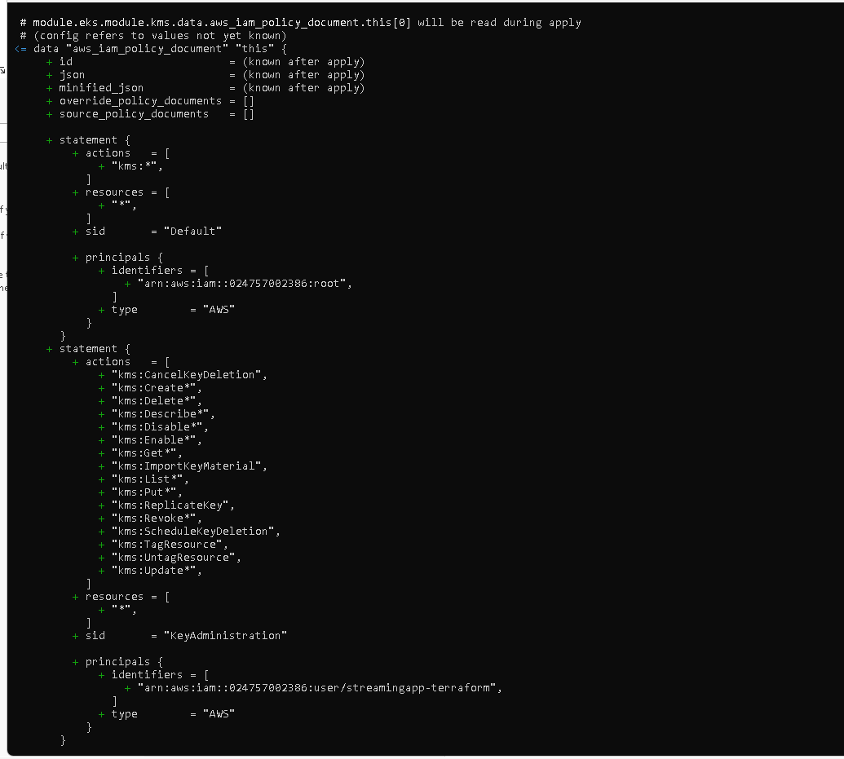
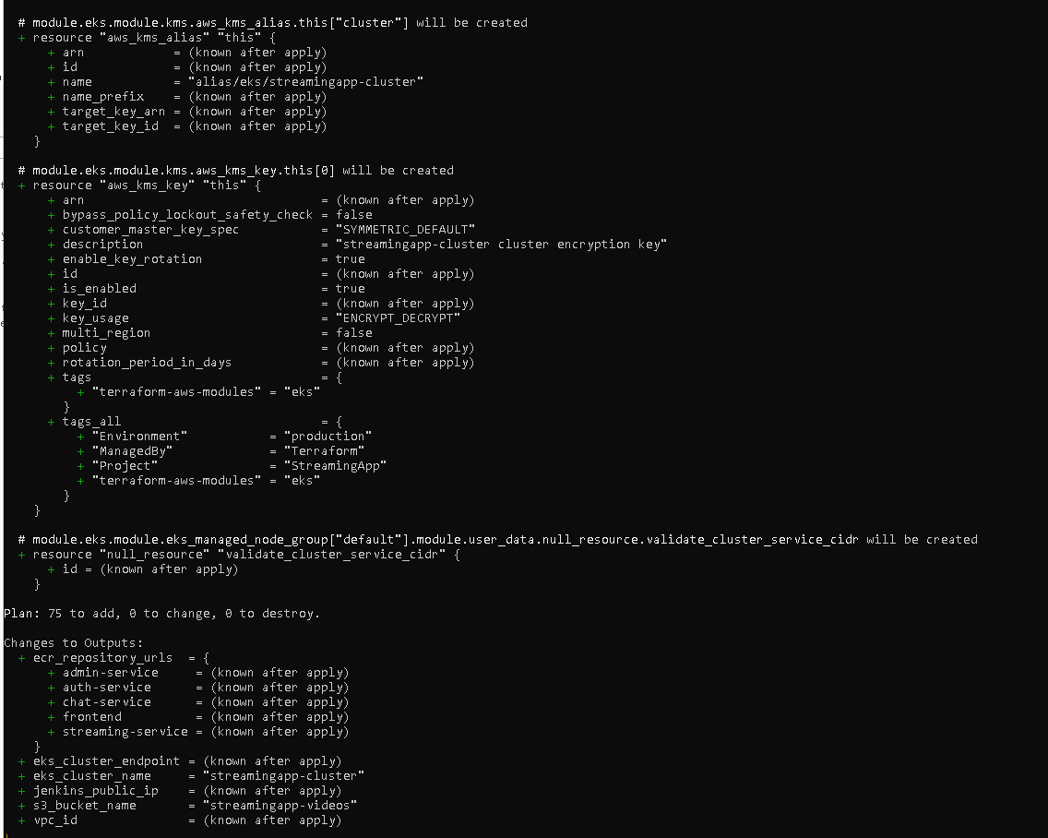
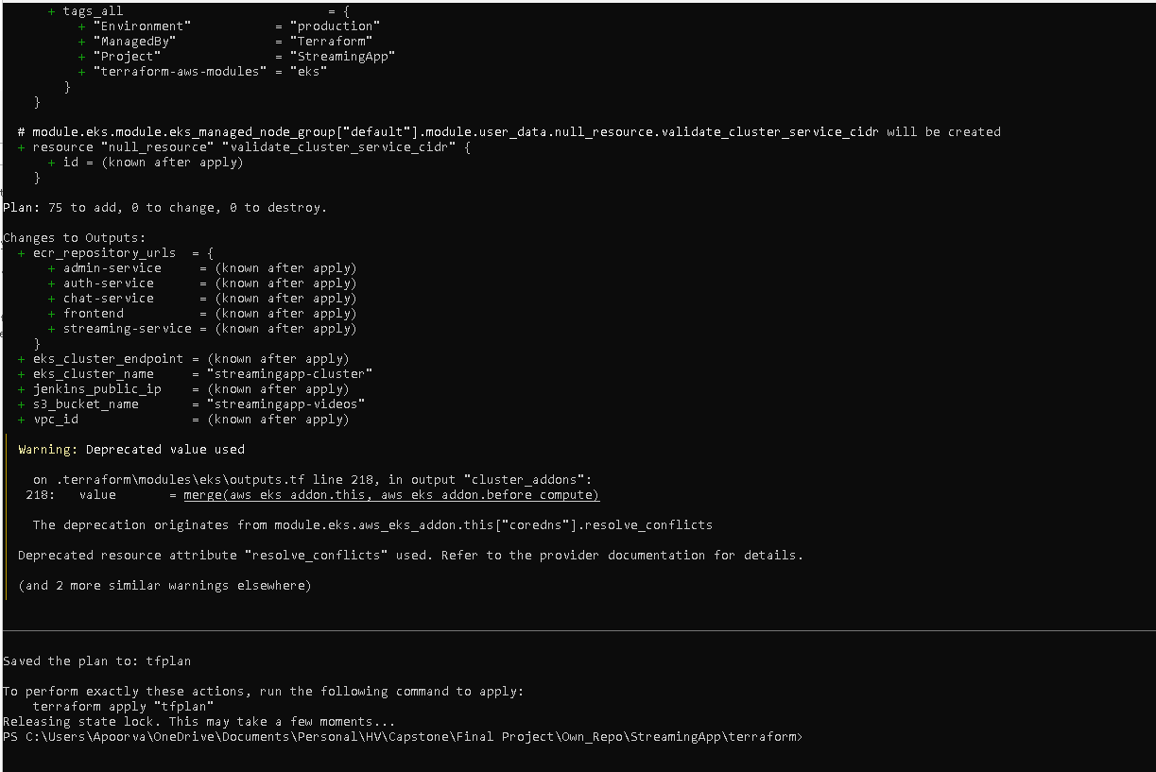
Terraform apply:
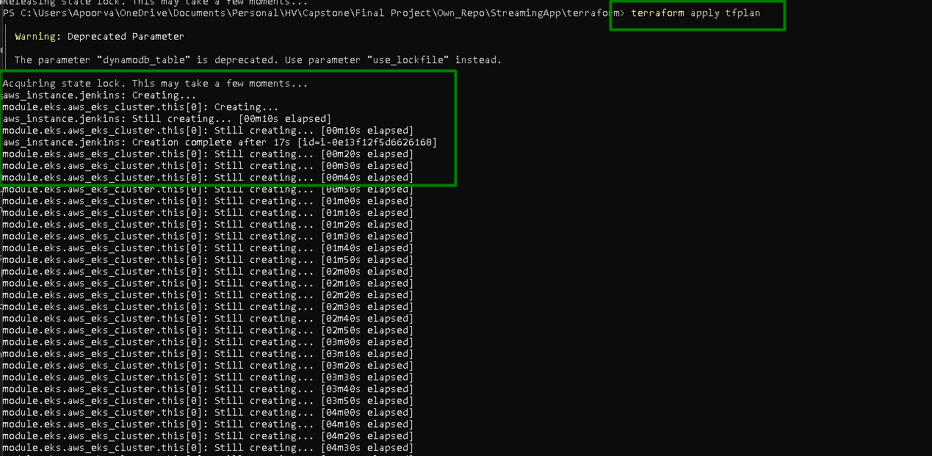
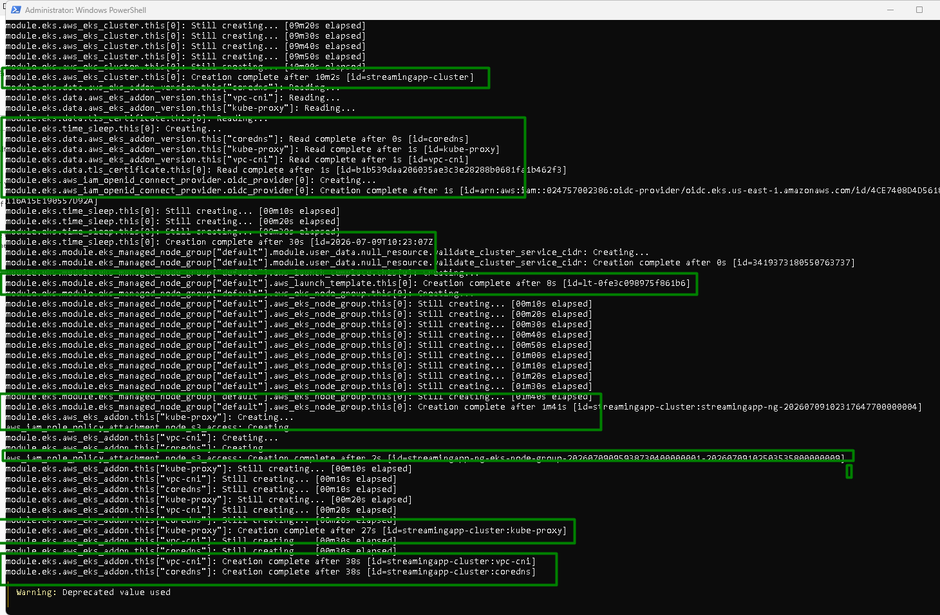
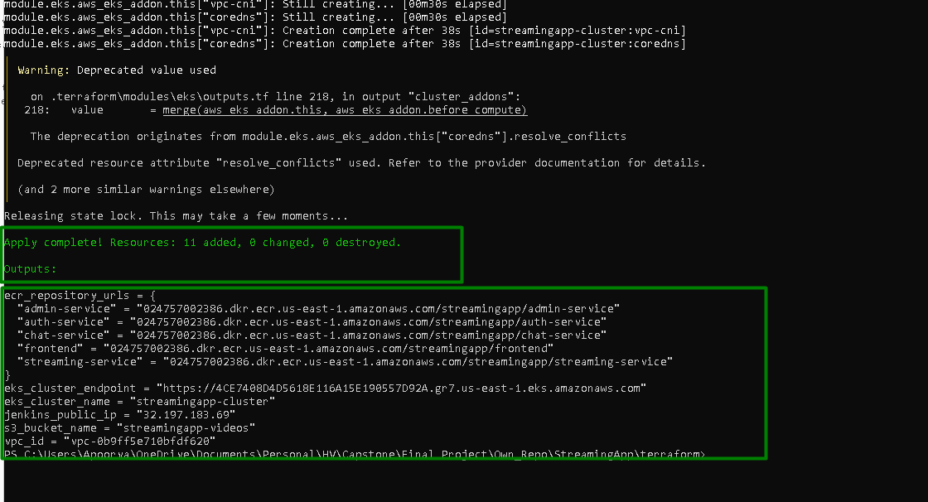

Confirm Jenkins EC2 is reachable:
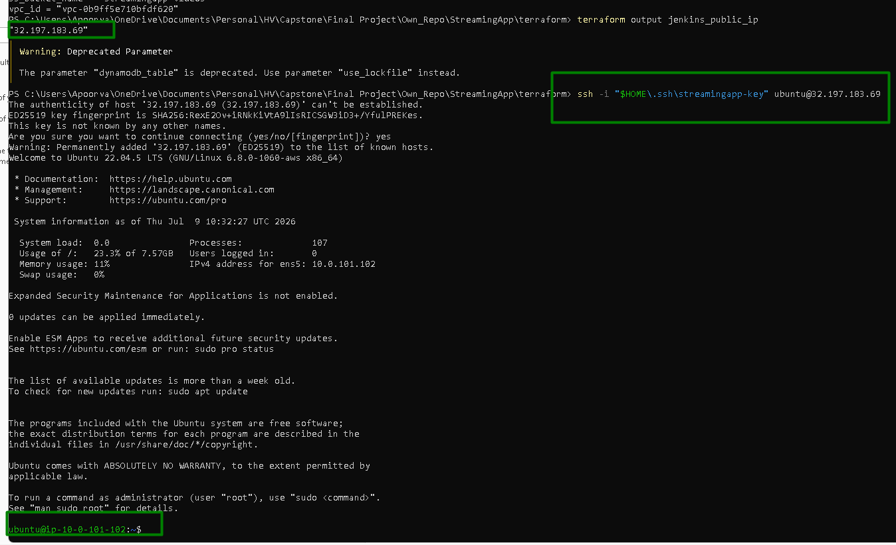

All the resources are created on AWS:

VPC is created
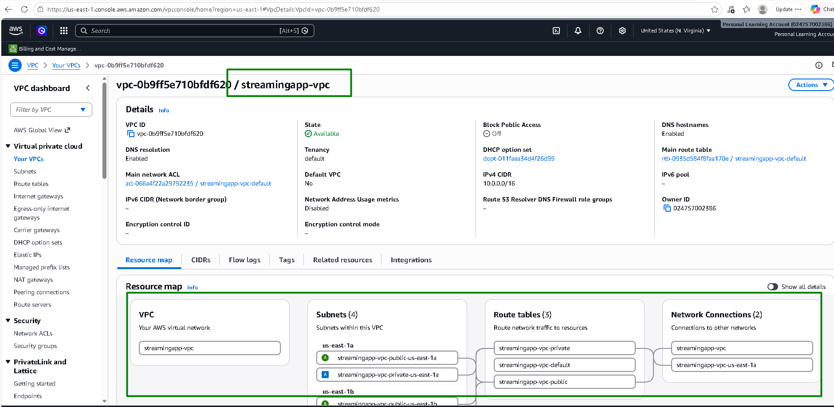
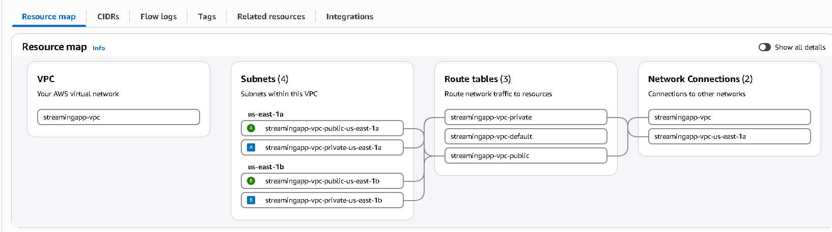
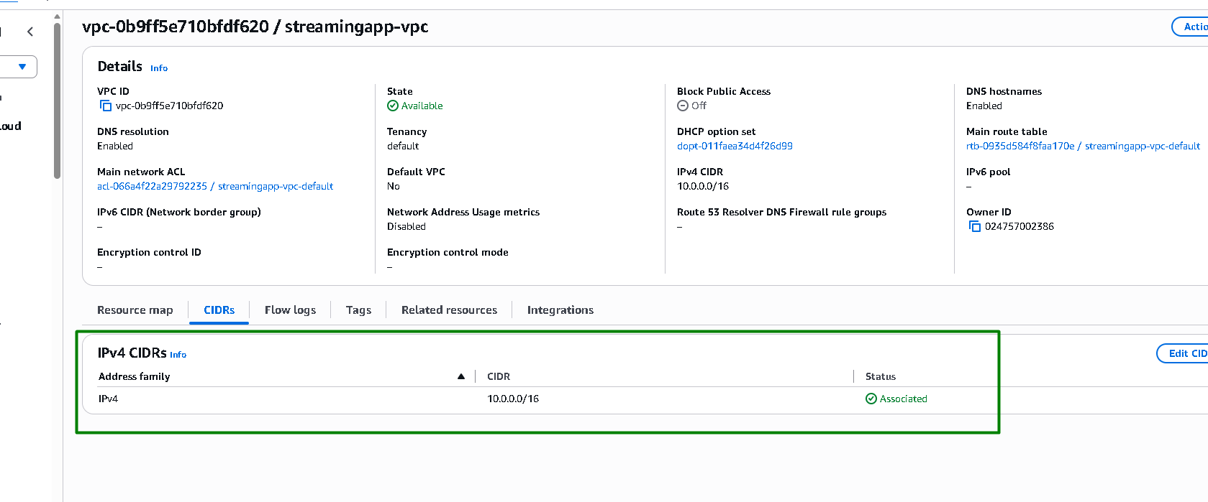

2 public and 2 private subnets are created:
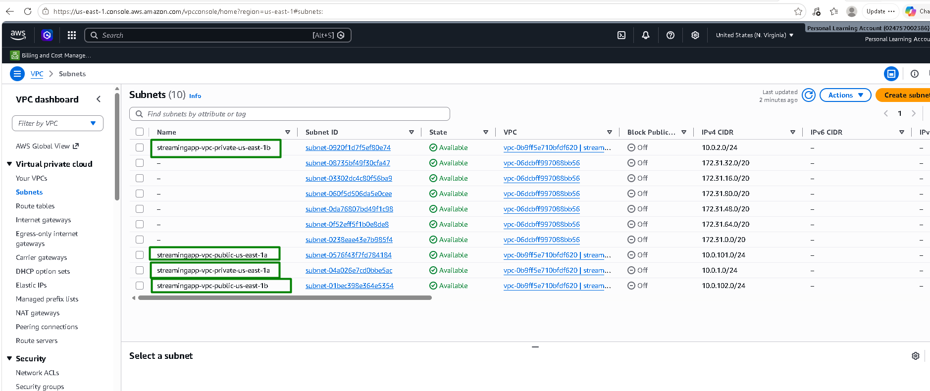

1 NAT Gateway:
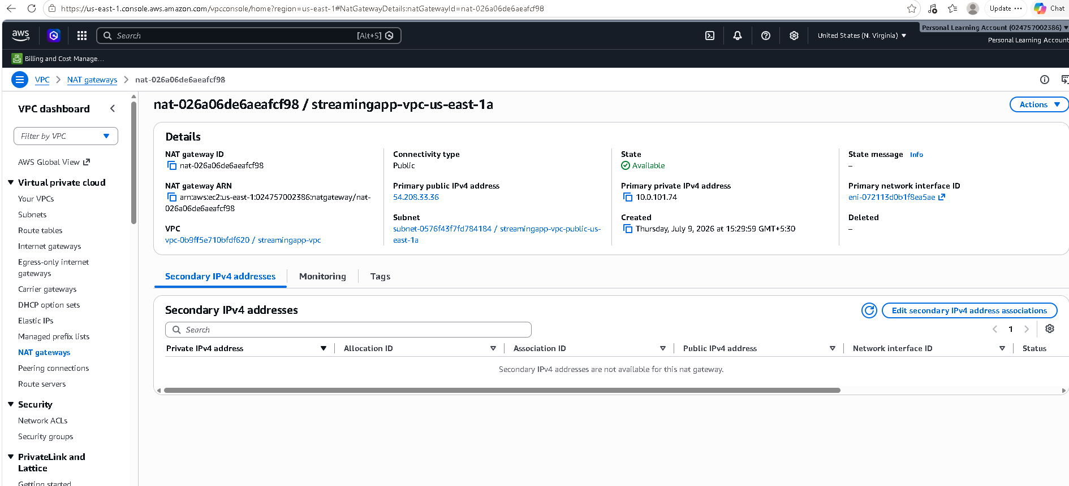

1 Internet Gateway:
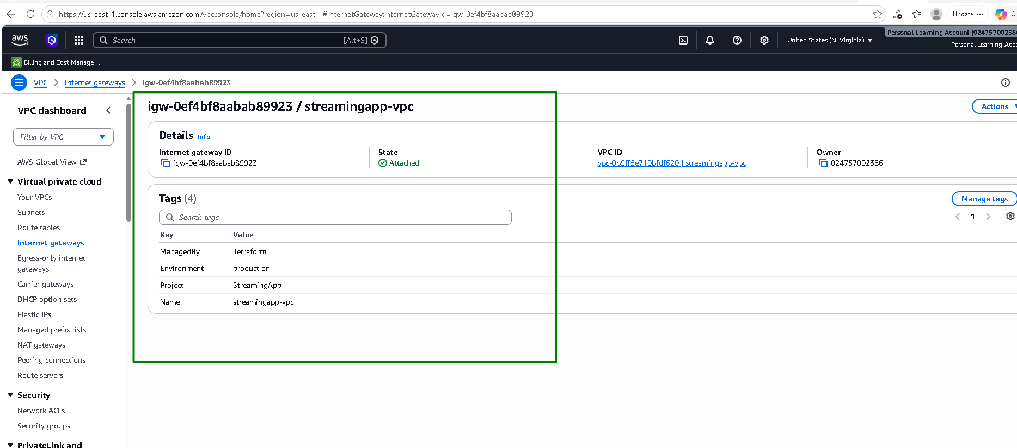

A public RT routing:
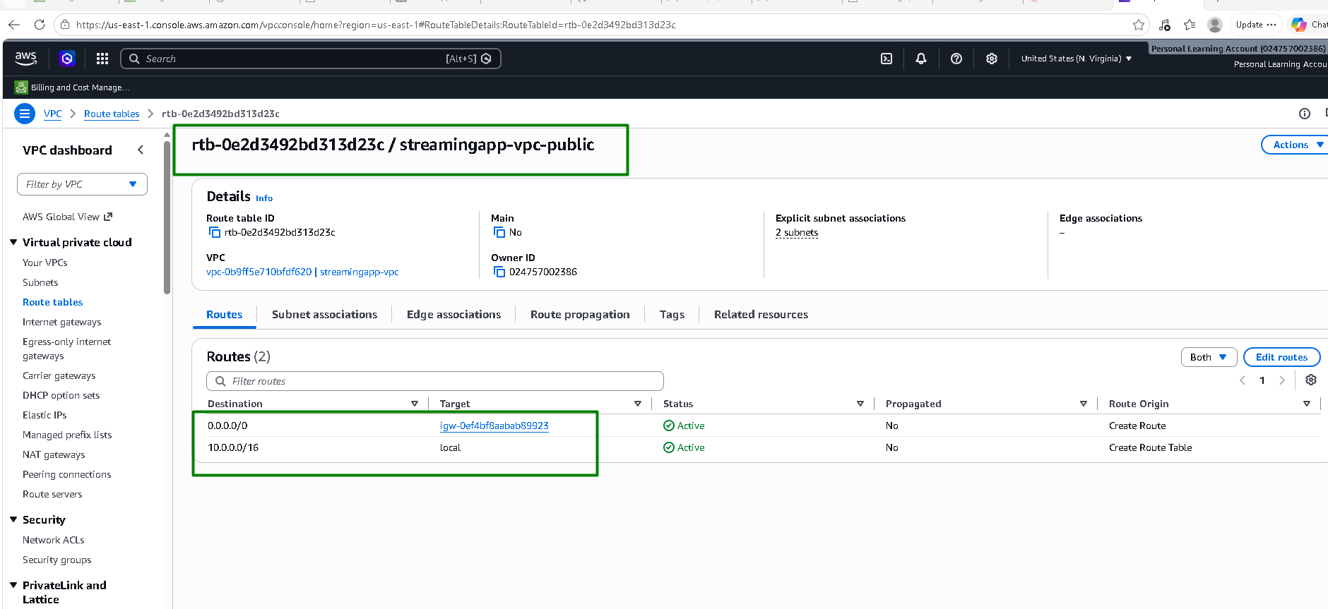

A private RT routing:
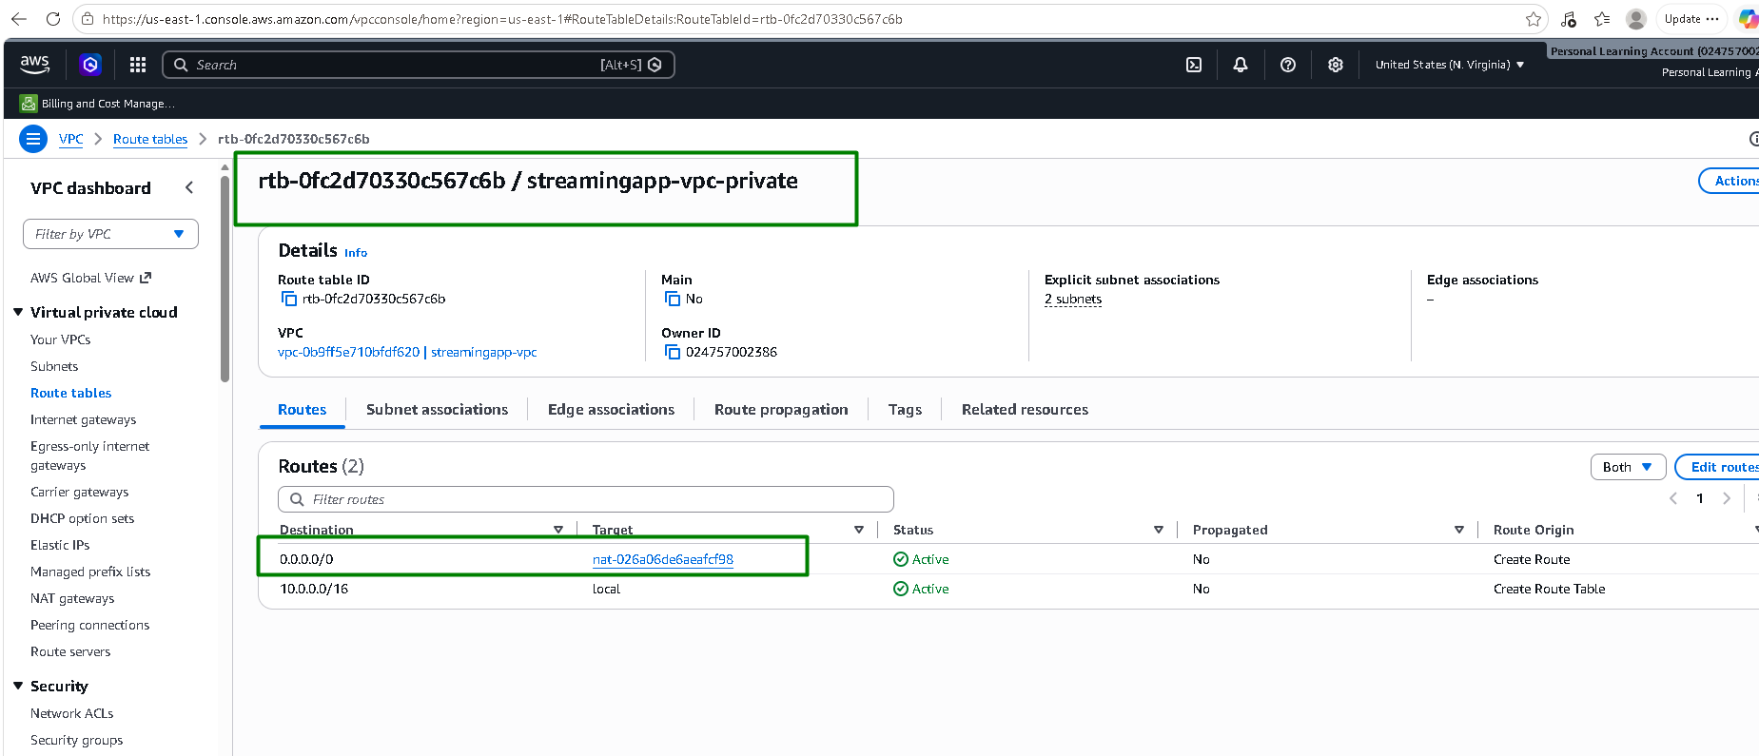

Streamingapp Cluster is created with node group and nodes:
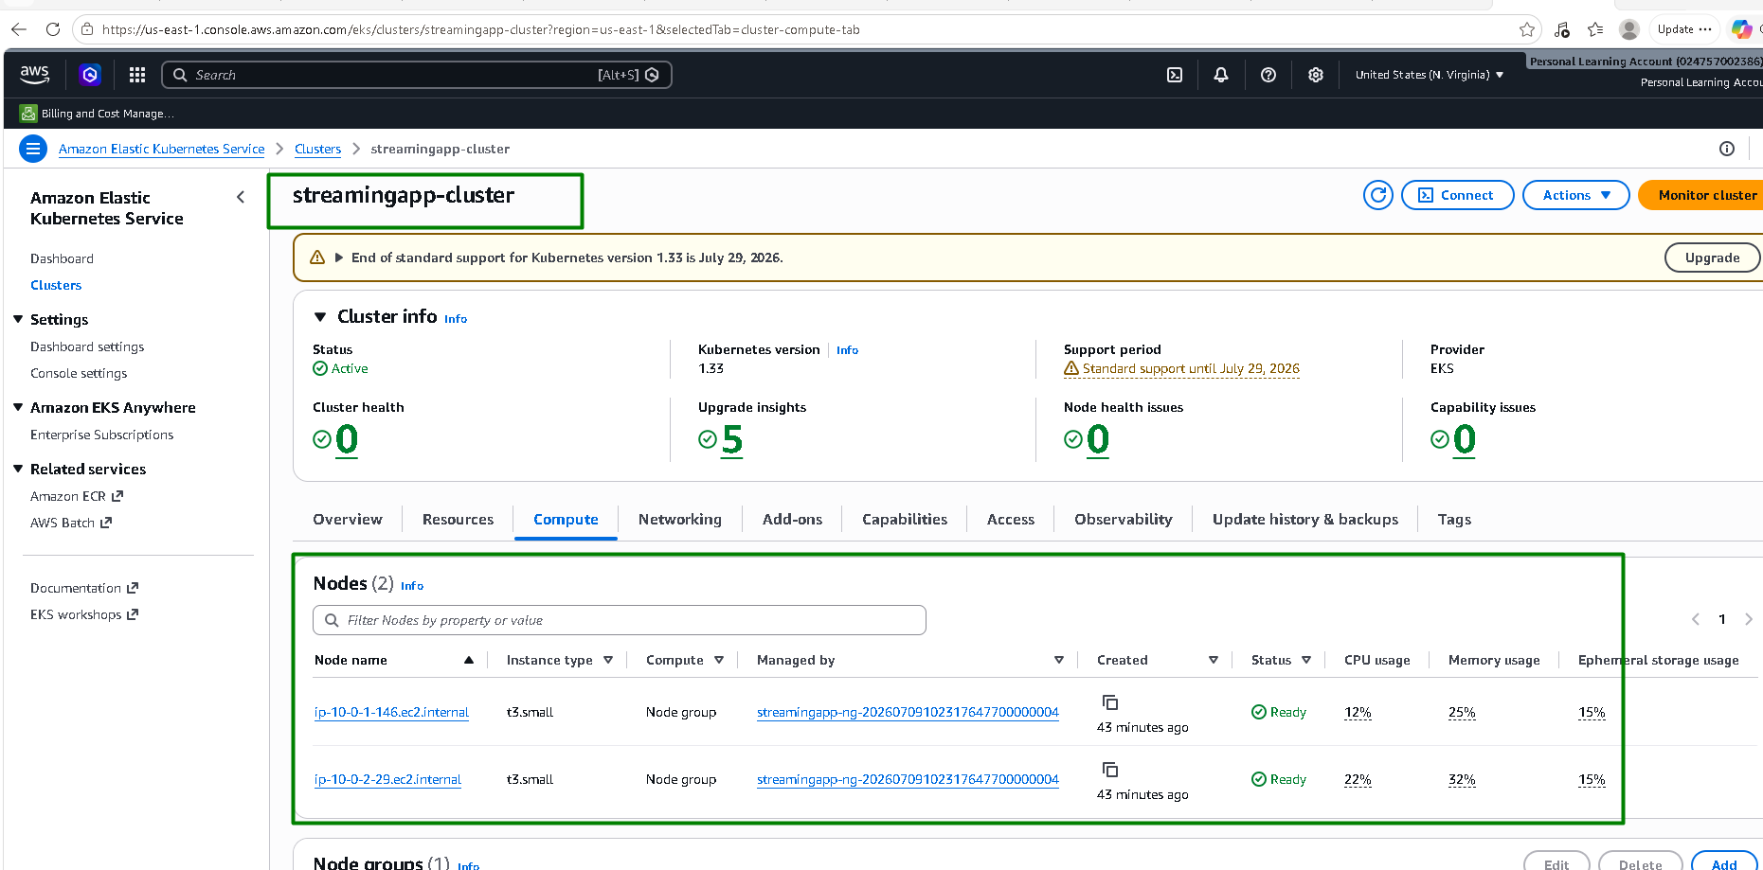
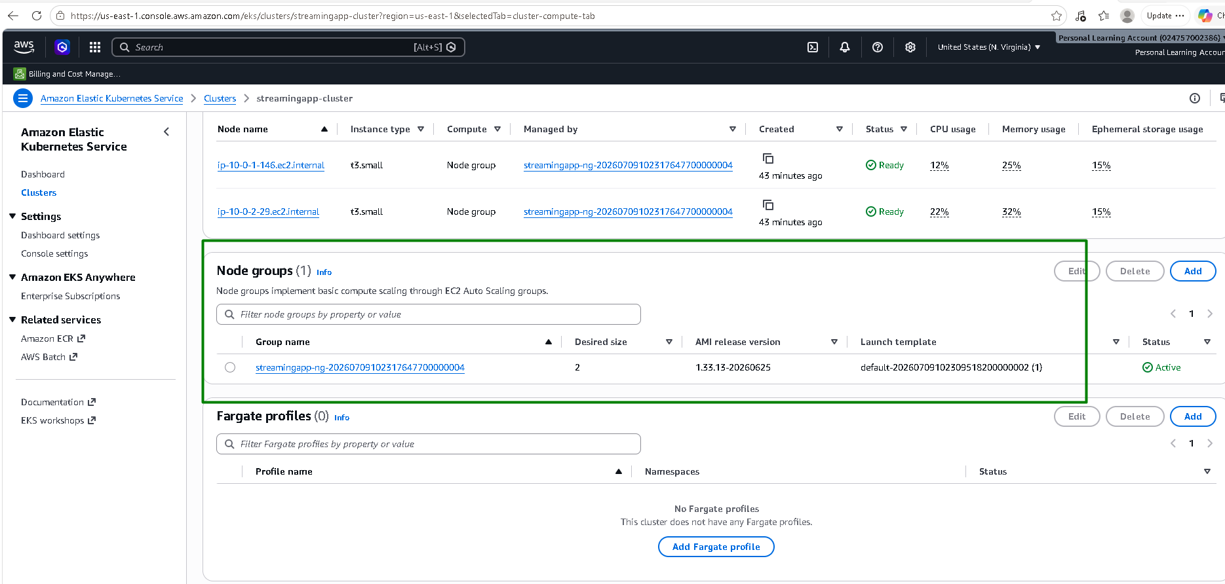

EC2:
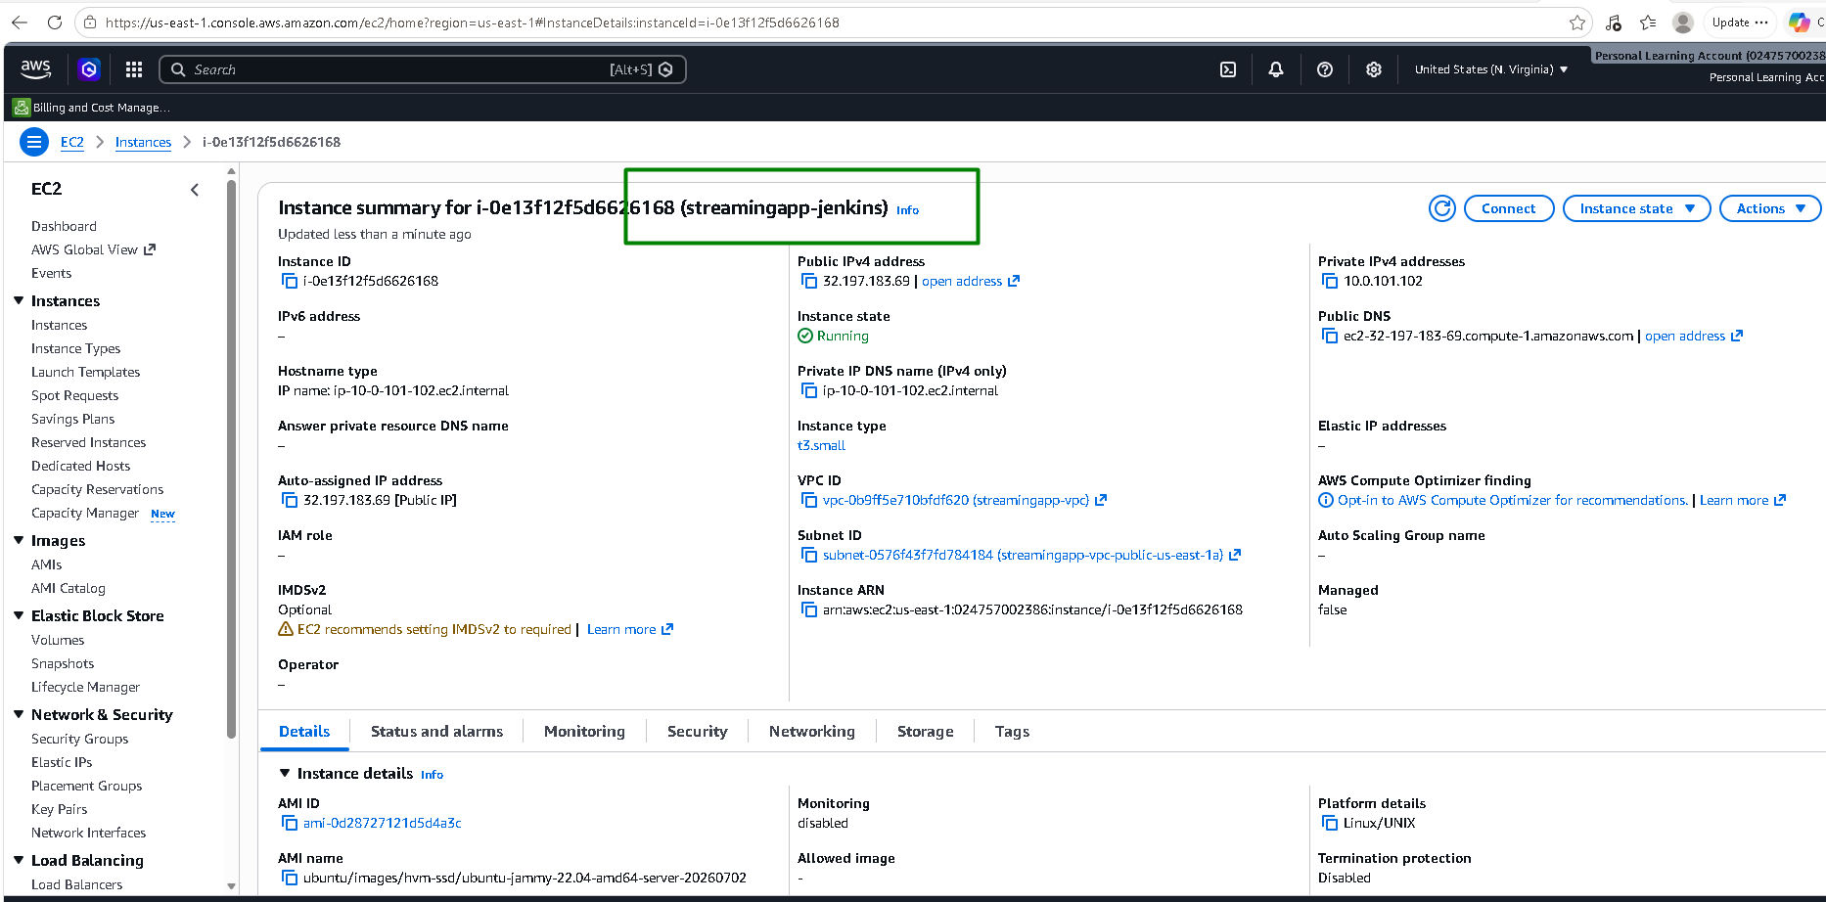
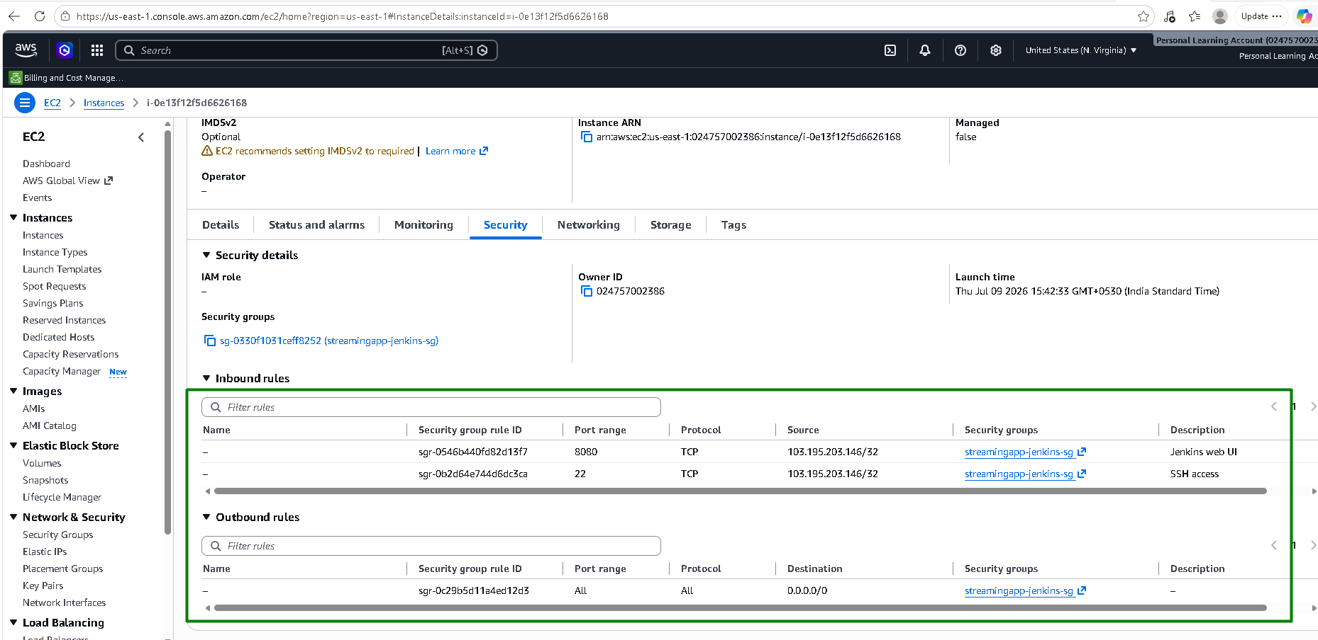

ECR:
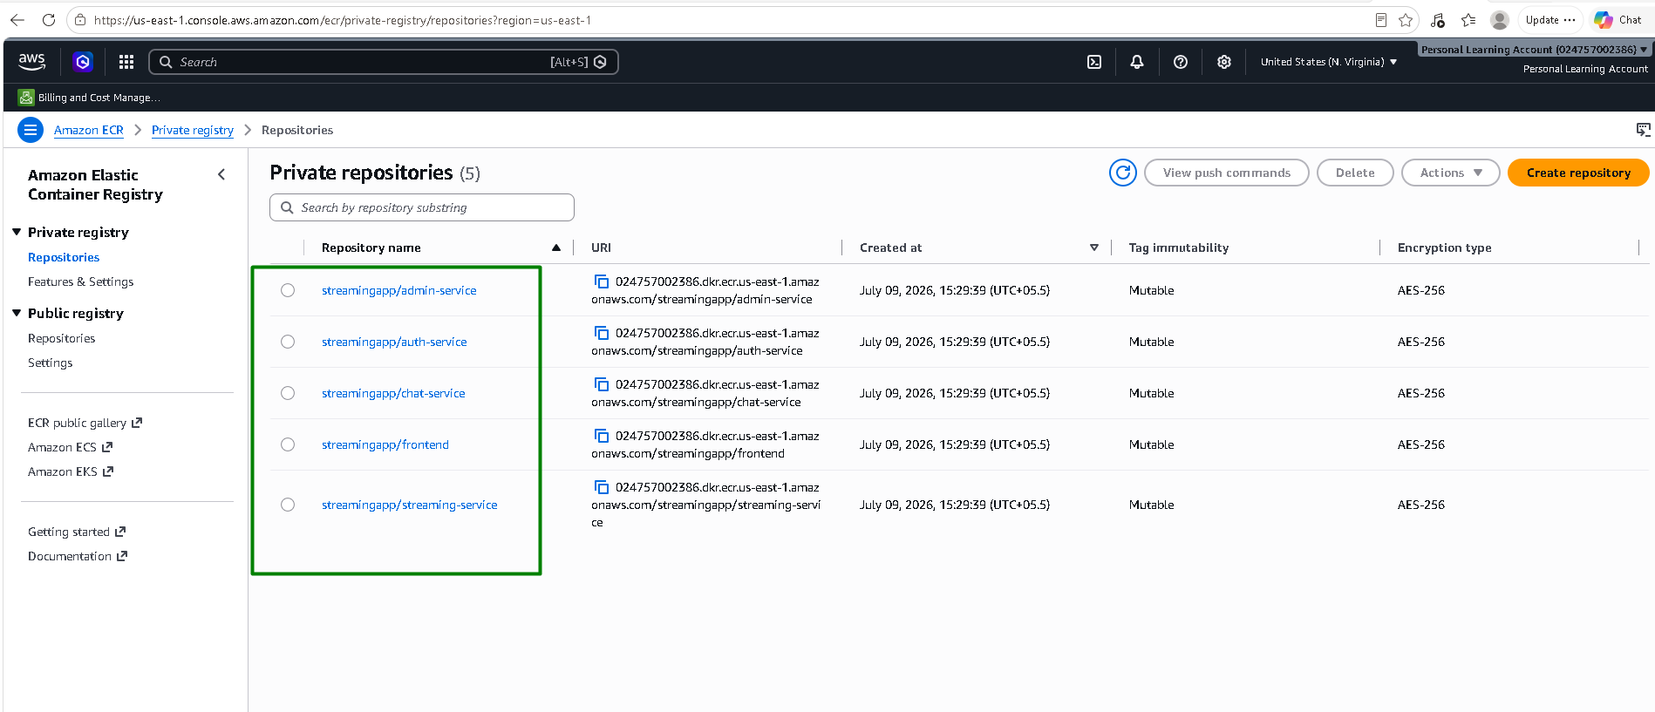

S3:
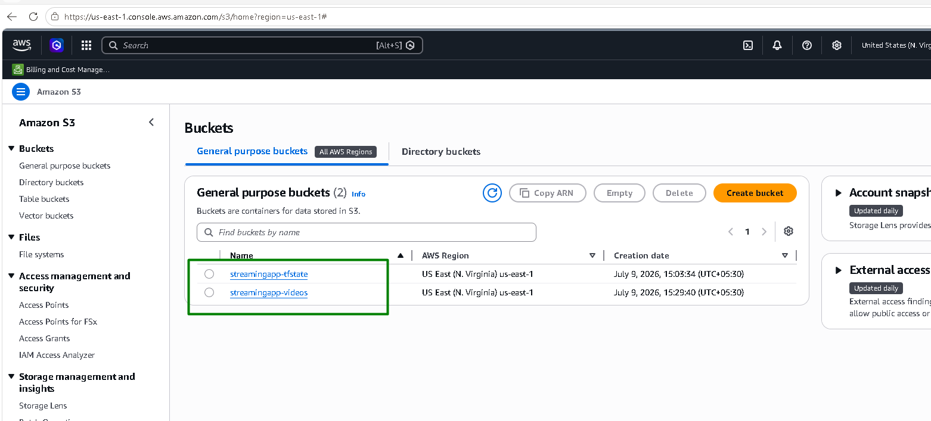

IAM roles:
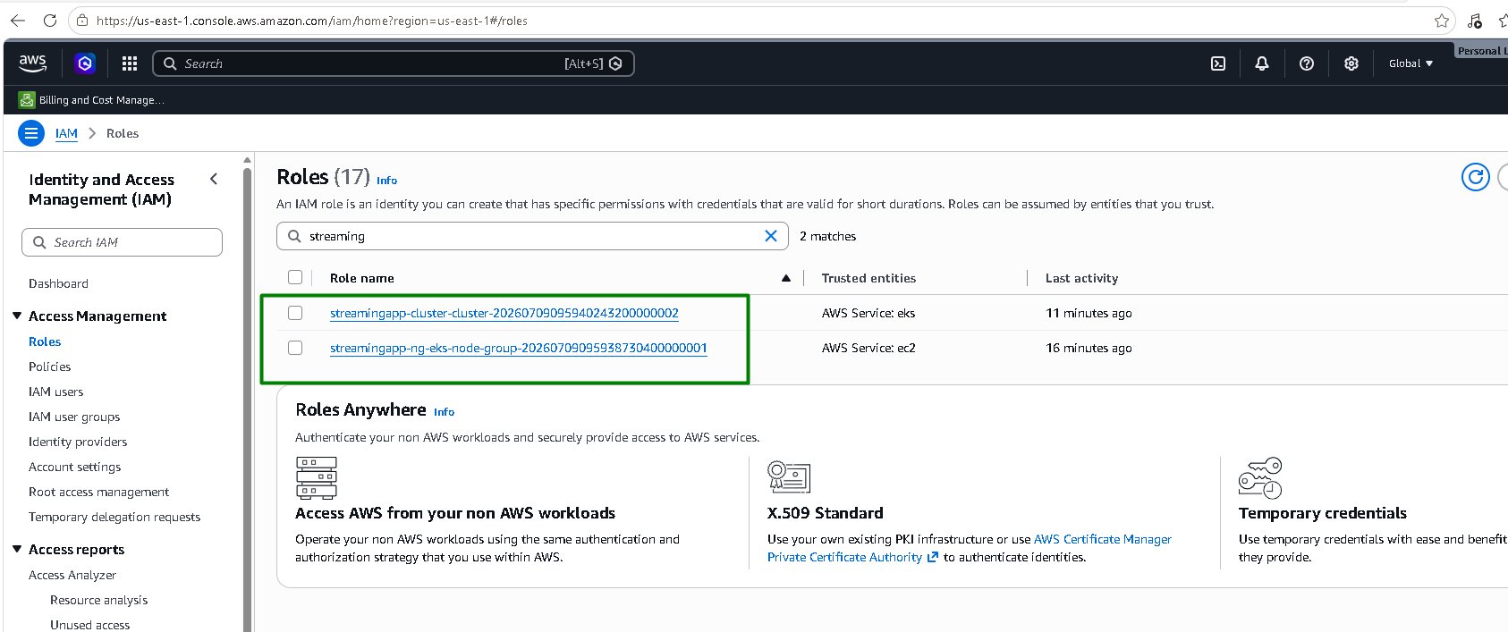
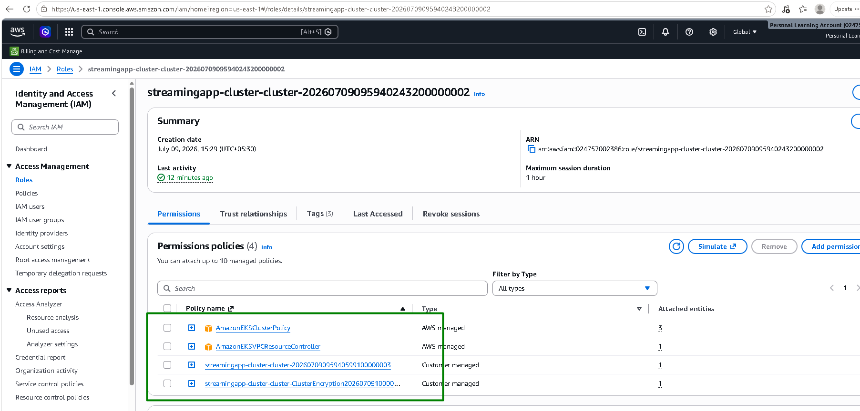
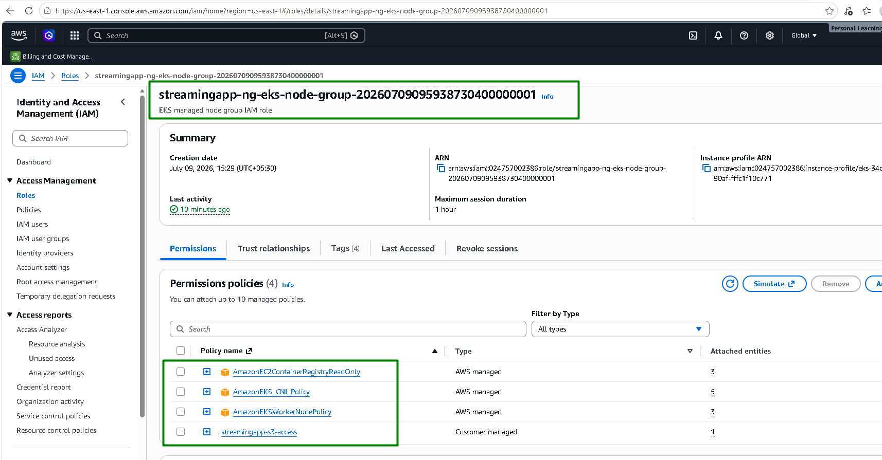

Dynamo DB:
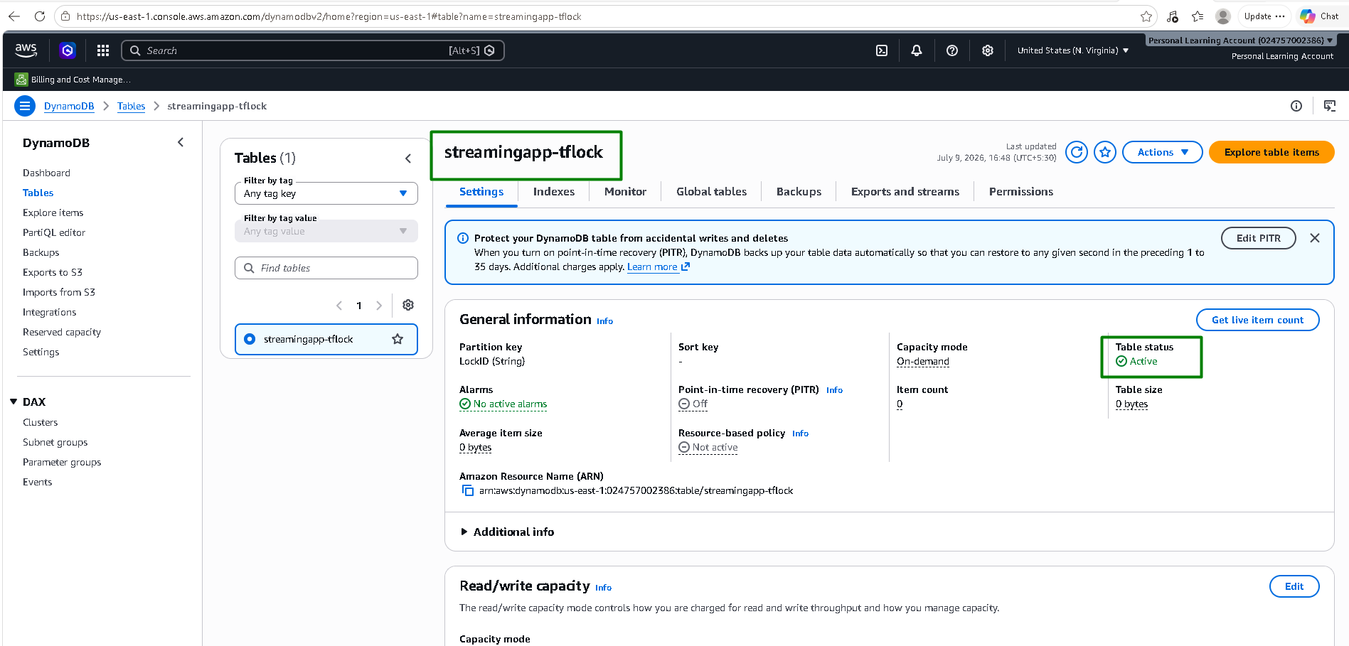

KMS:
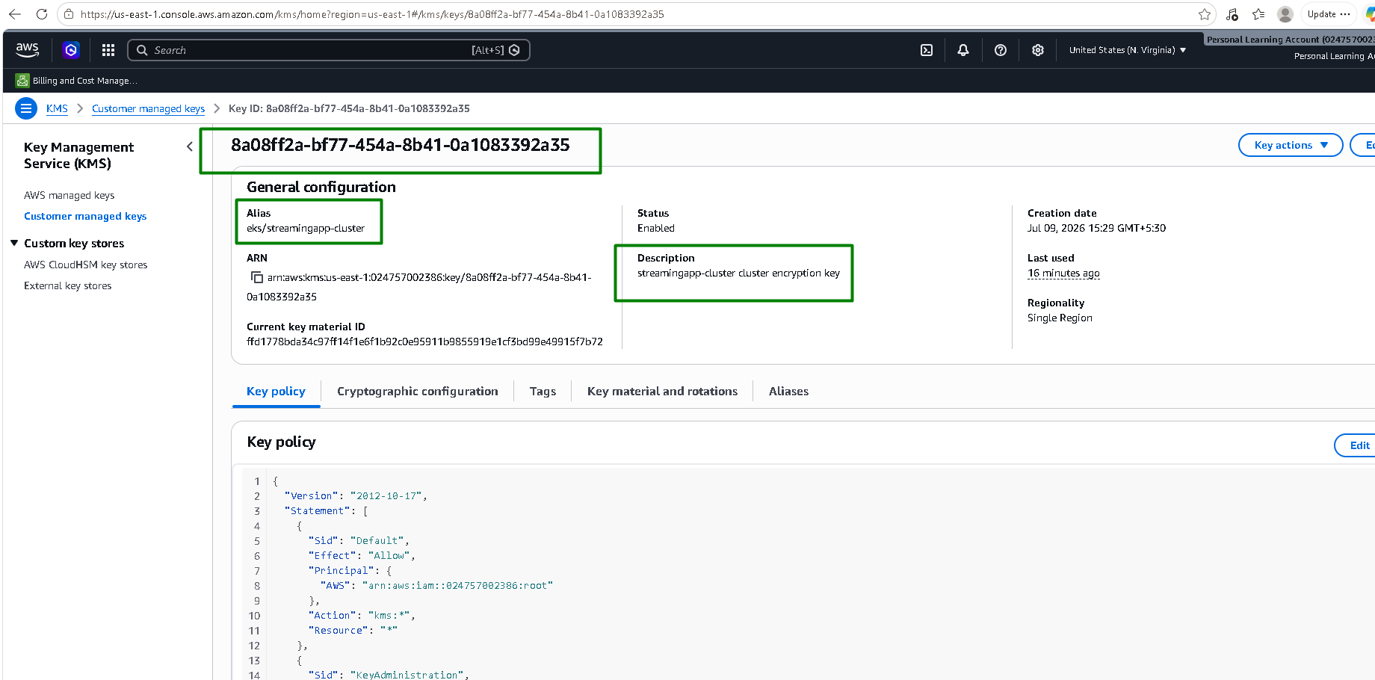

Cloudwatch:
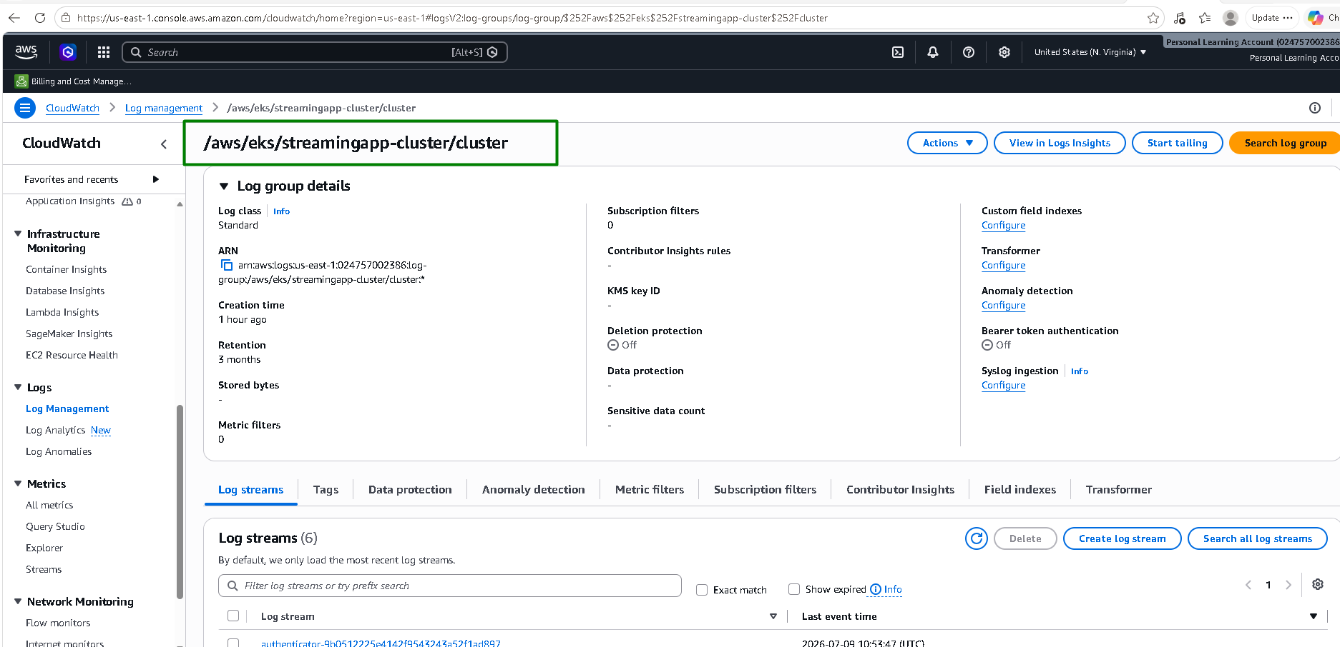
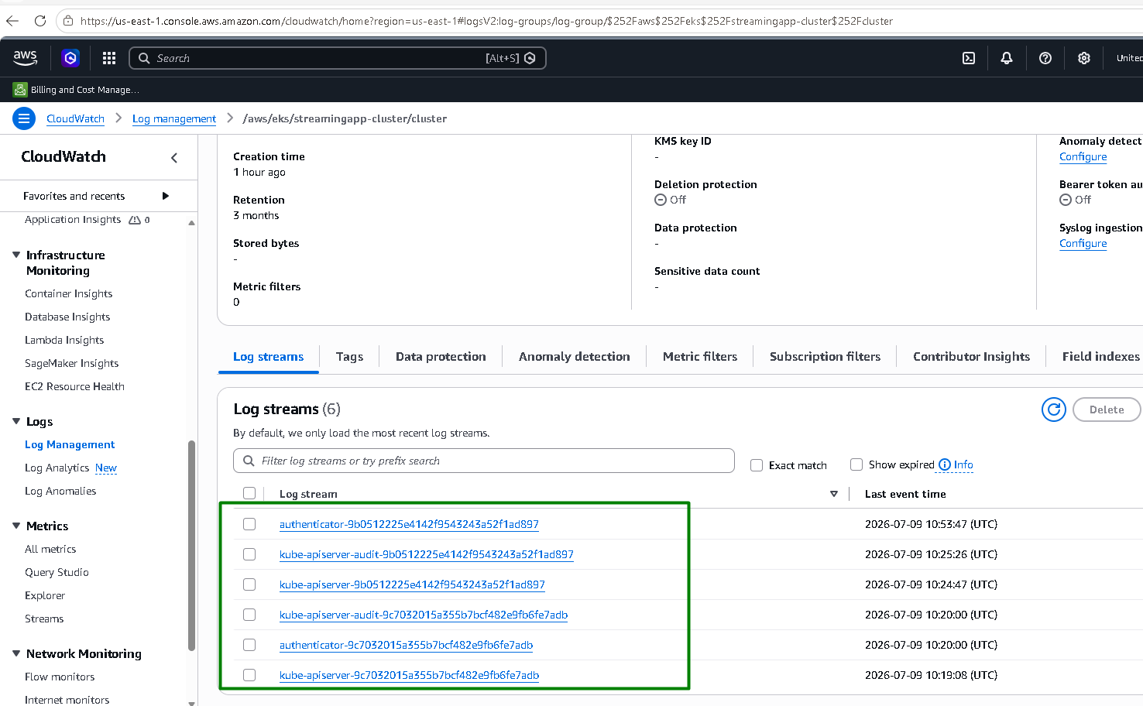

Ansible — Jenkins EC2 fully configured via the dynamic AWS inventory, real SSH, real playbook run, zero failures
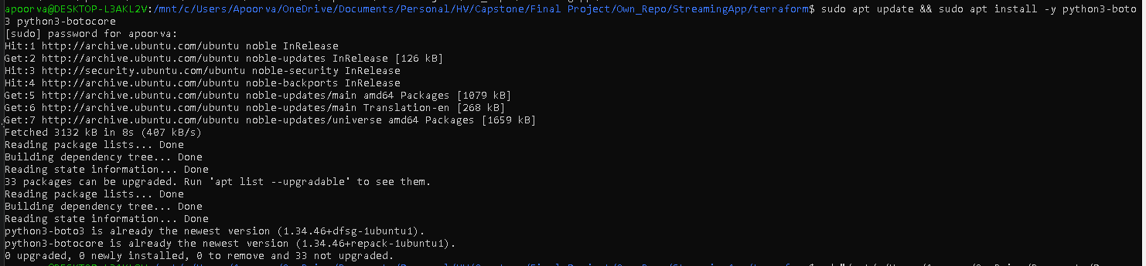
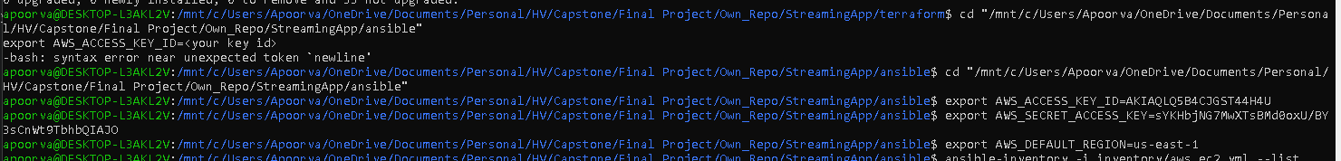
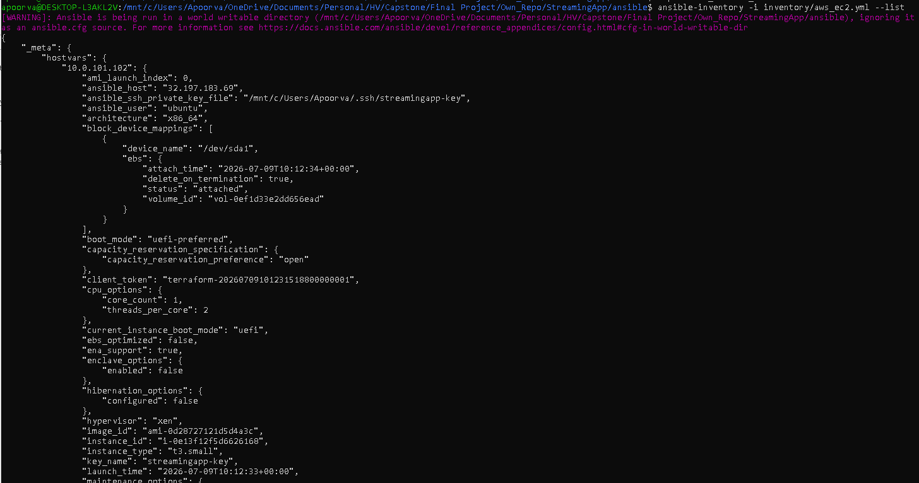
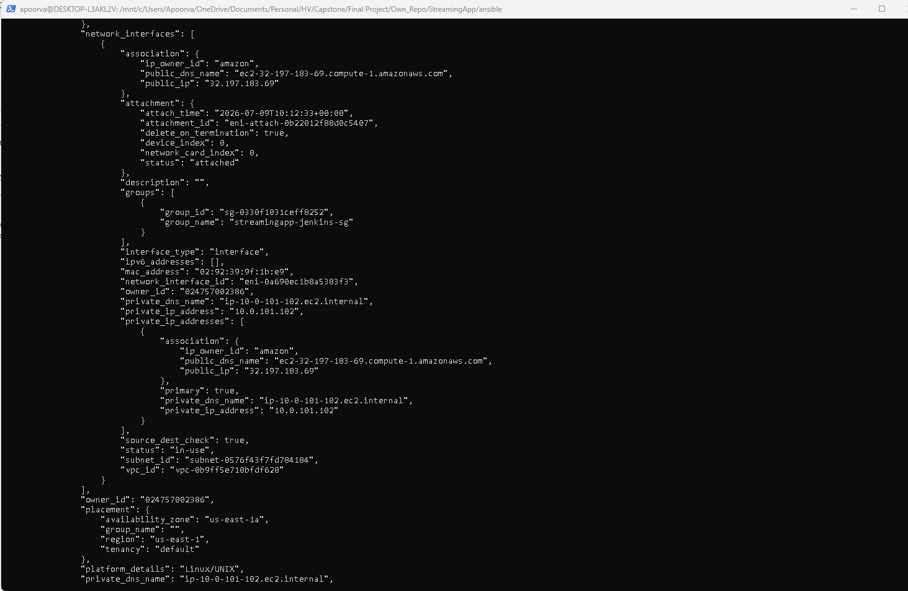
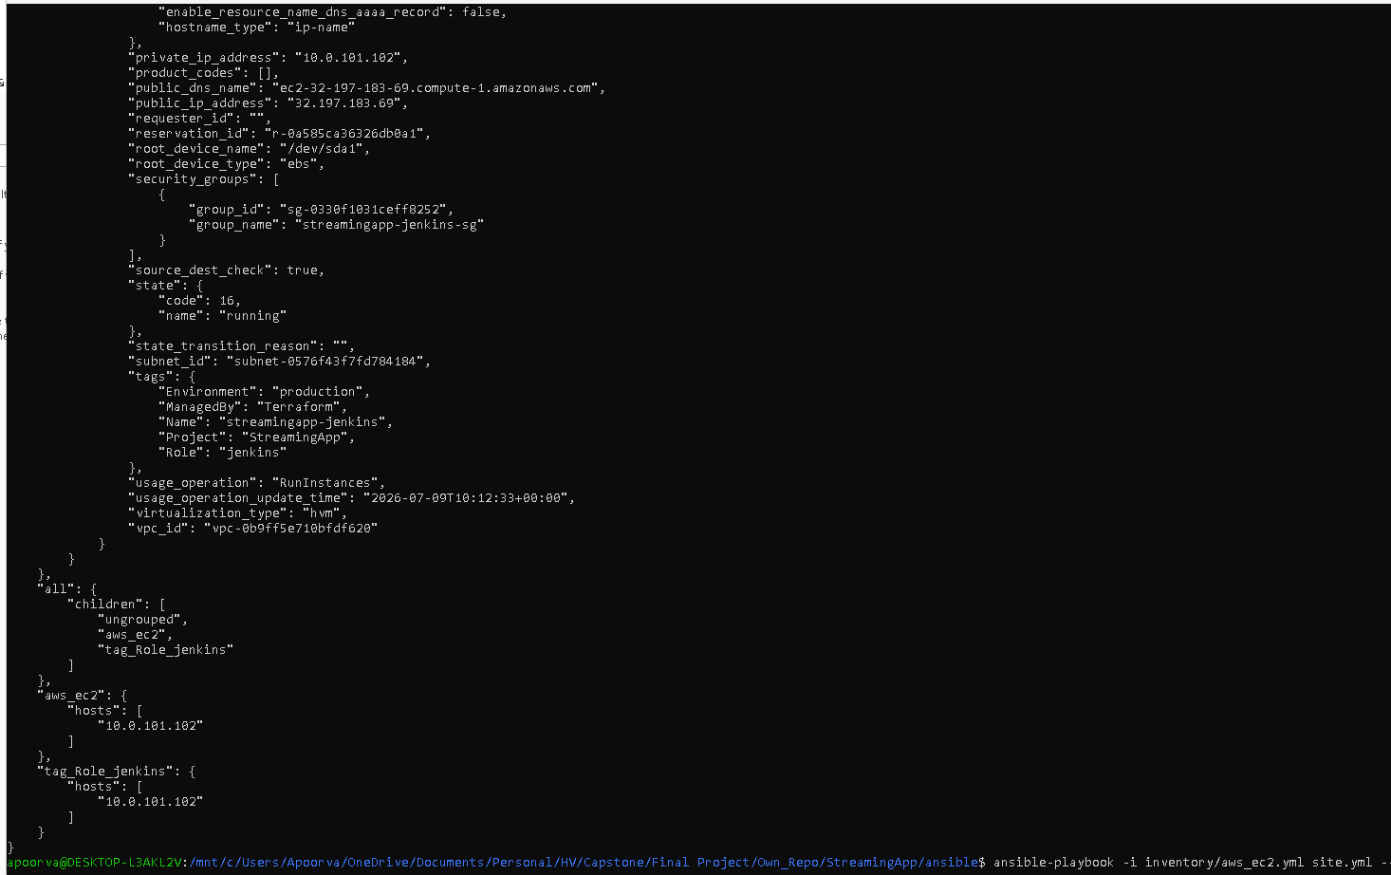
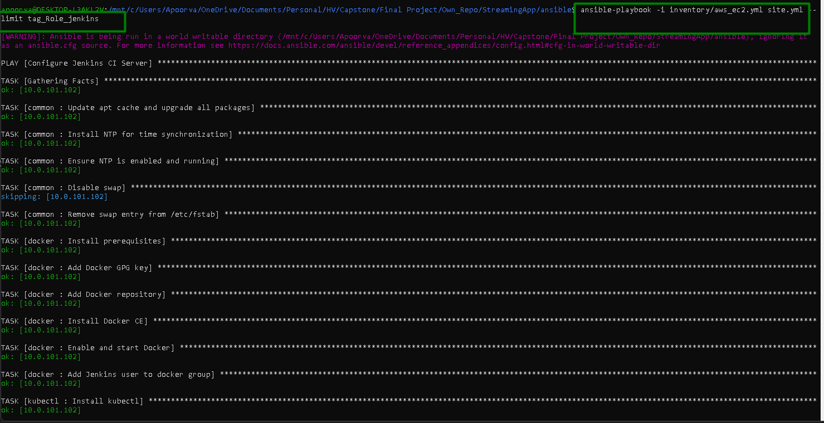
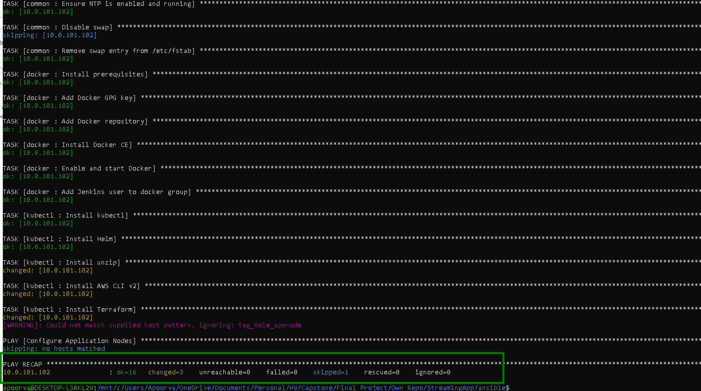

That's everything through Ansible confirmed working on actual AWS infrastructure, not just locally.

Next Steps: building/pushing real images to ECR, deploying the app to EKS, and eventually the ALB Ingress

Screenshots:

Sprint 2 Progress (At this stage trial is done till checking the App is live)

IAM User Creation
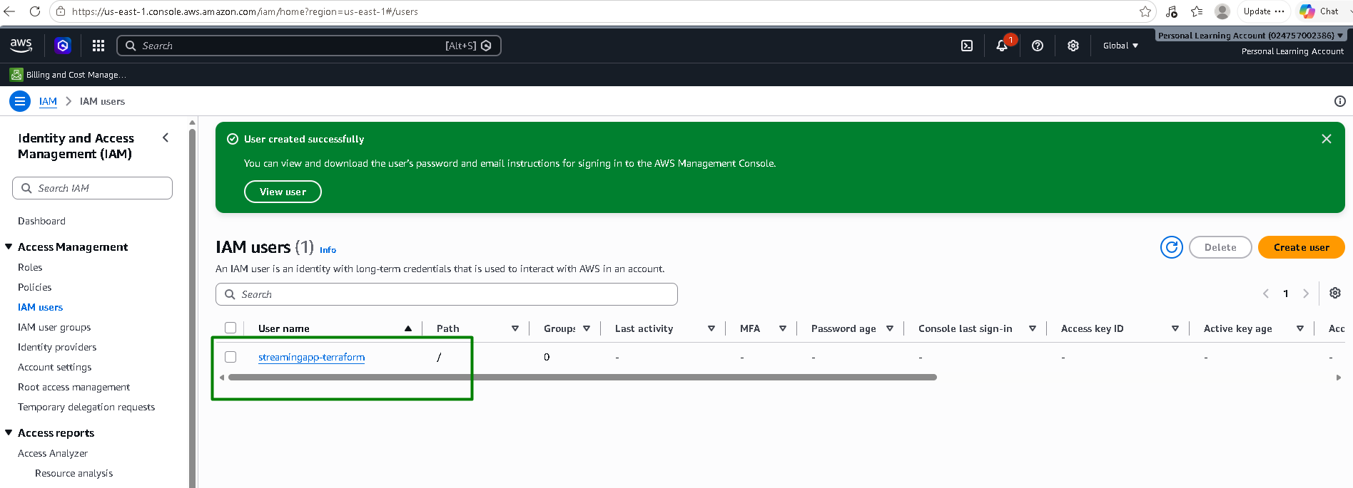

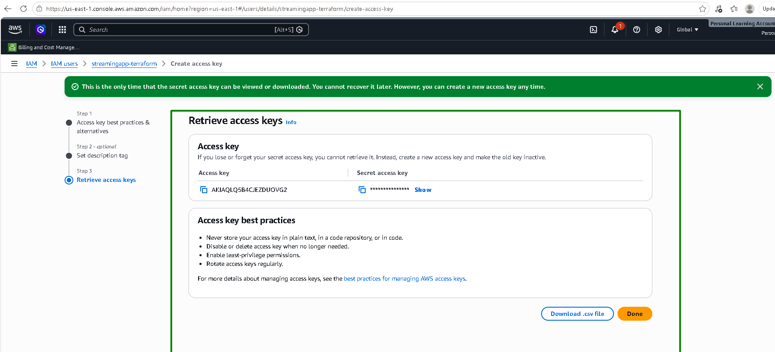

Configure AWS CLI:
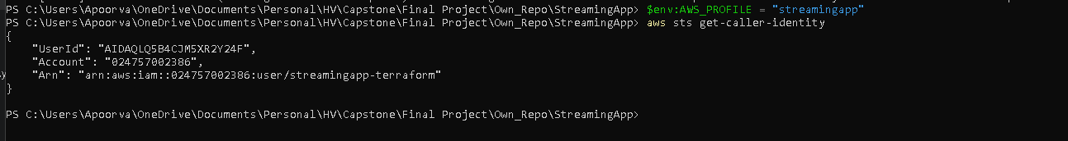

Terraform infra:
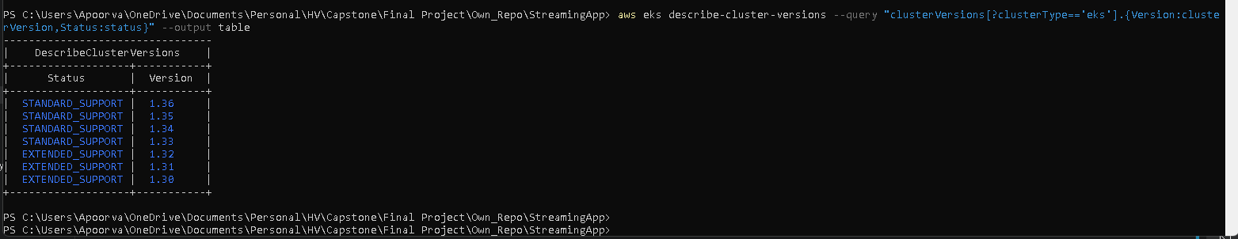

Create S3 bucket:

Create DynamoDB table:
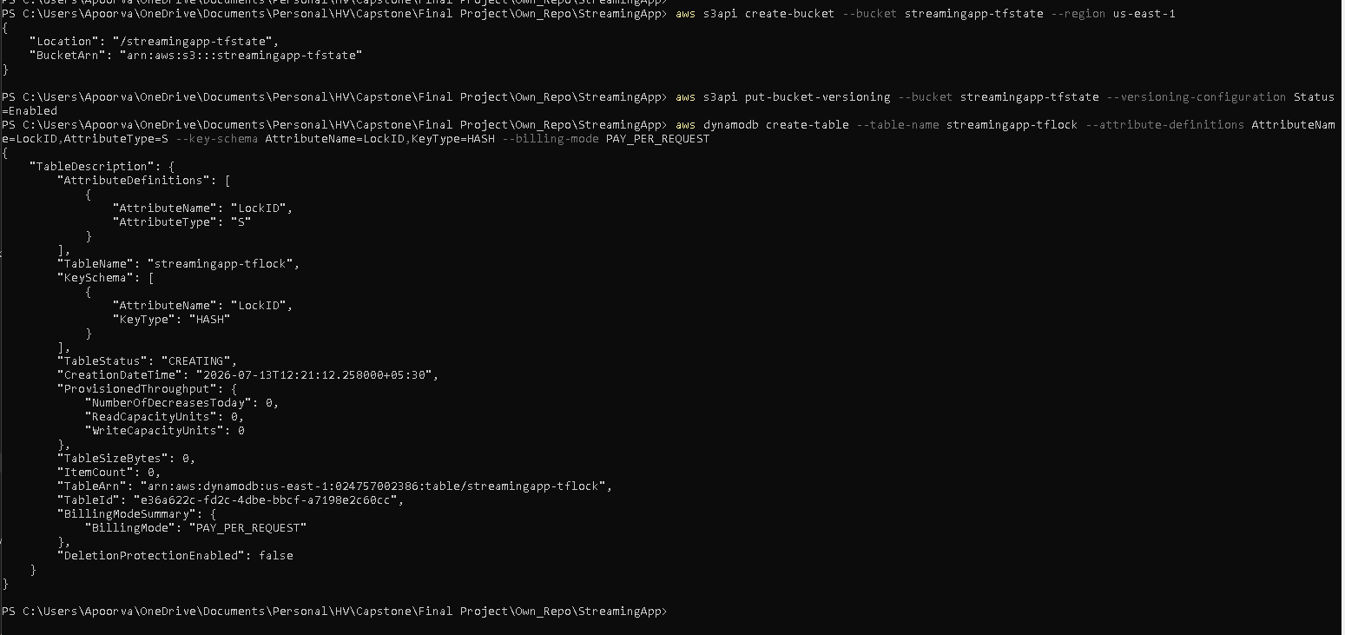

Terraform init and apply:
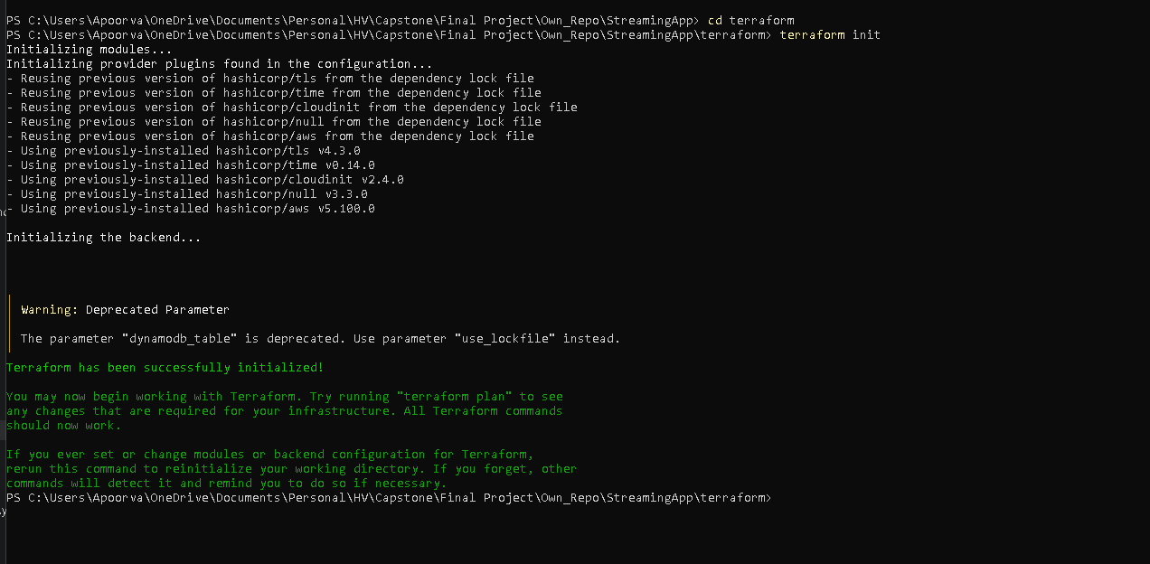
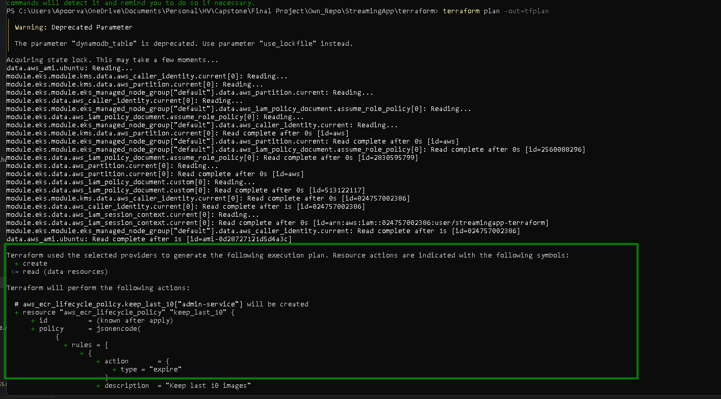
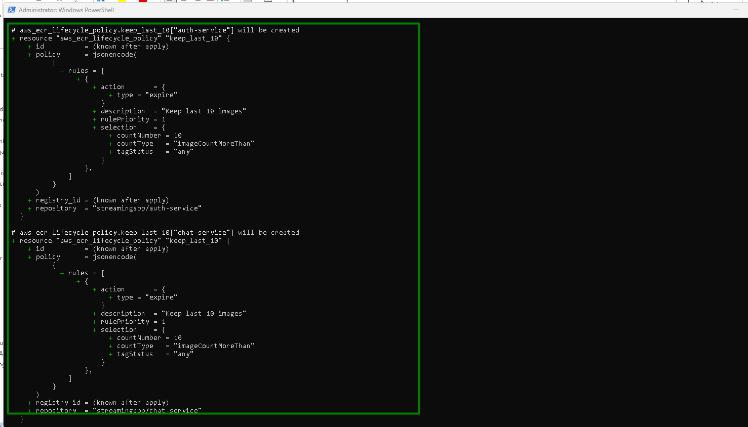
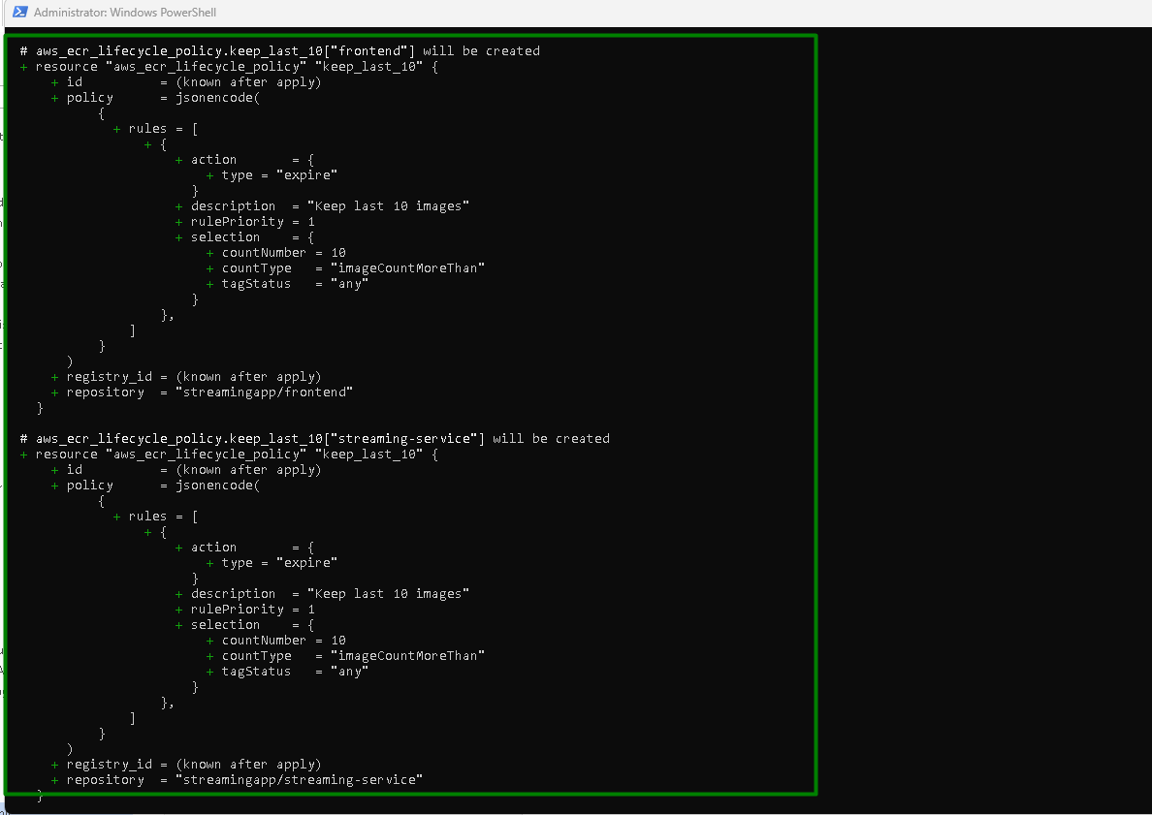

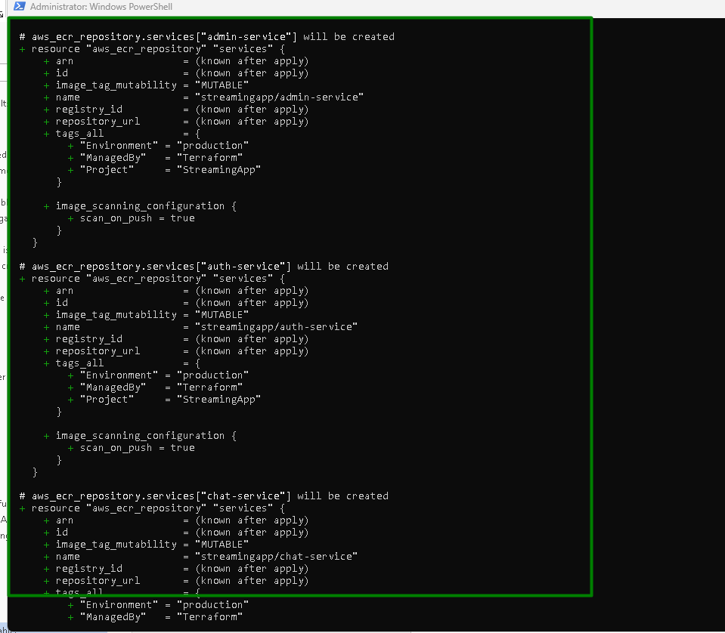

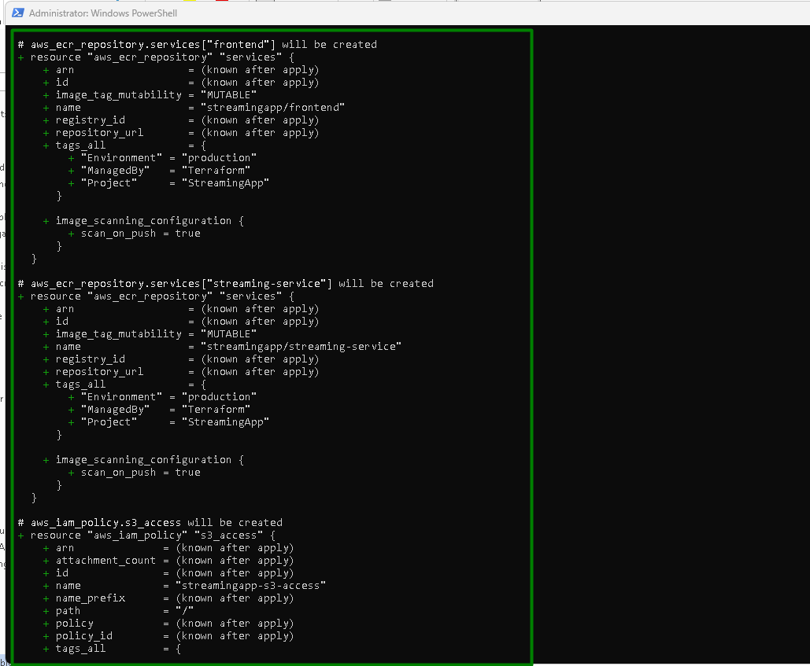
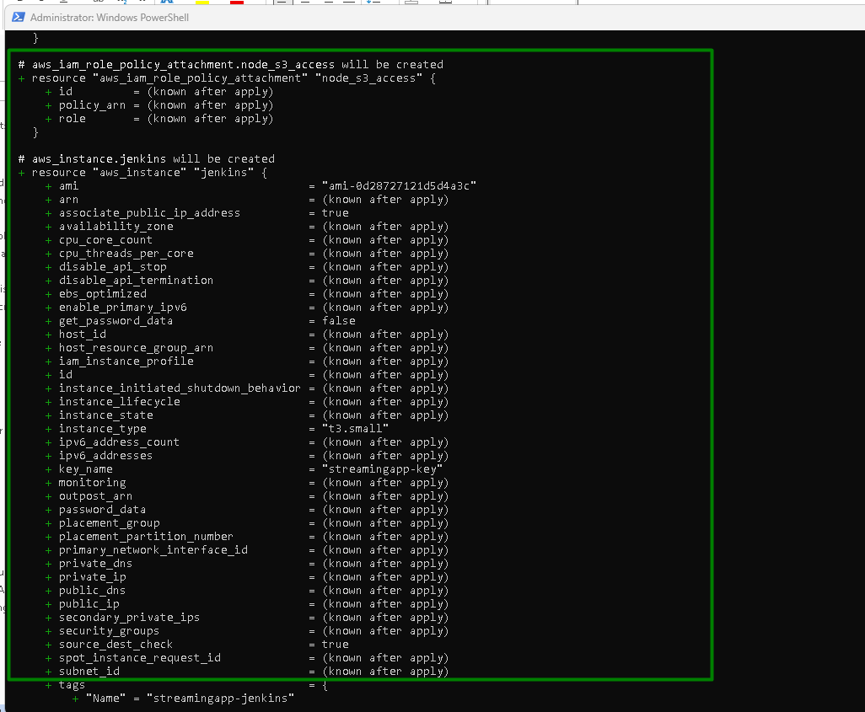
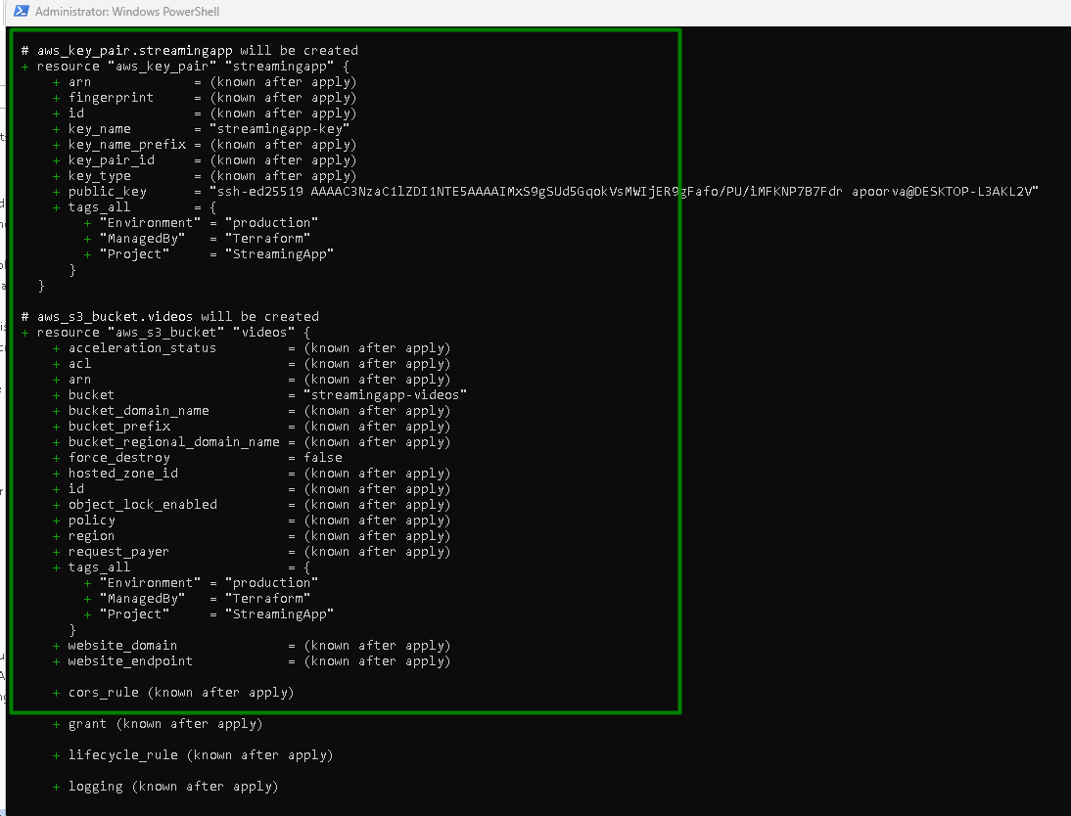
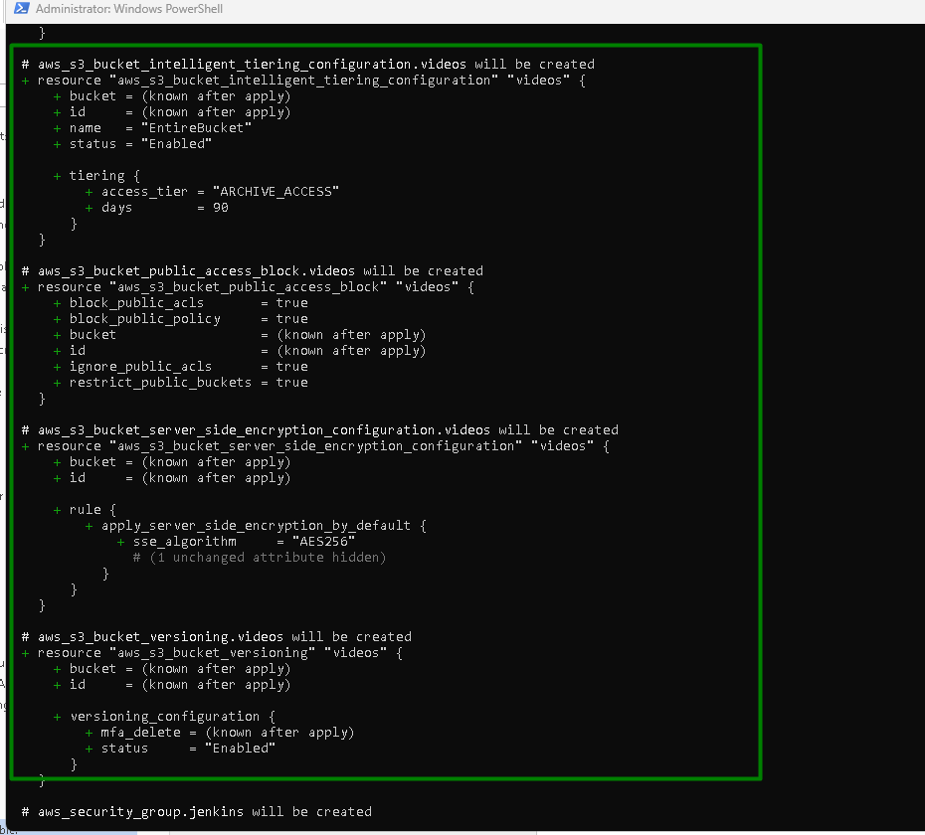
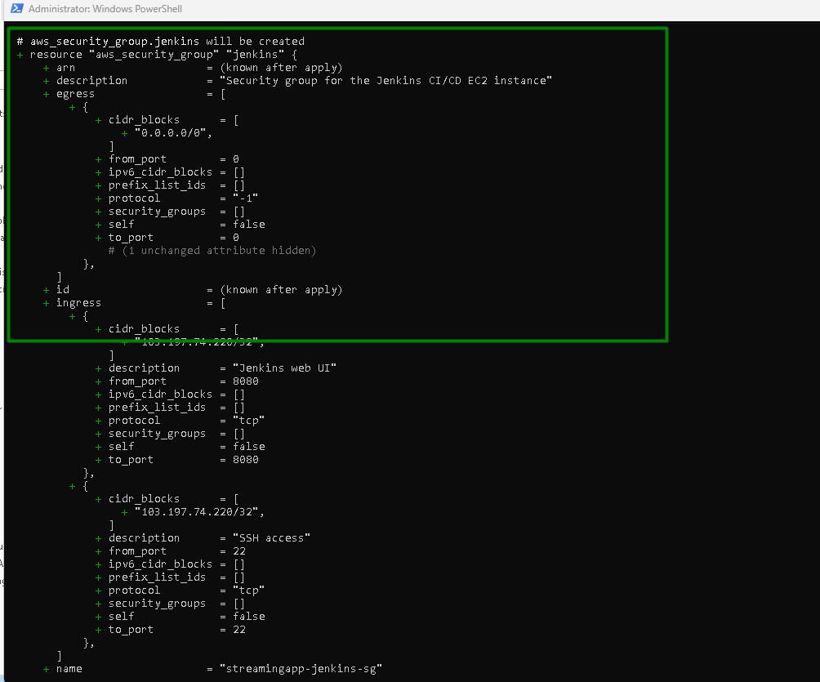
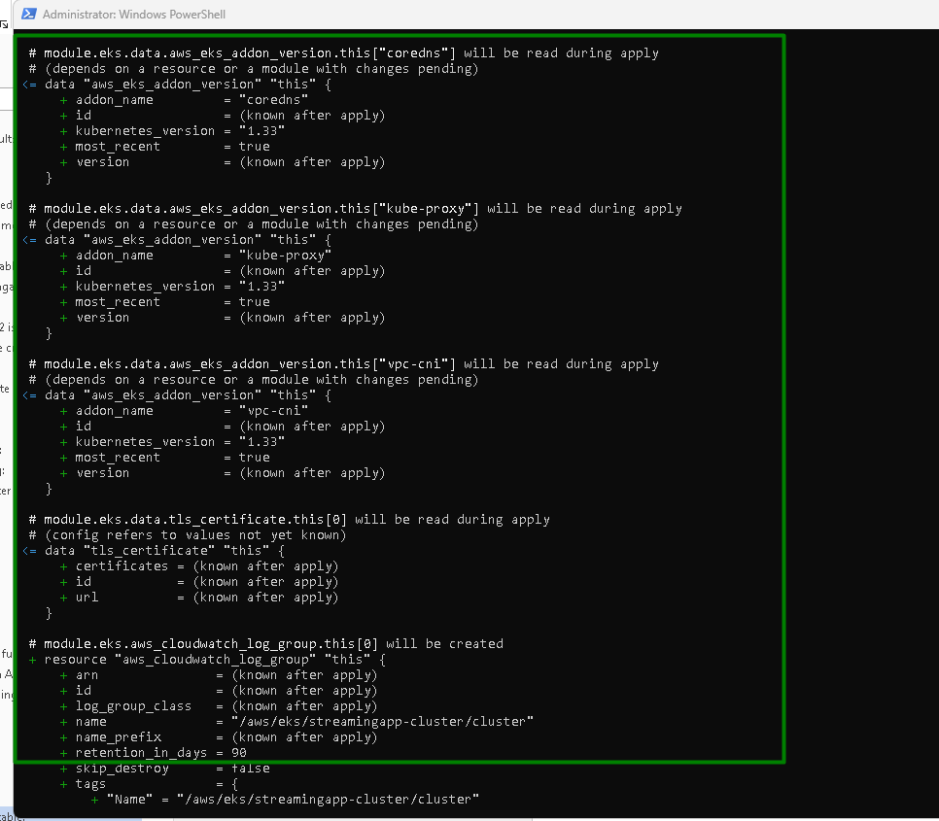
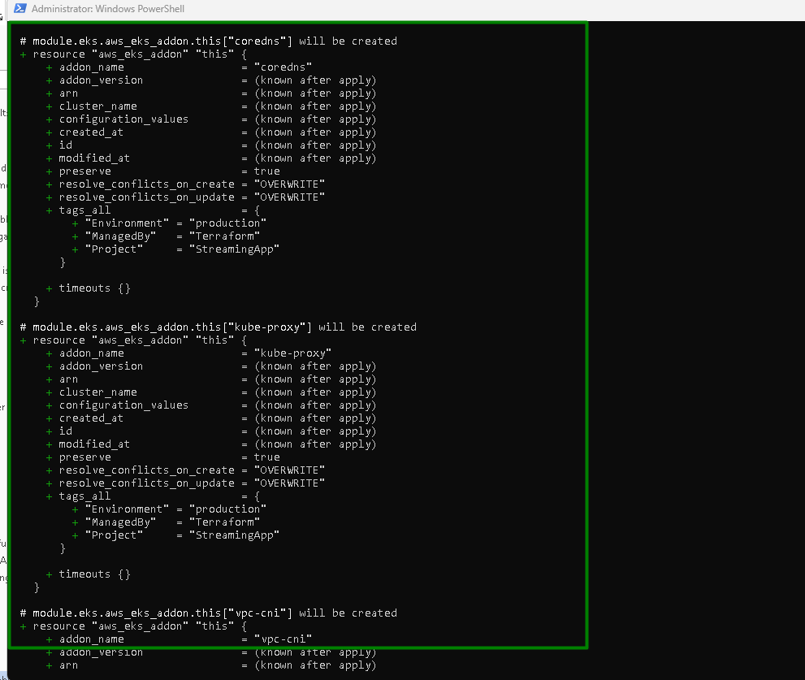
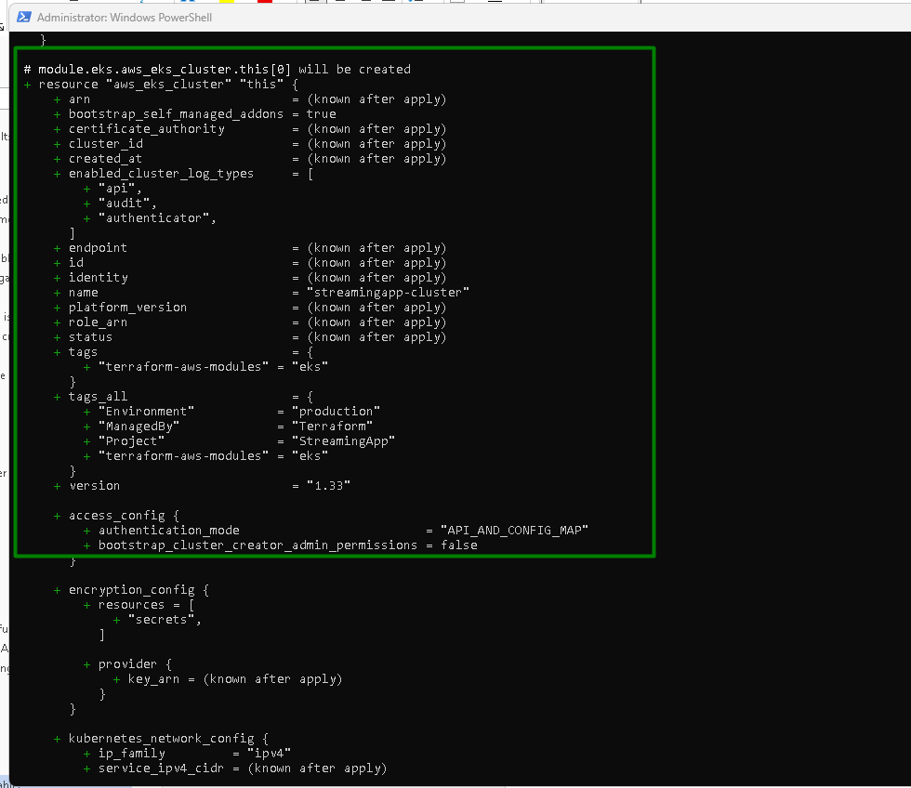
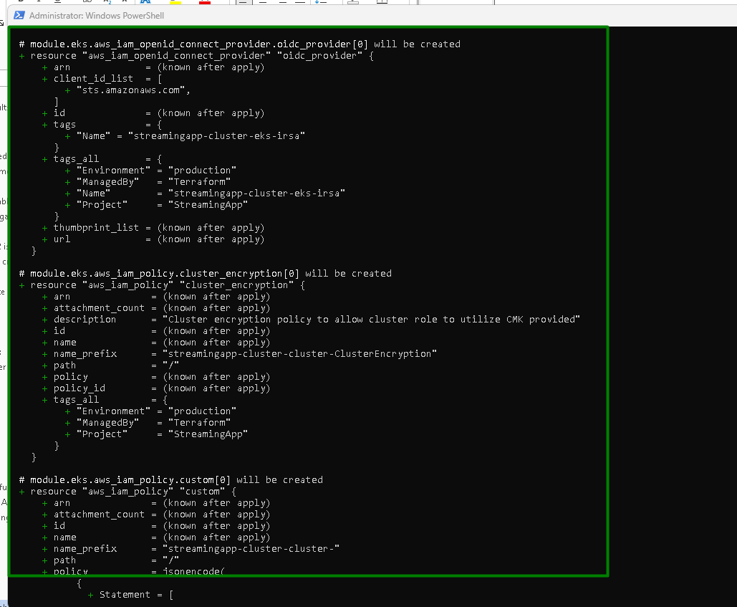
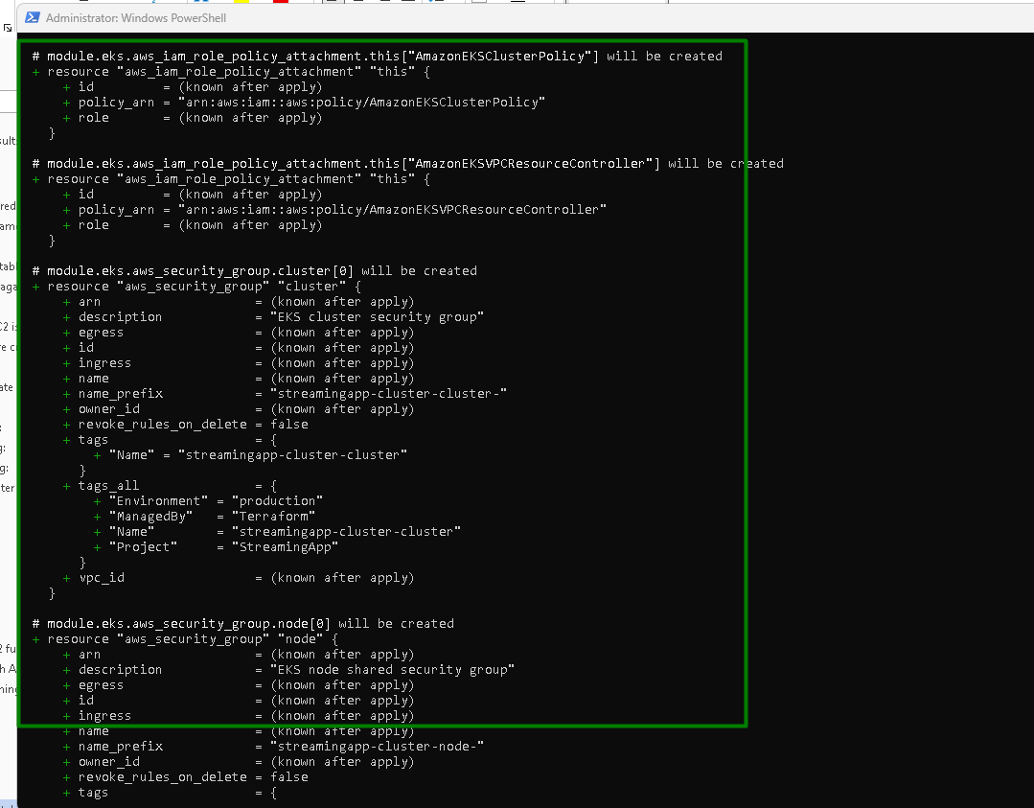
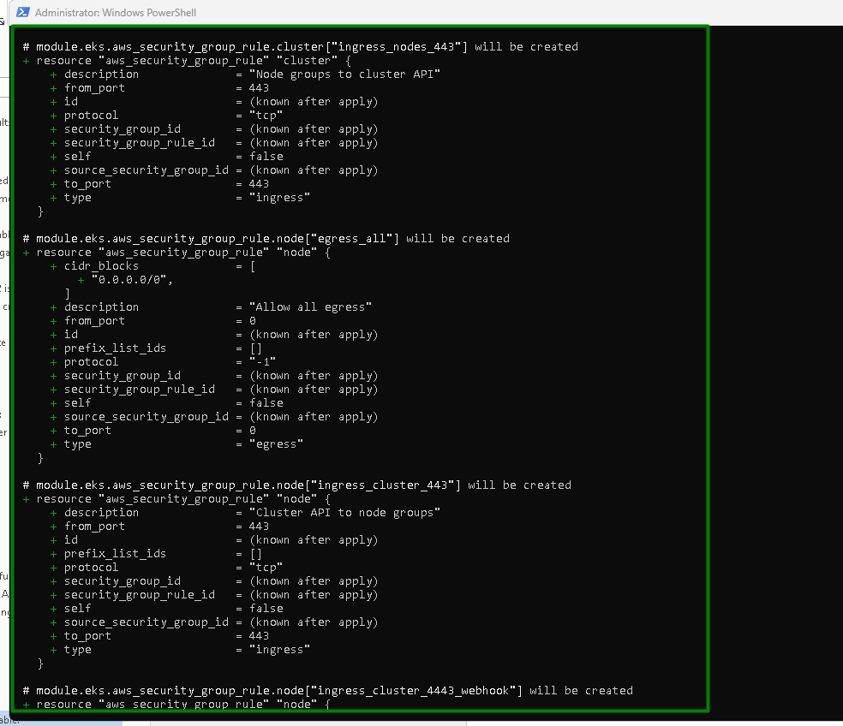
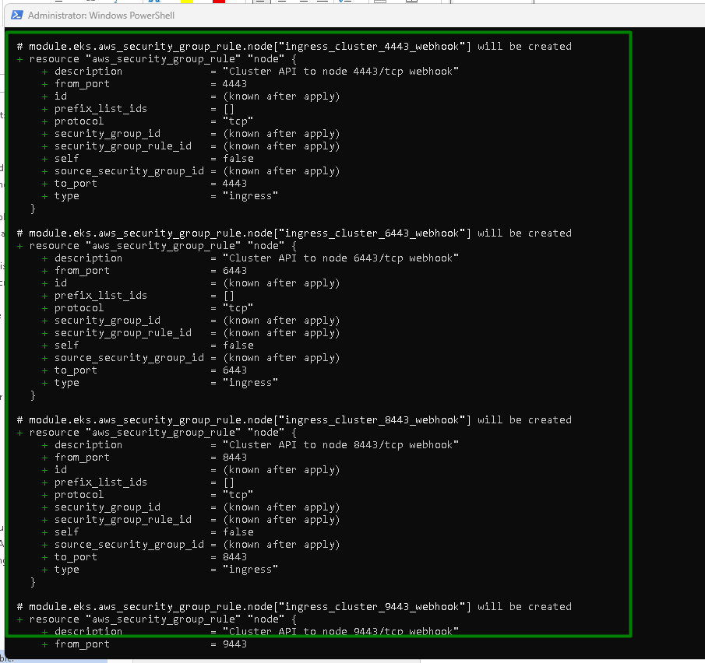

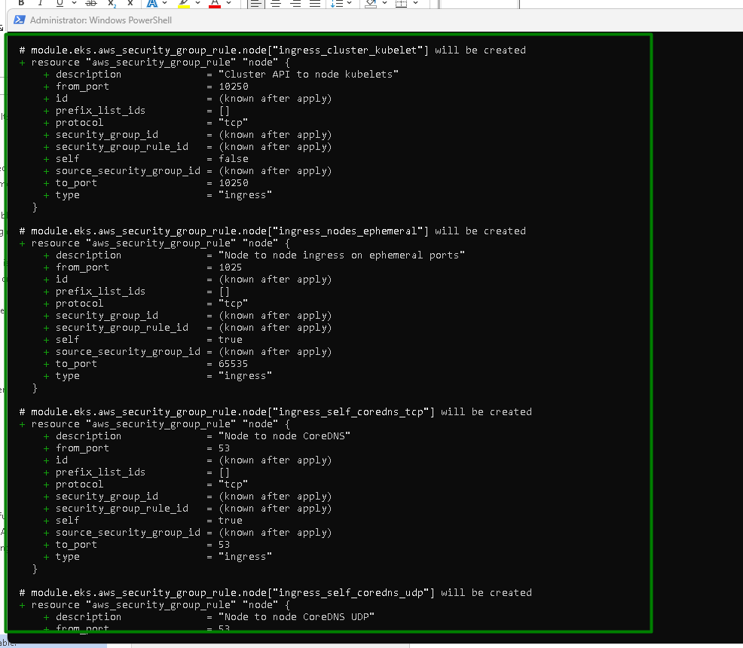
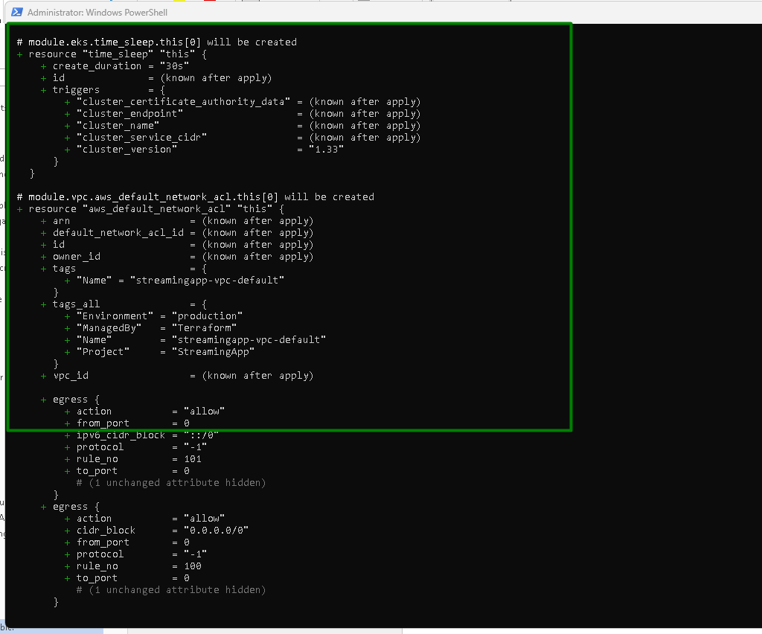
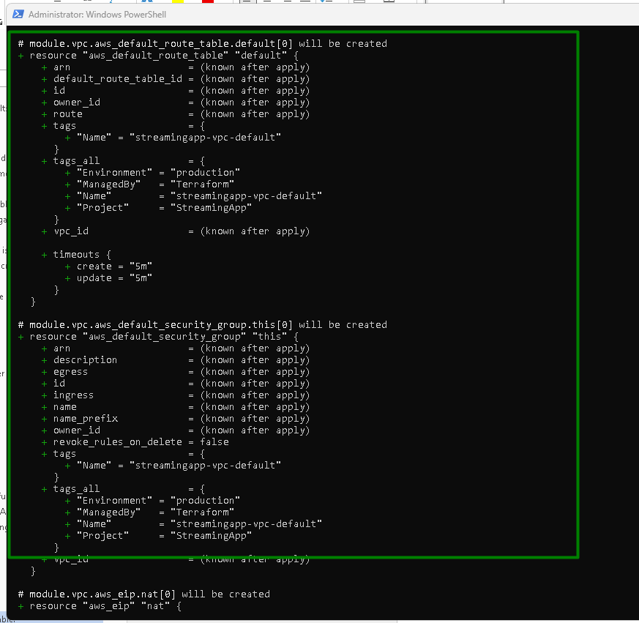
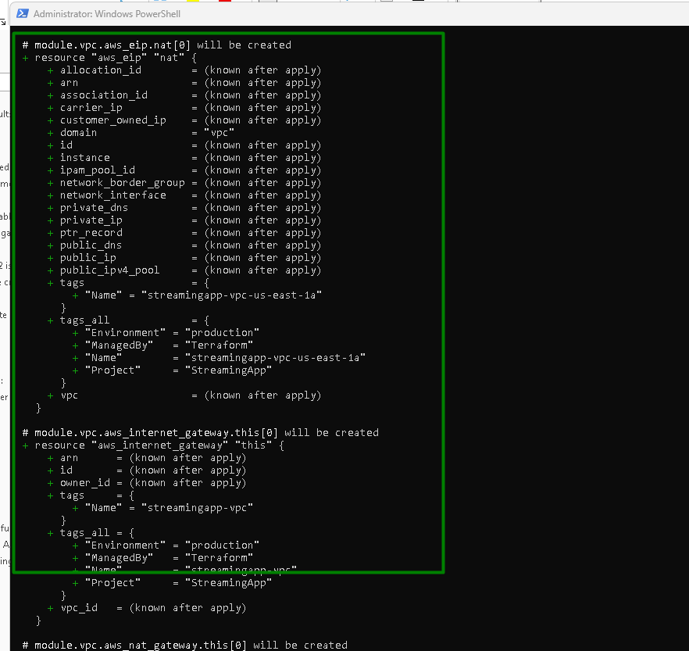

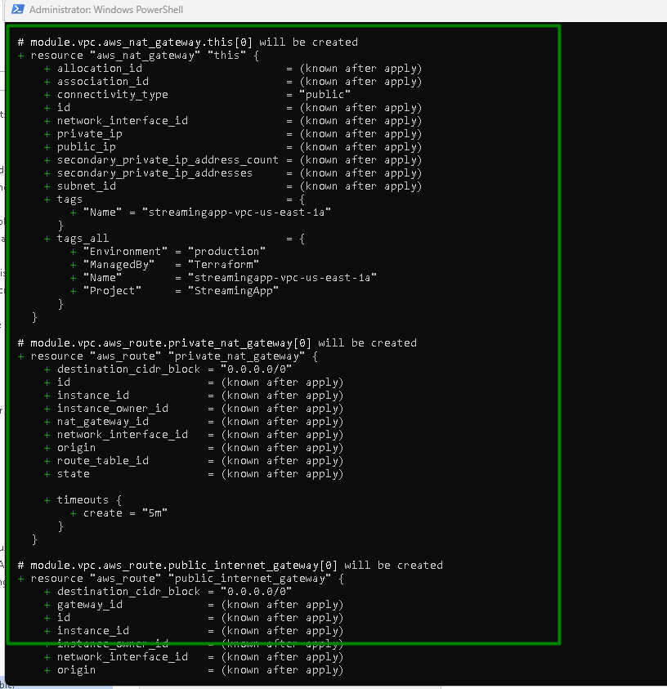
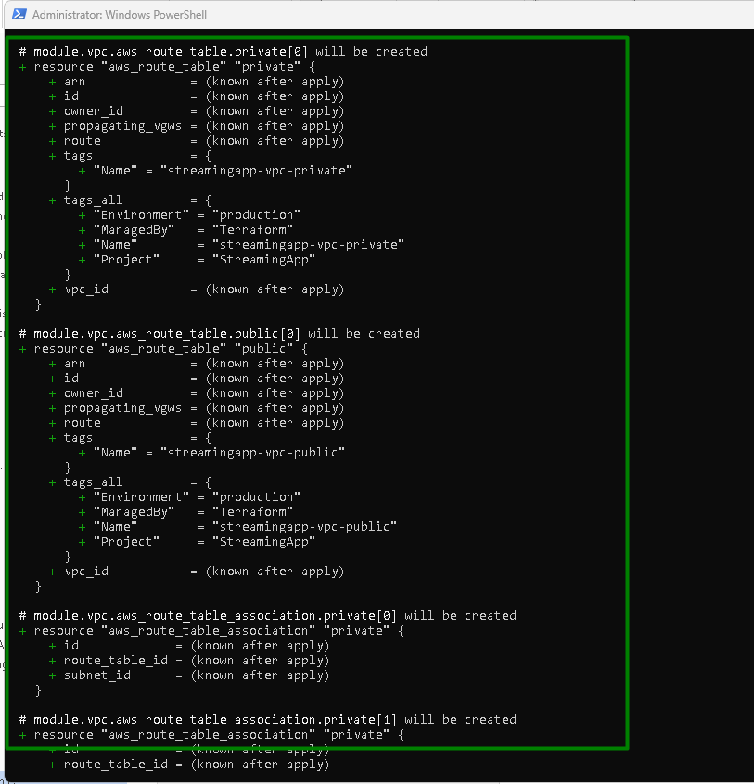
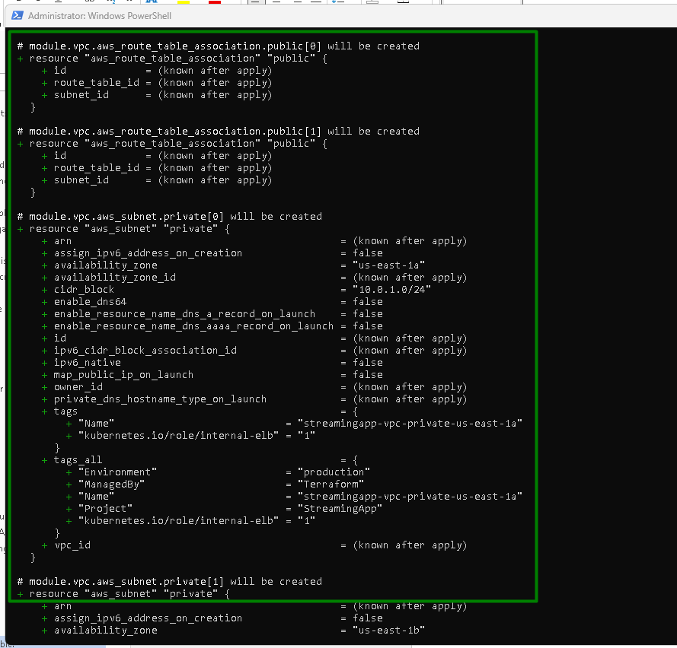
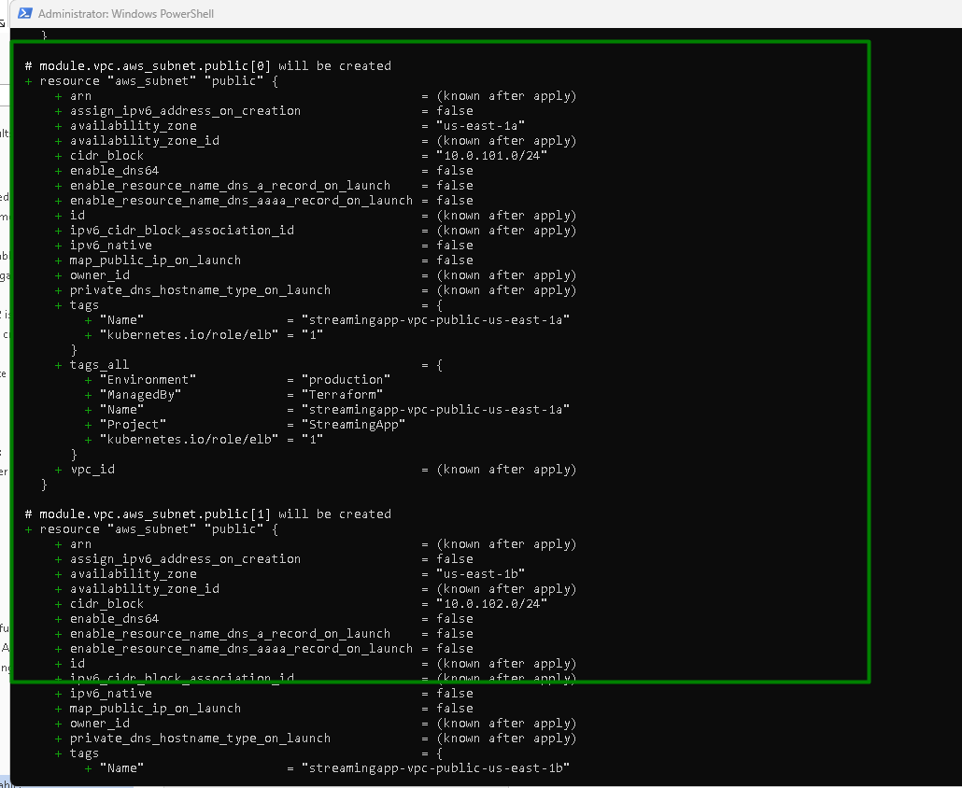
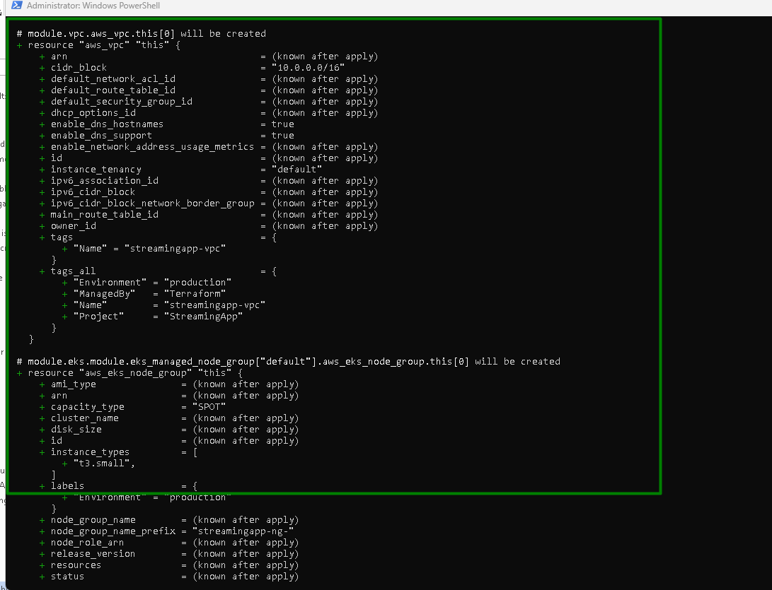
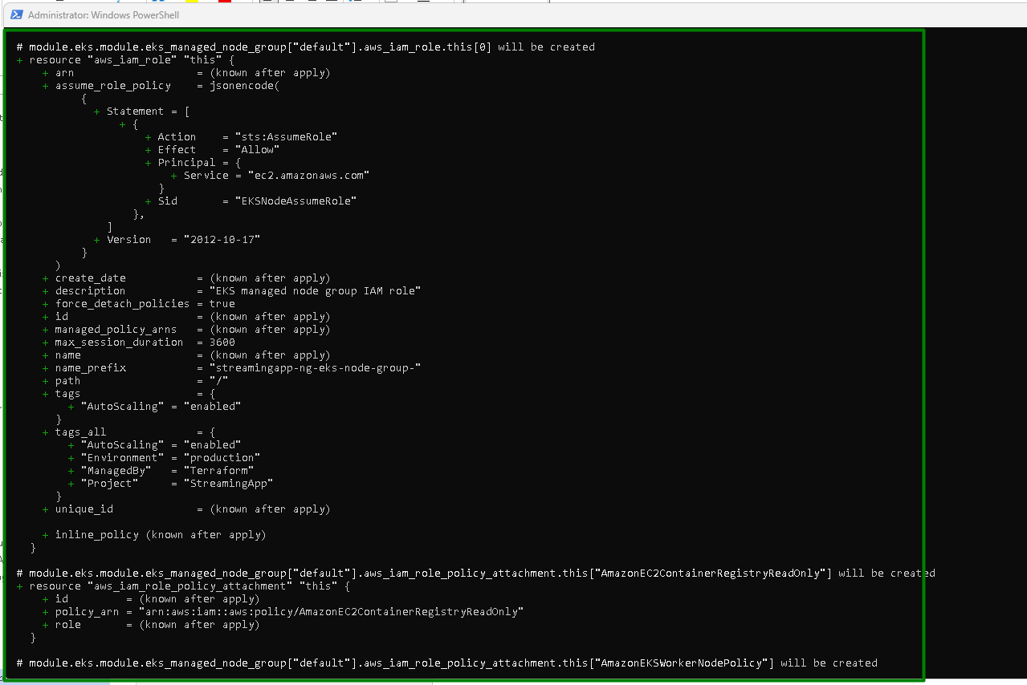
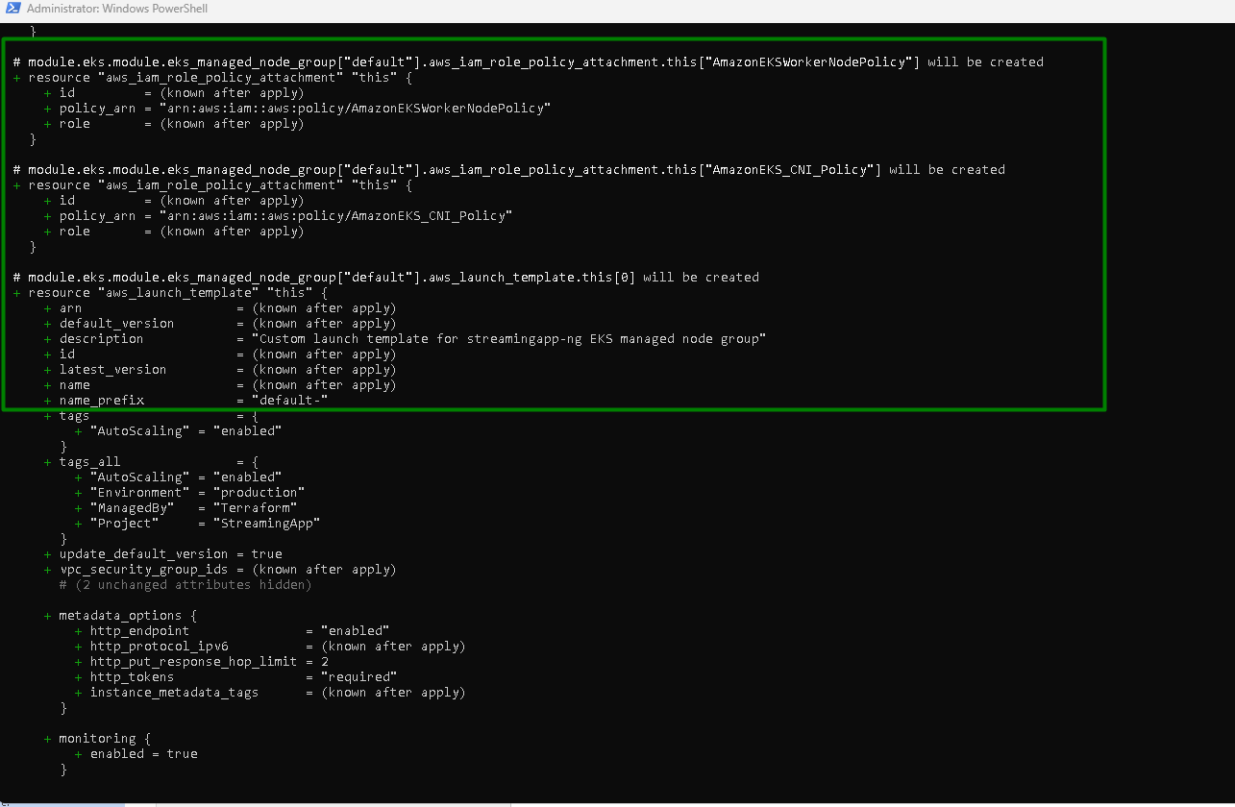
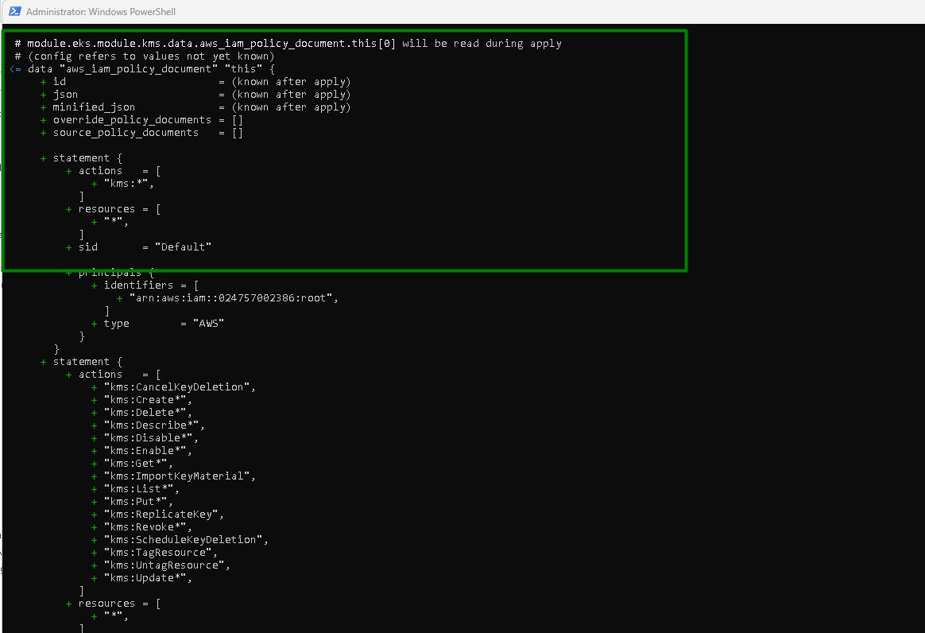

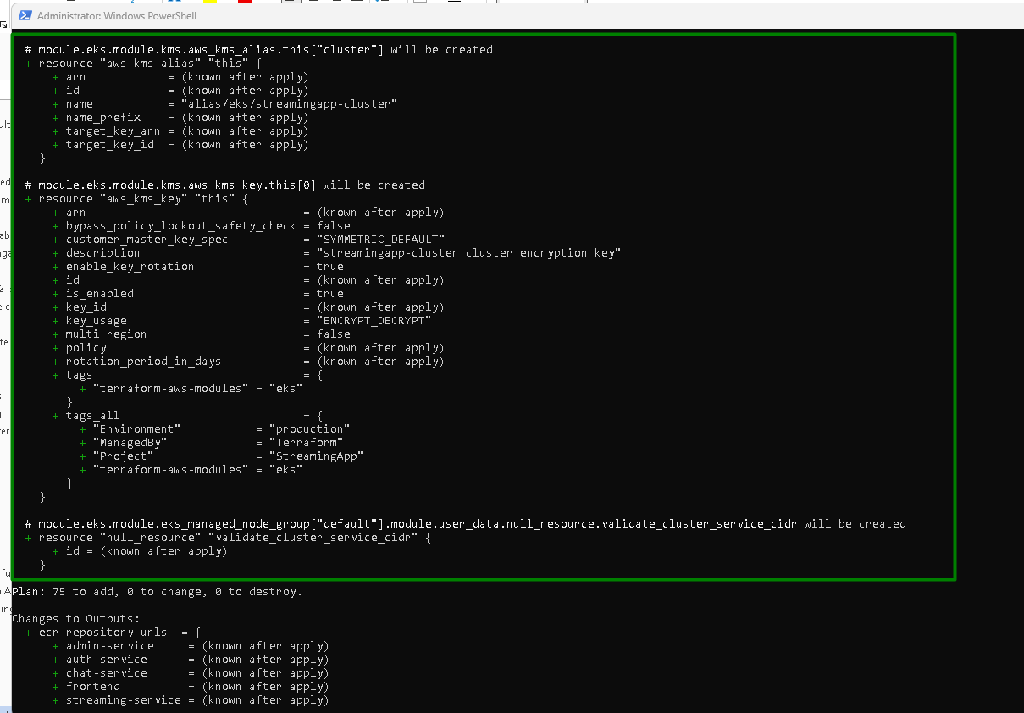
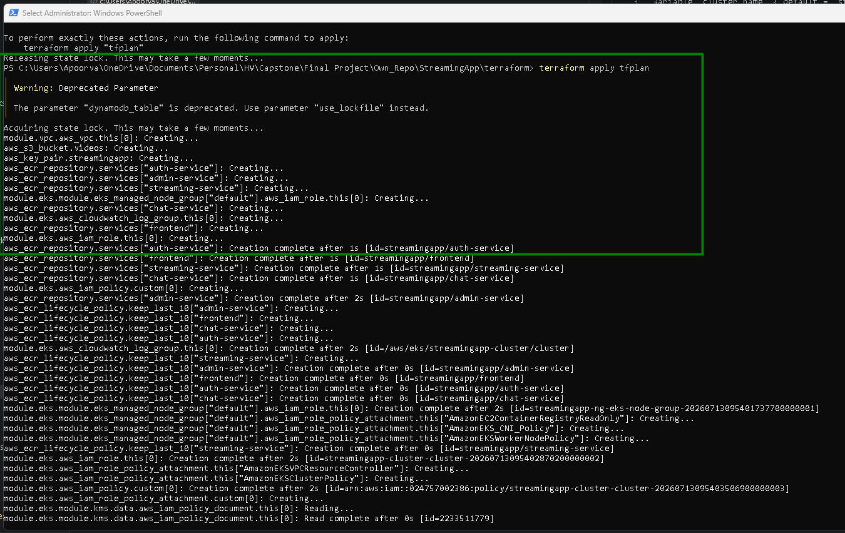
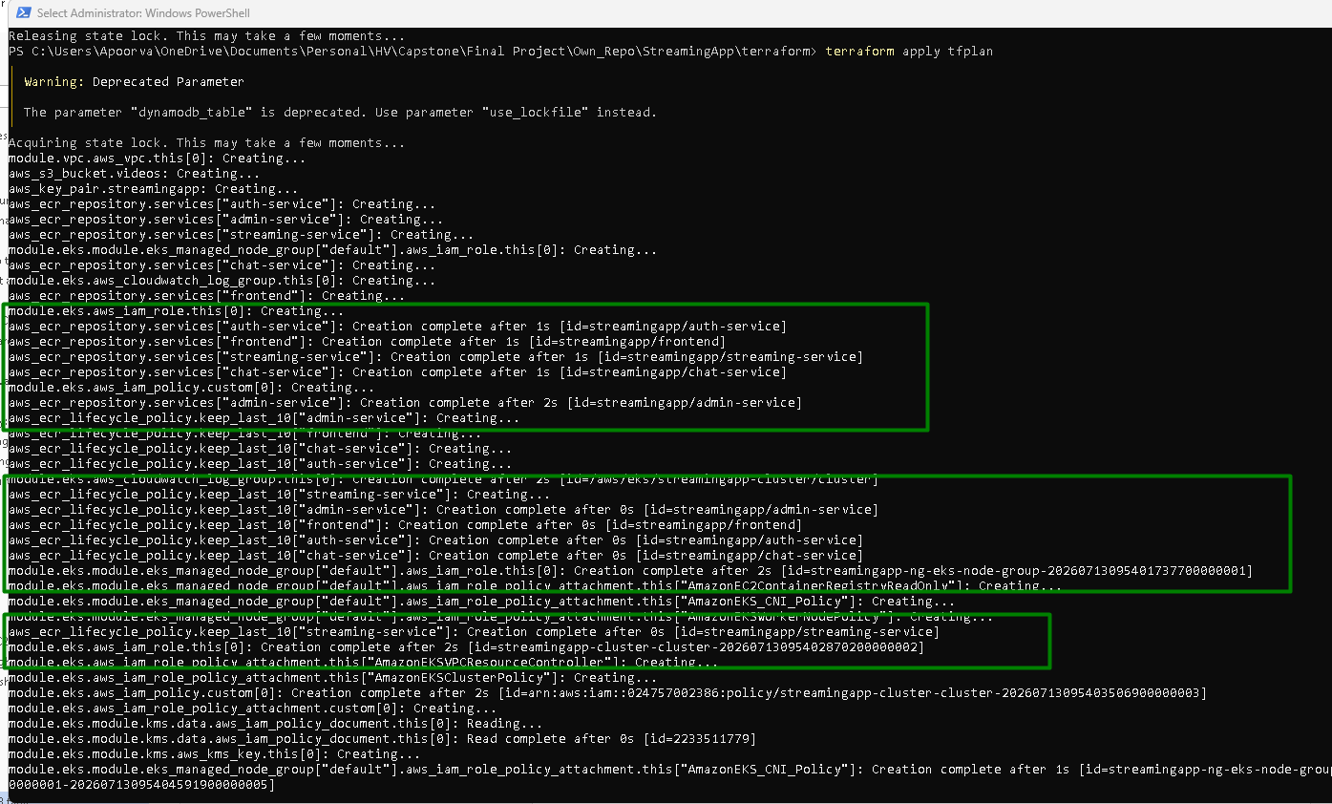
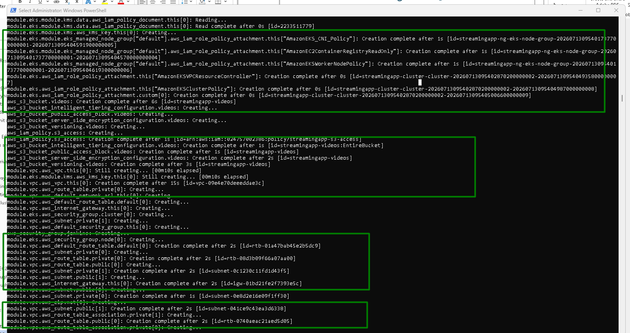
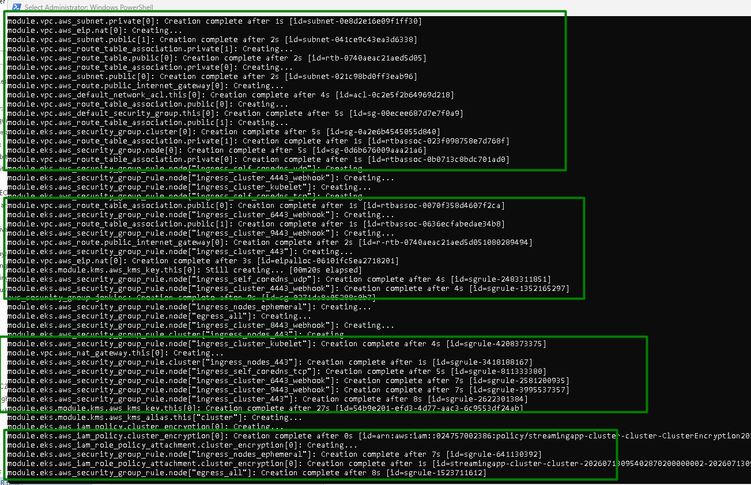
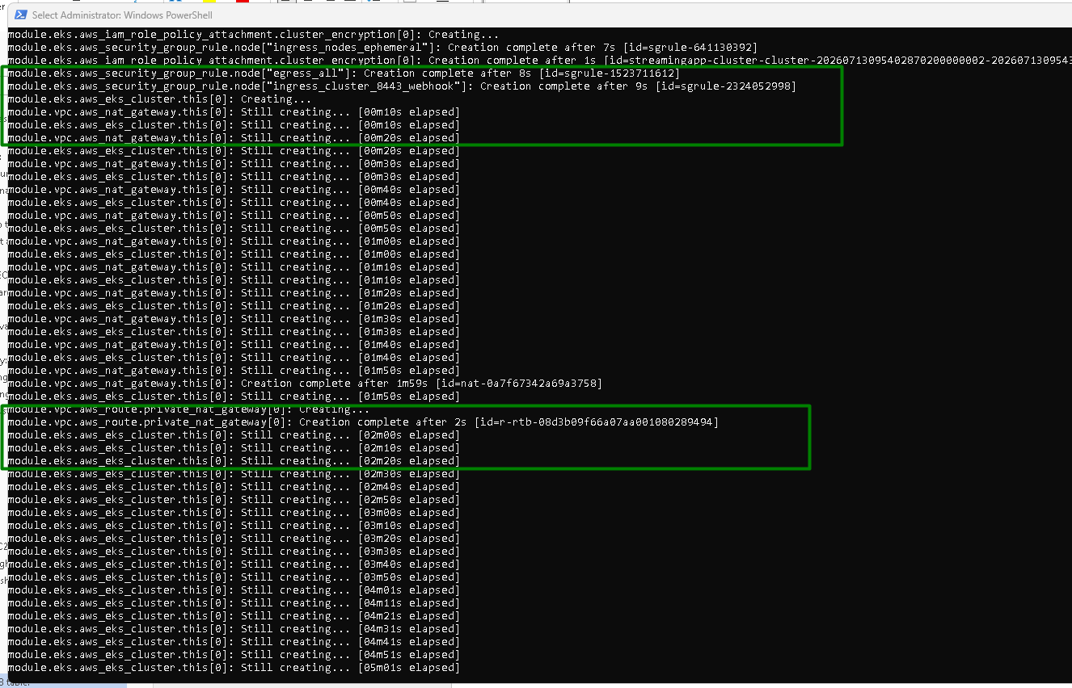
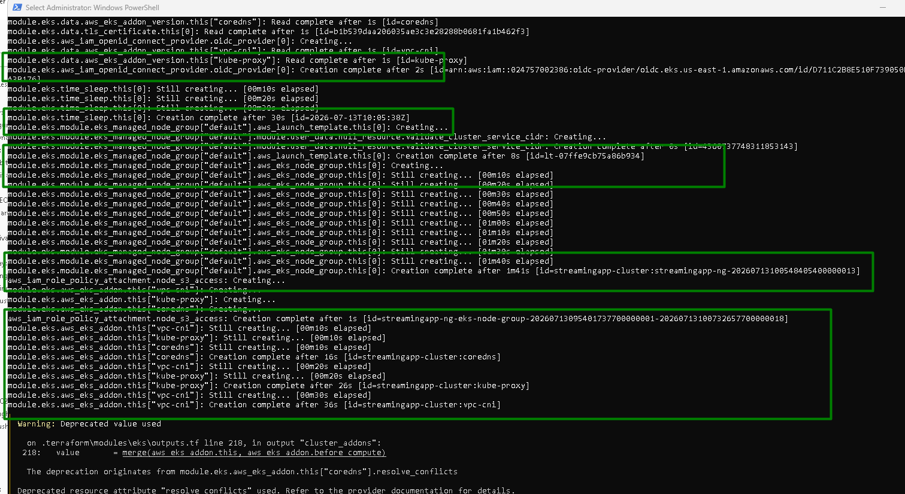
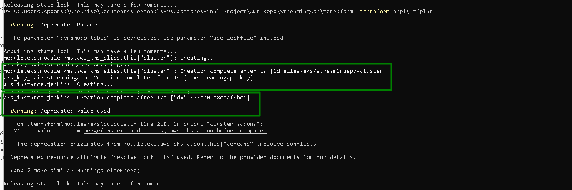

VPC is created:
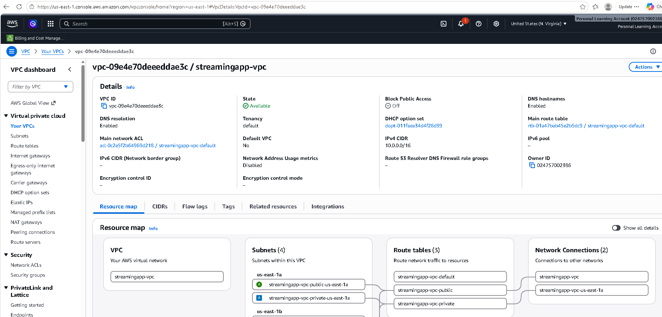

2 public and 2 private subnets are created:
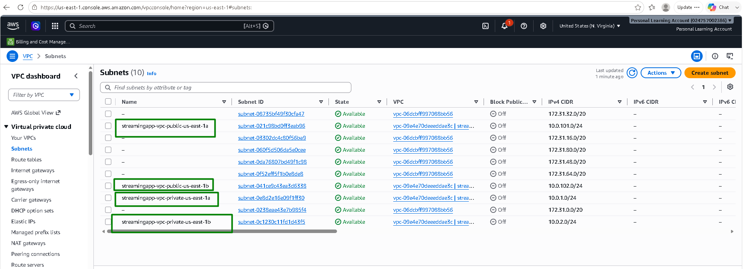

1 NAT Gateway:
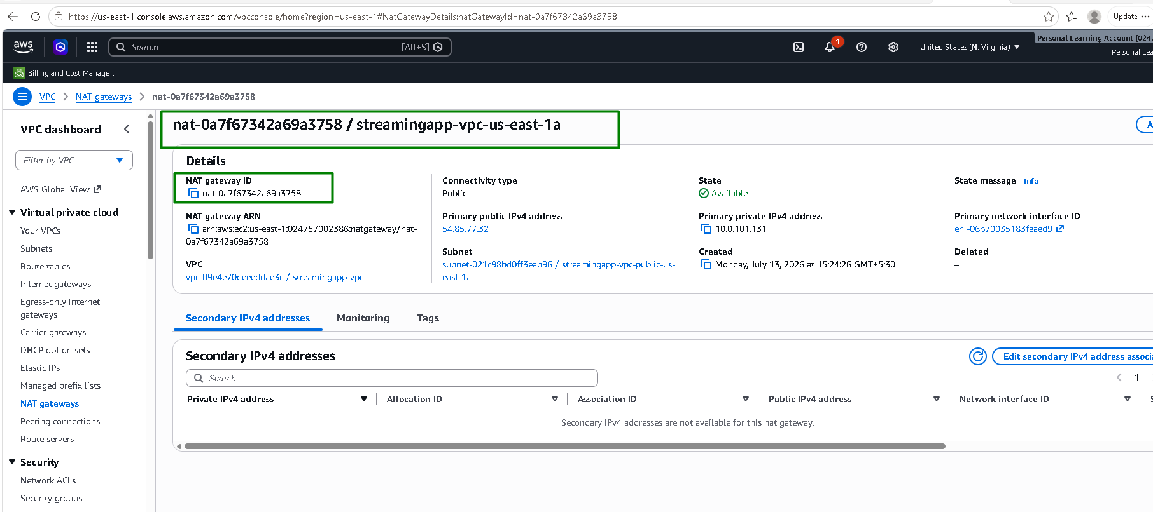

1 Internet Gateway:
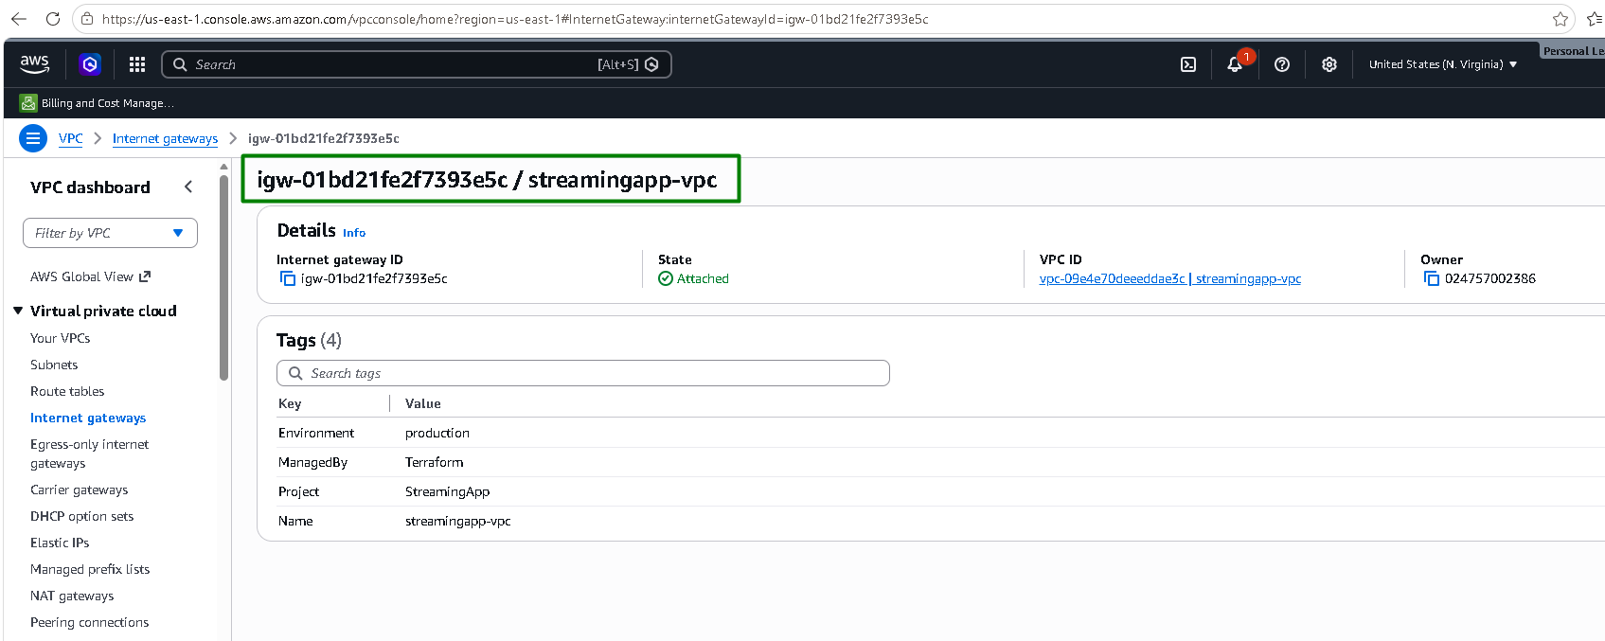

1 public routing:
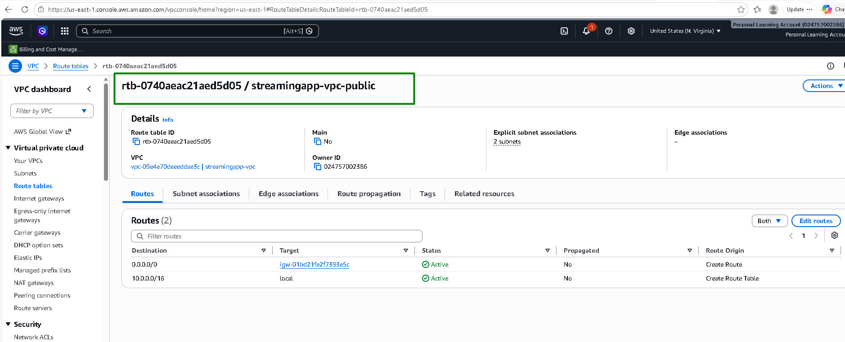

1 private routing:
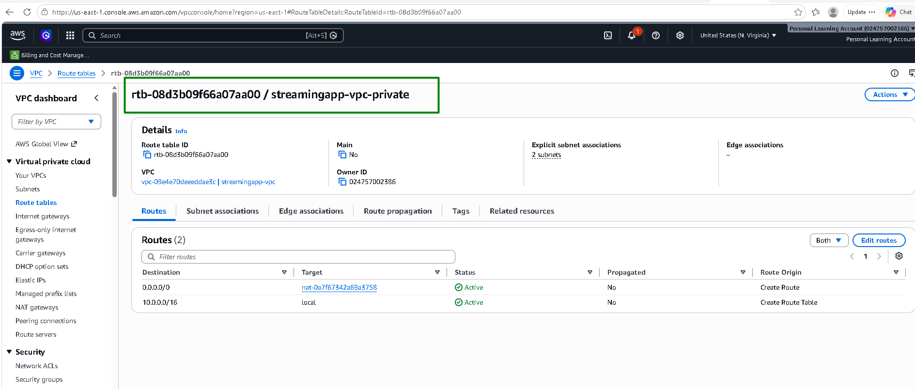

Streaming app cluster:

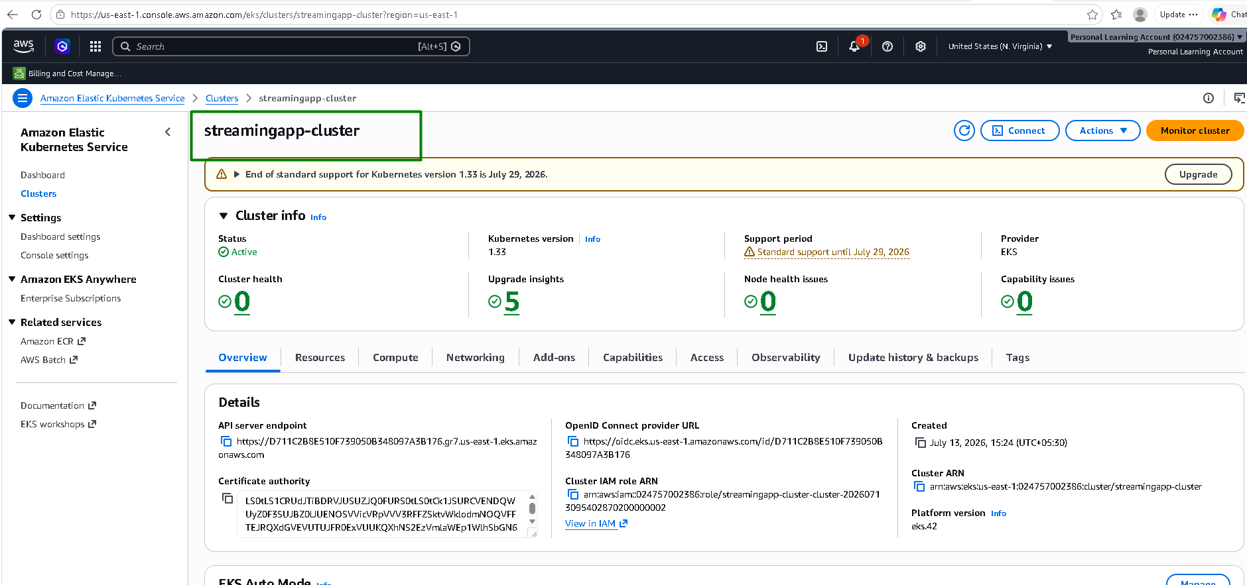
EC2:
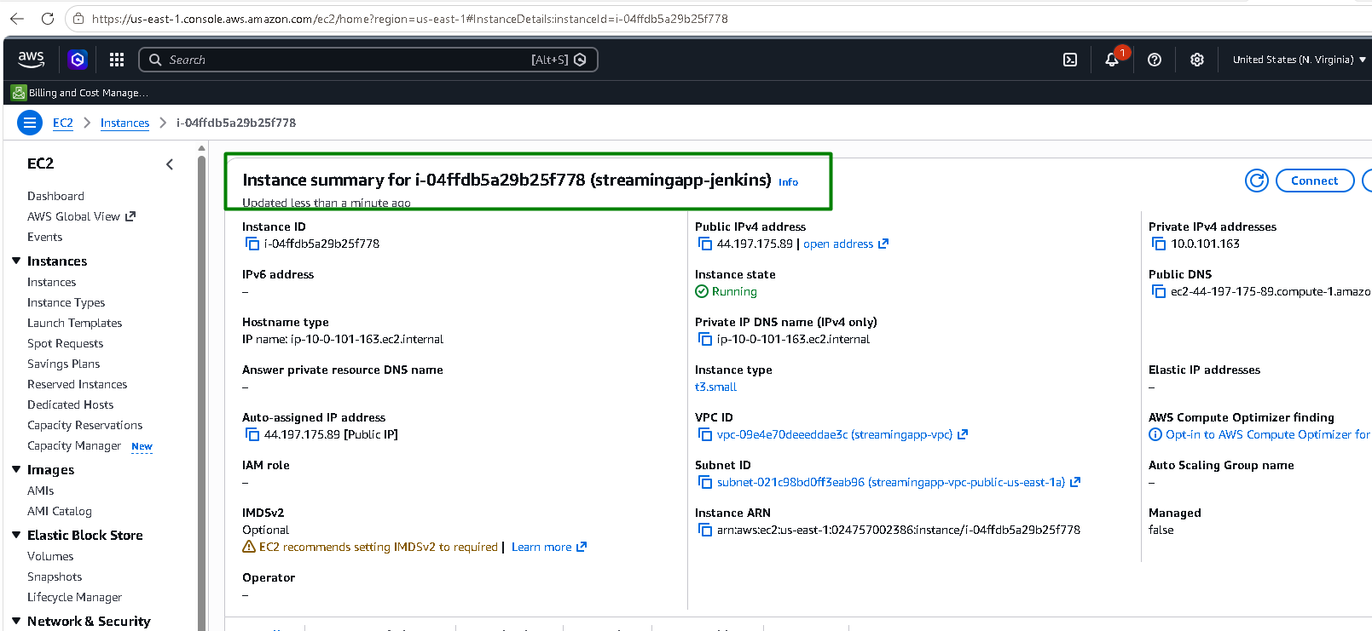

ECR:

Images pushed to repository
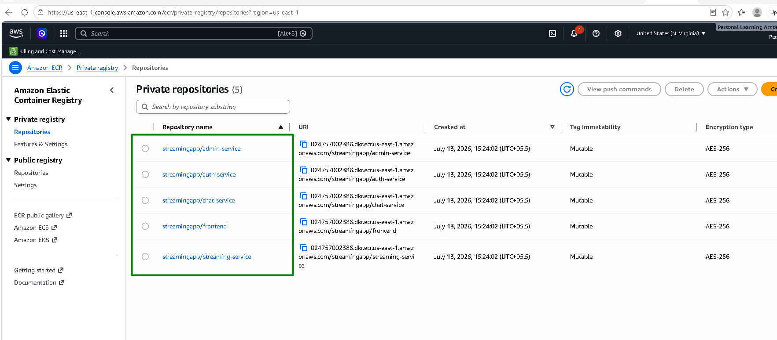

S3:
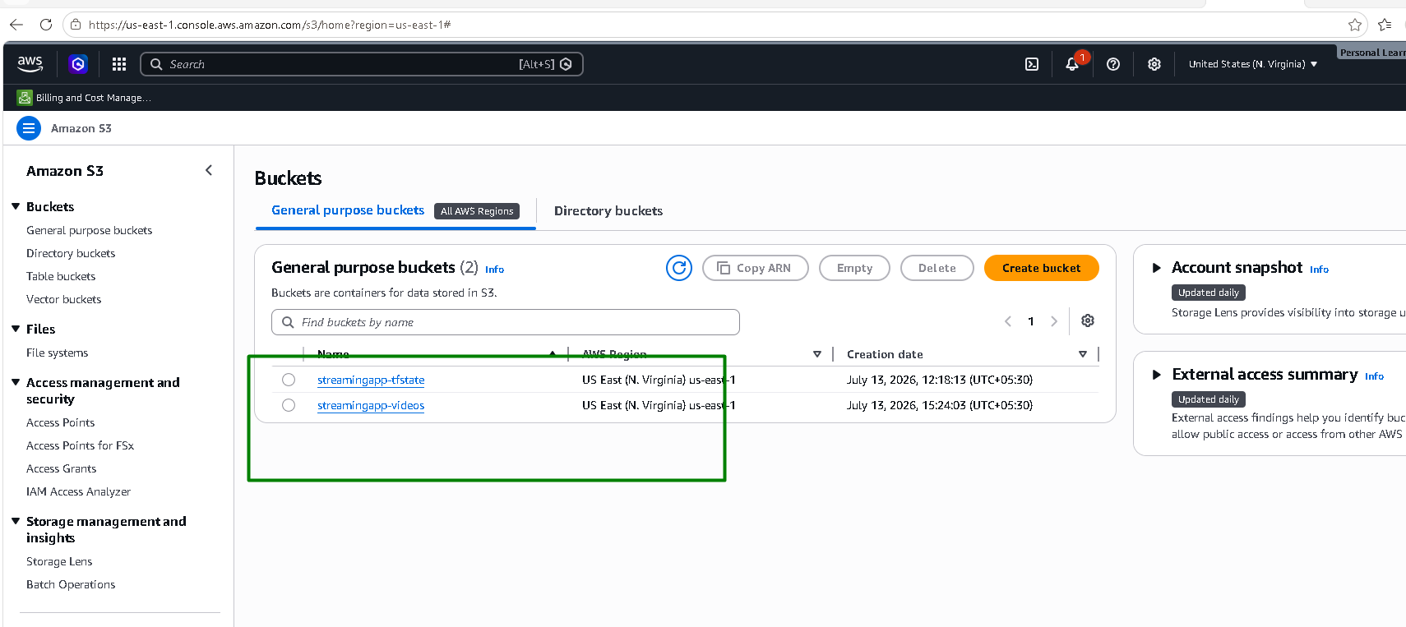

Dynamo DB:
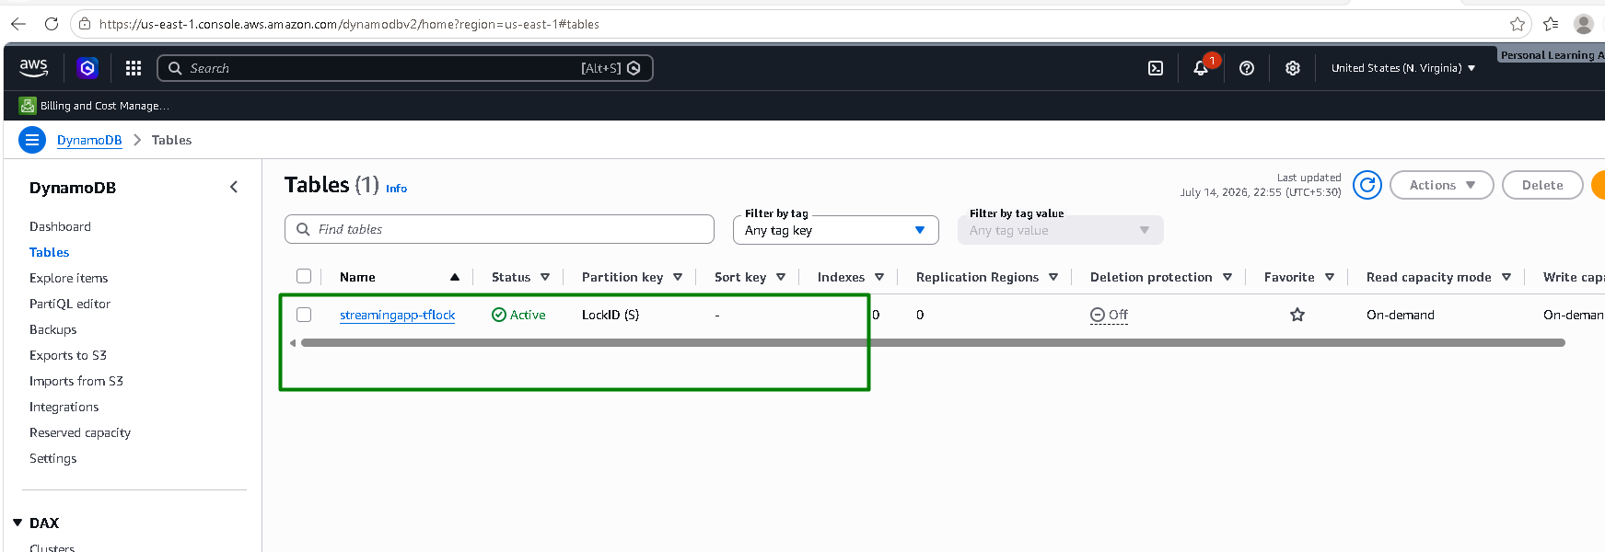

Grant Terraform identity Kubernetes RBAC access
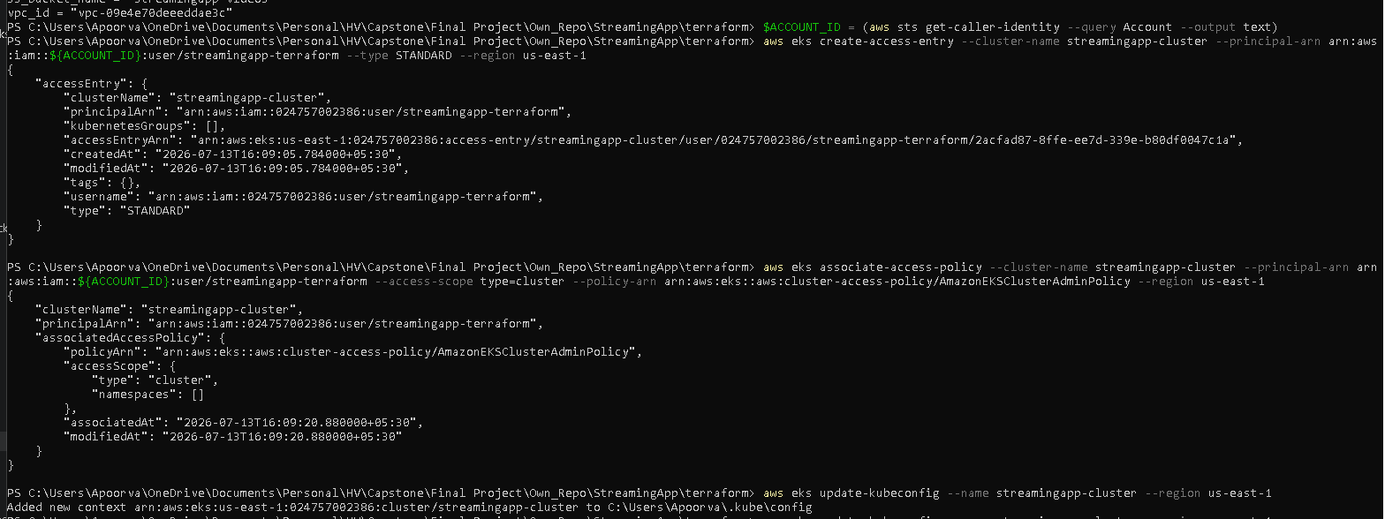
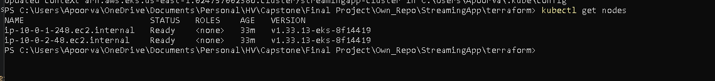

Ansible configures Jenkins EC2:

Generate SSH key pair and replace it in EC2.tf file:
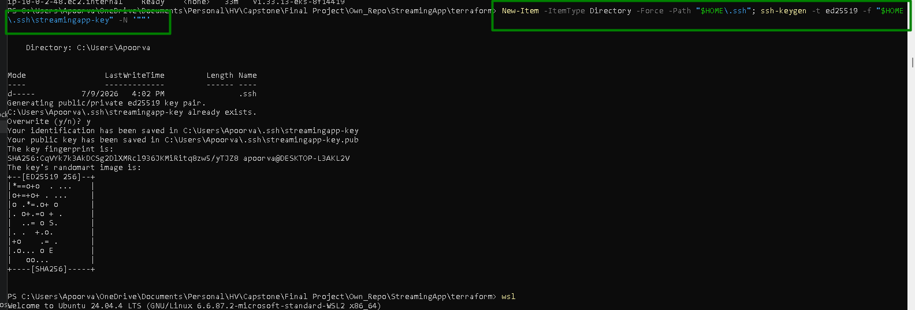

Copy the key to wsl’s native filesystem:
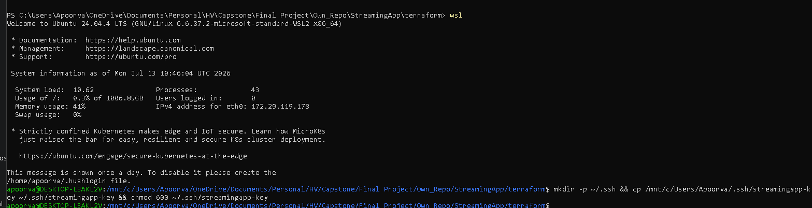

Run the Ansible playbook:
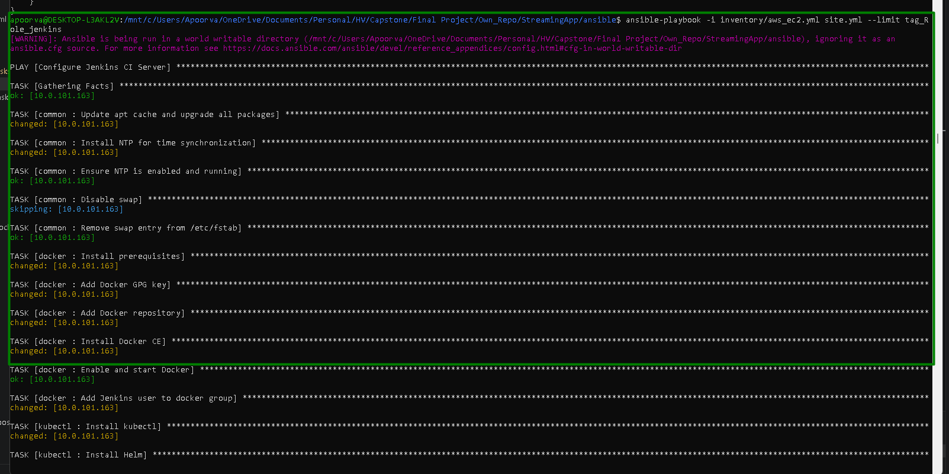
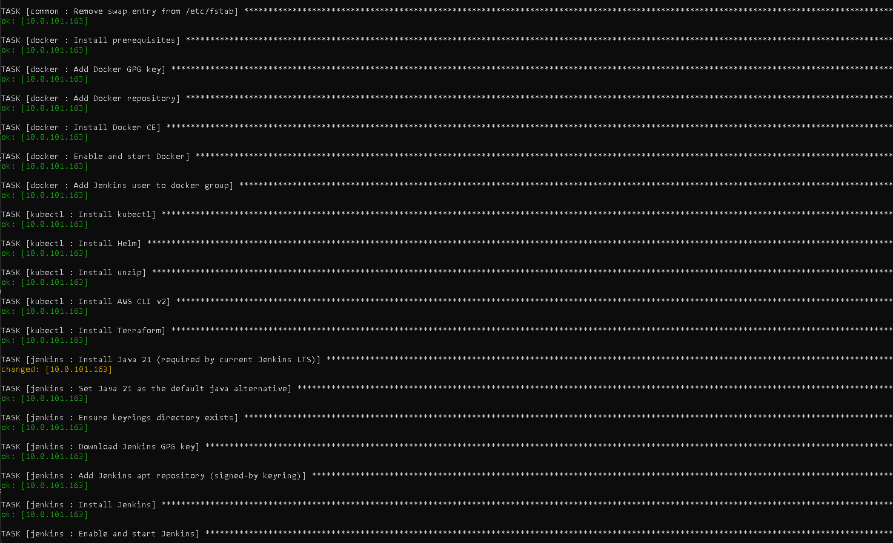
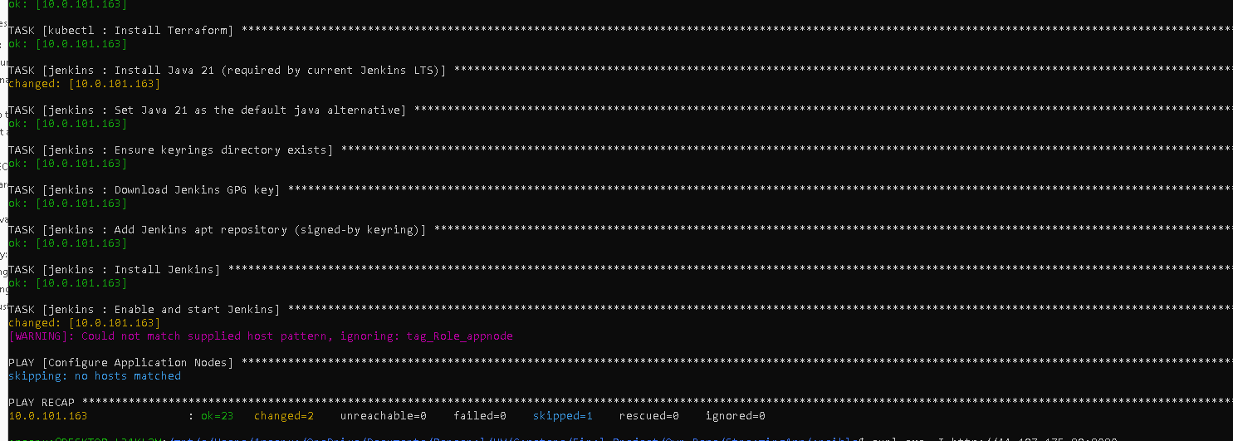

Build and push real docker images to ECR:

Build frontend
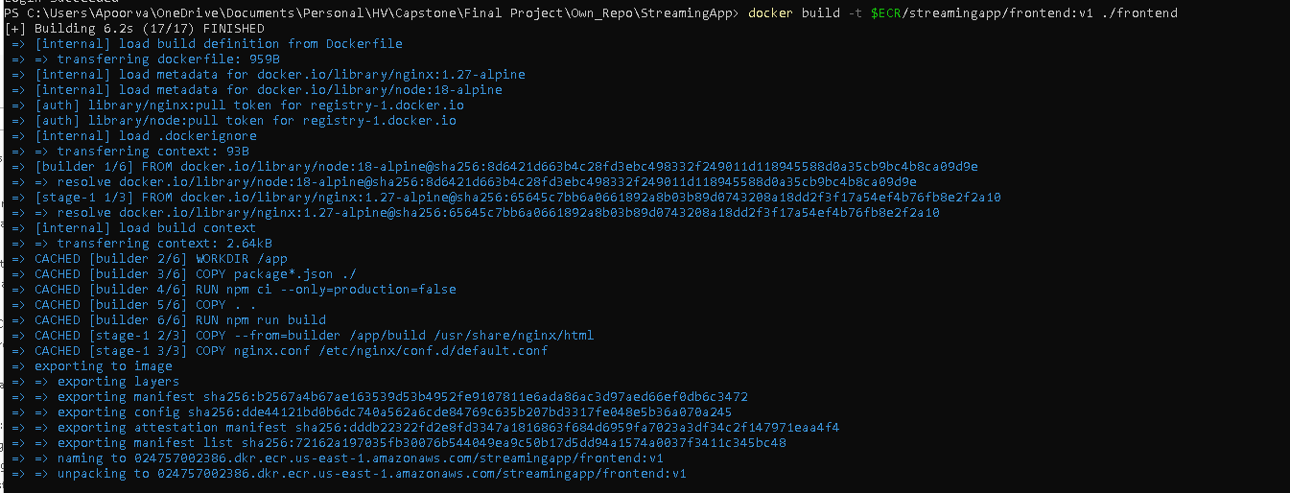

Build auth-service:
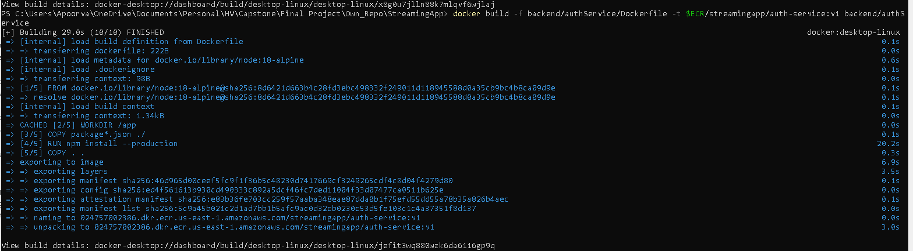

Build streaming-service:
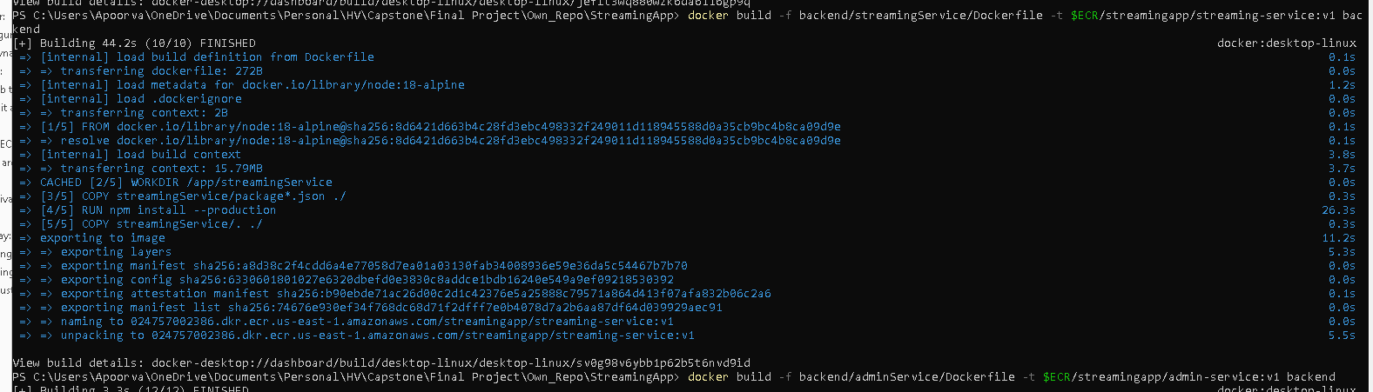

Build admin service:
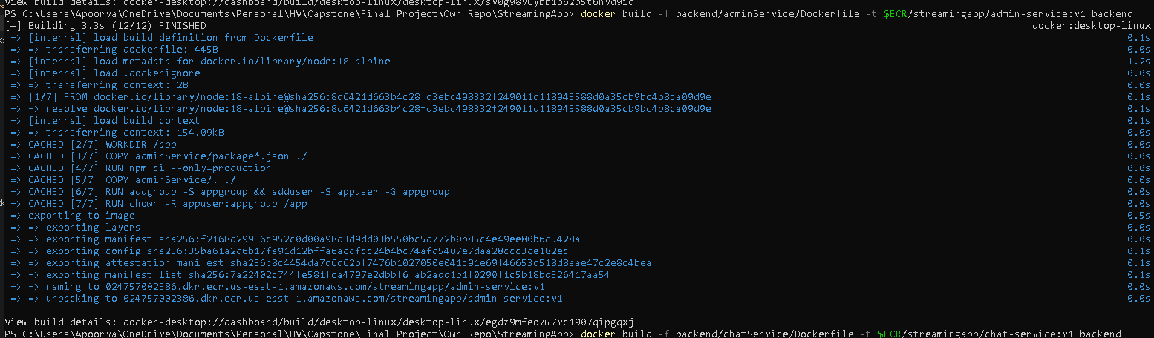

Build chat-service:
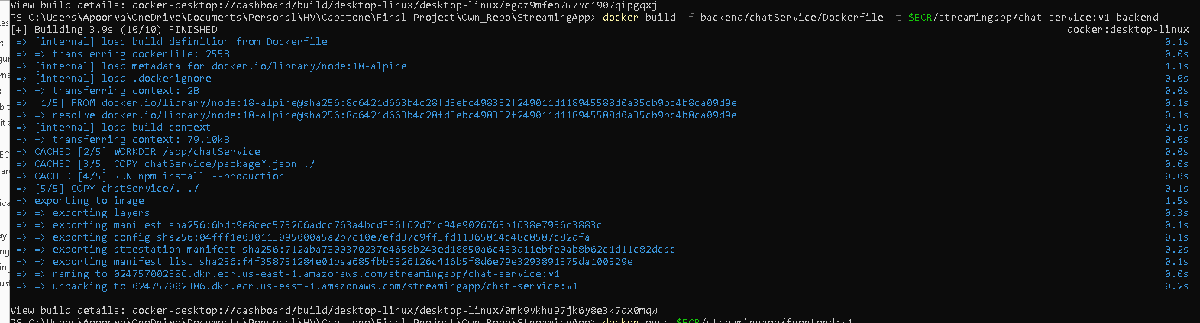

Push all the images to ECR
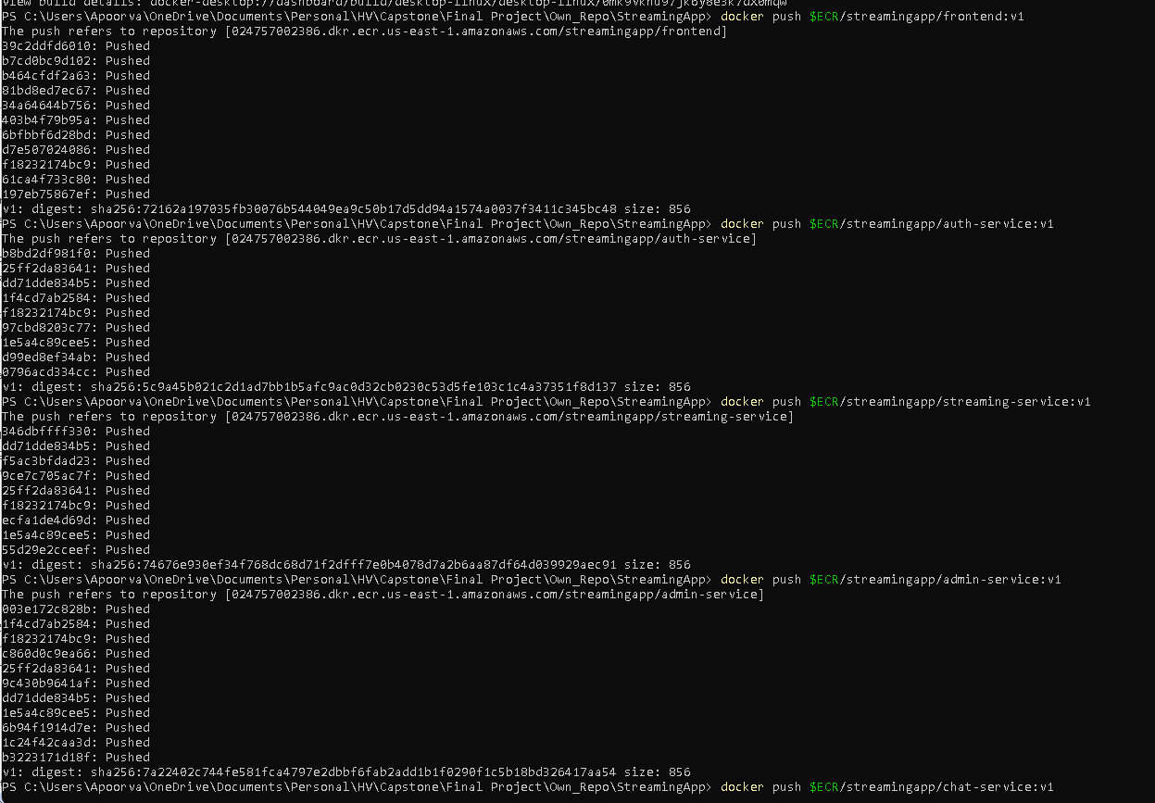
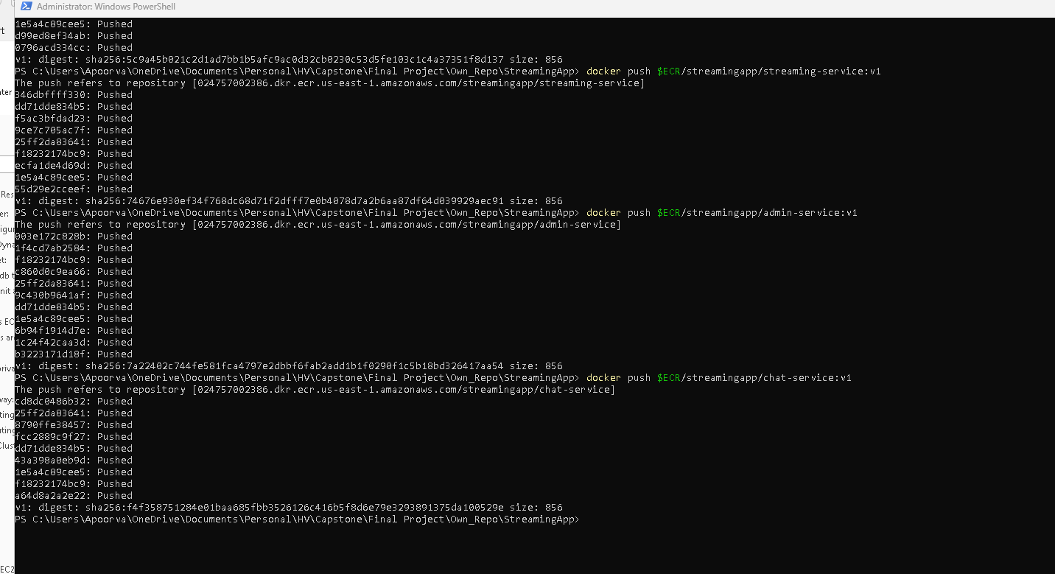

Populate the real secret:
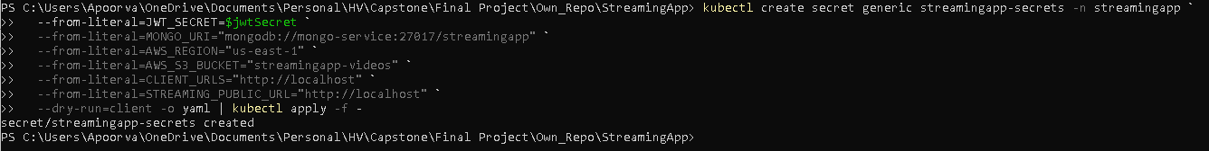

Deploy MongoDB and the app:

Deploy the 5 services via Helm, overriding the image tag to what was just pushed:
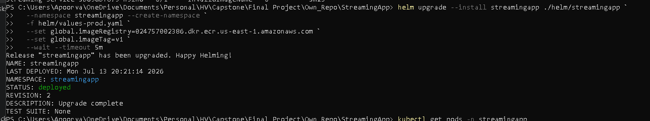

All pods now show running:
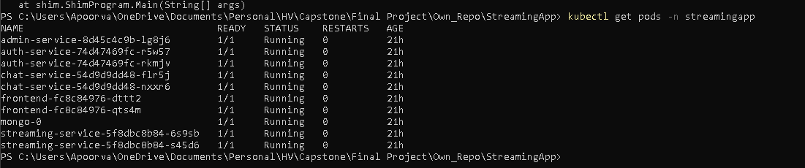

AWS Load Balancer Controller + Ingress
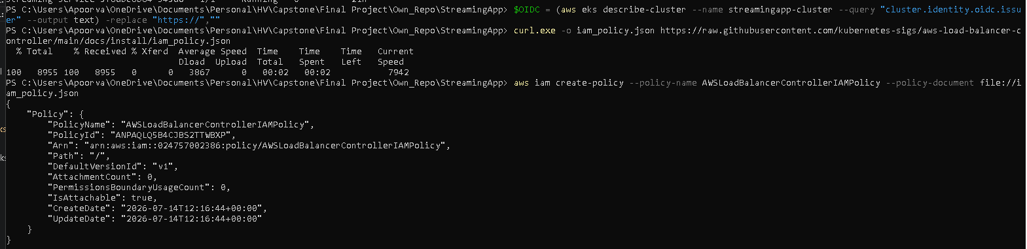
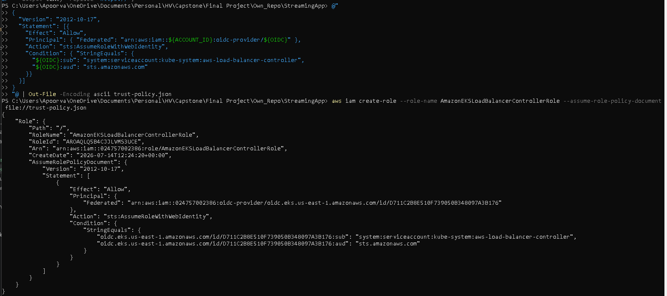
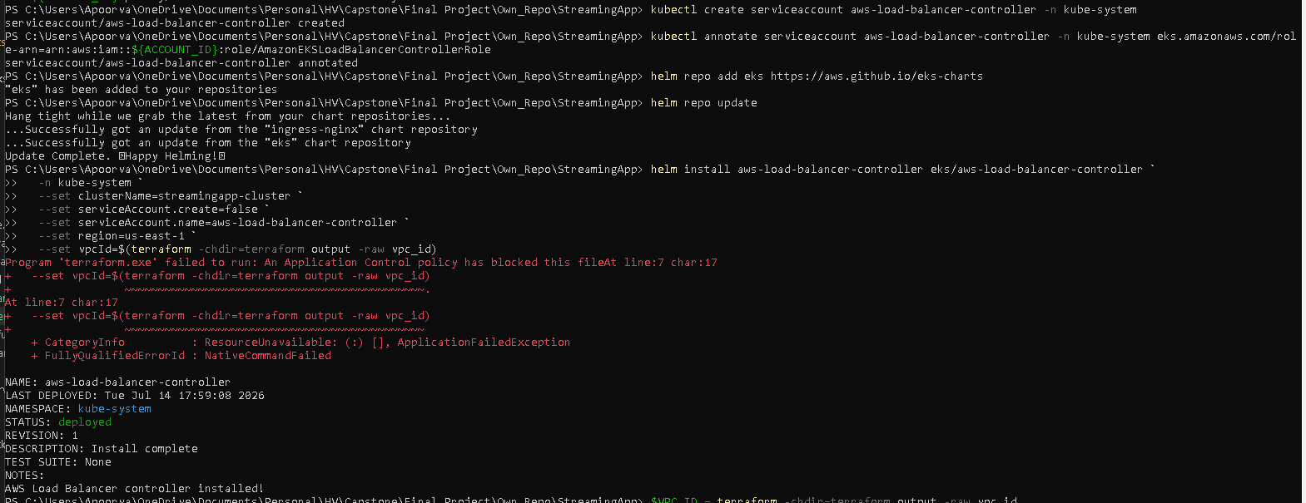
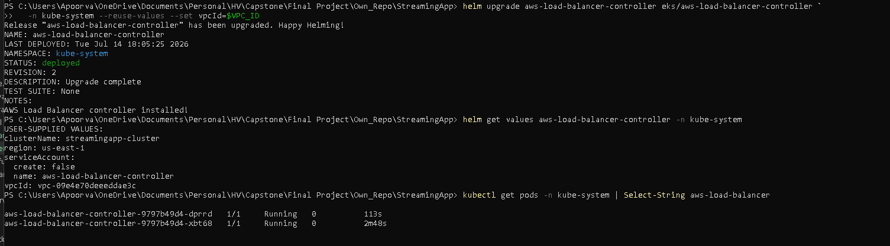
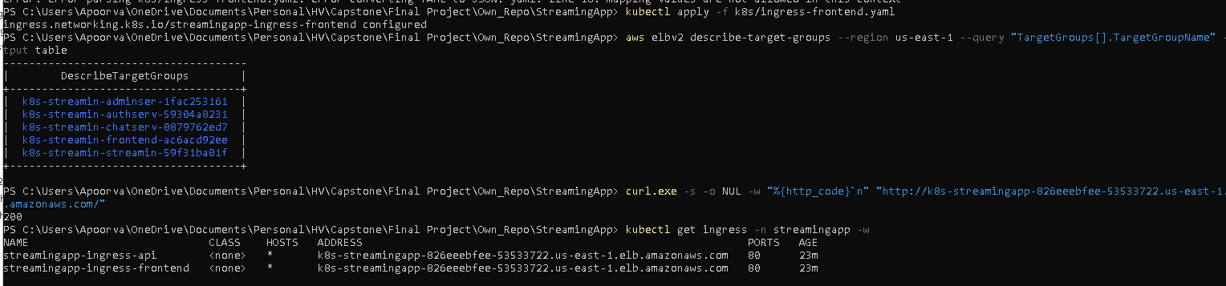

Test the Jenkinsfile:
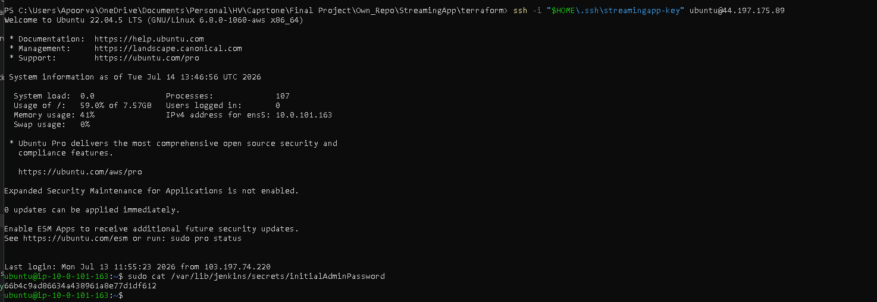
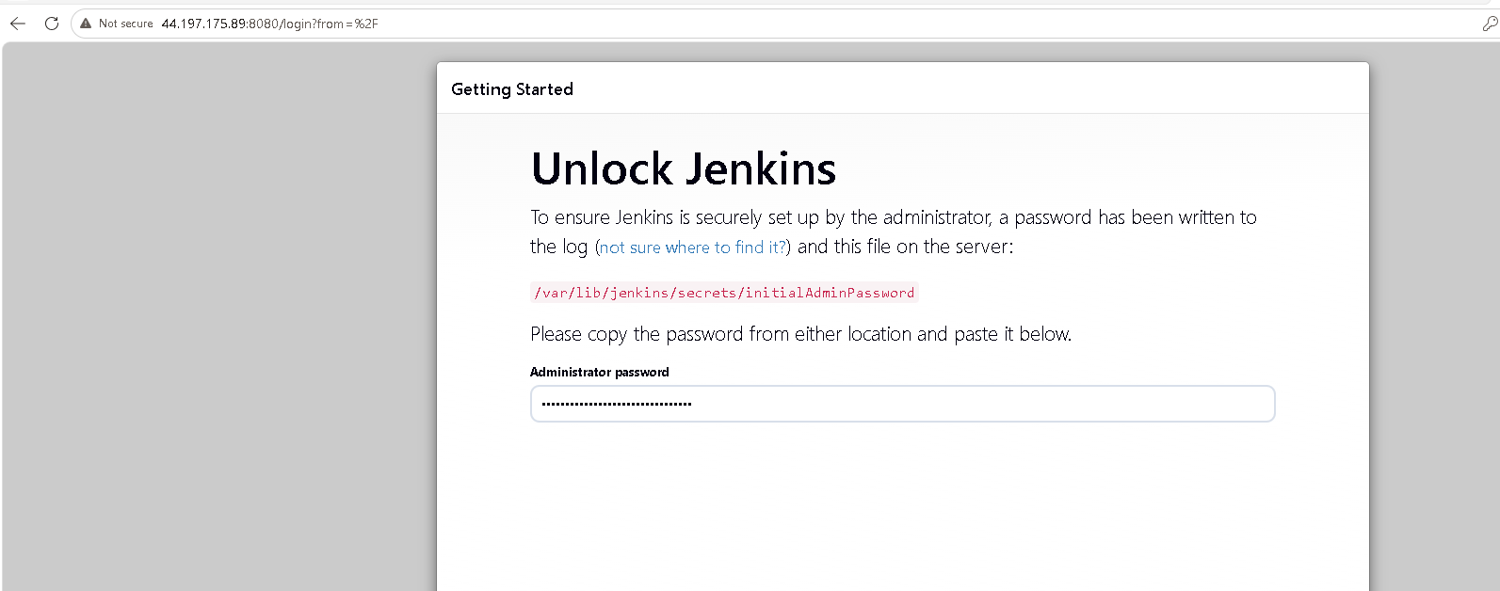

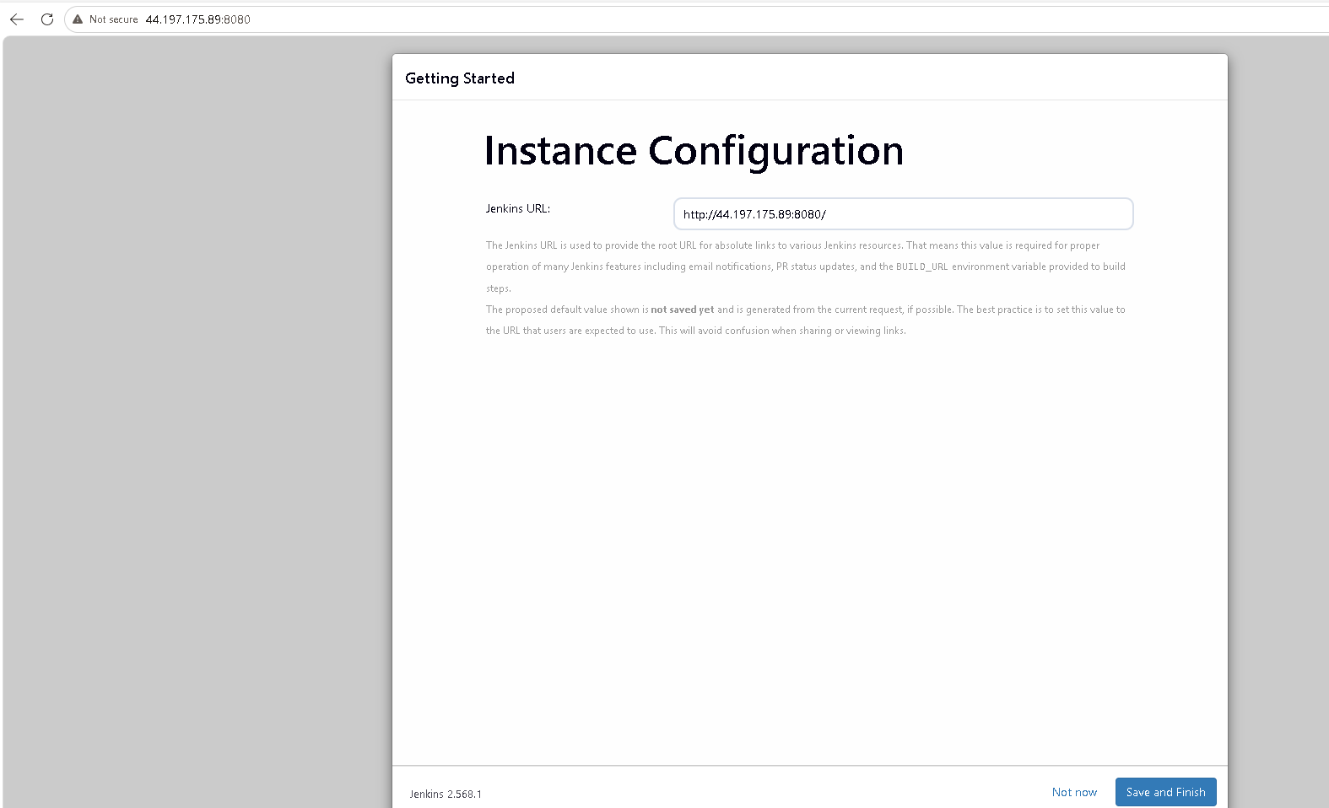
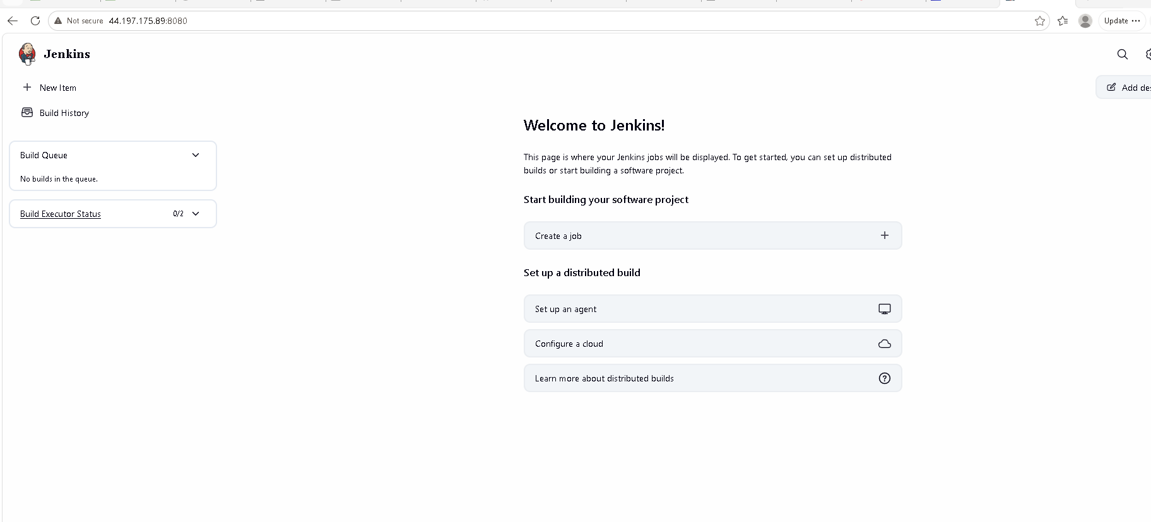

App is live :


